Review and Assessment of Sensing and Measurement Technology for Electric Power Grids
Devices Including Communications and Data Analytics Requirements
February 2019
D. Tom Rizy, PI
Paul Ohodnicki, PlusOne
GMLC Project Team

DOCUMENT AVAILABILITY
Reports produced after January 1, 1996, are generally available free via US Department of Energy (DOE) SciTech Connect.

Website www.osti.gov

Reports produced before January 1, 1996, may be purchased by members of the public from the following source:

National Technical Information Service
5285 Port Royal Road
Springfield, VA 22161
Telephone 703-605-6000 (1-800-553-6847)
TDD 703-487-4639
Fax 703-605-6900
E-mail info@ntis.gov
Website http://classic.ntis.gov/

Reports are available to DOE employees, DOE contractors, Energy Technology Data Exchange representatives, and International Nuclear Information System representatives from the following source:

Office of Scientific and Technical Information
PO Box 62
Oak Ridge, TN 37831
Telephone 865-576-8401
Fax 865-576-5728
E-mail reports@osti.gov
Website http://www.osti.gov/contact.html

This report was prepared as an account of work sponsored by an agency of the United States Government. Neither the United States Government nor any agency thereof, nor any of their employees, makes any warranty, express or implied, or assumes any legal liability or responsibility for the accuracy, completeness, or usefulness of any information, apparatus, product, or process disclosed, or represents that its use would not infringe privately owned rights. Reference herein to any specific commercial product, process, or service by trade name, trademark, manufacturer, or otherwise, does not necessarily constitute or imply its endorsement, recommendation, or favoring by the United States Government or any agency thereof. The views and opinions of authors expressed herein do not necessarily state or reflect those of the United States Government or any agency thereof.
“This research was supported by the Grid Modernization Initiative of the U.S. Department of Energy as part of its Grid Modernization Laboratory Consortium, a strategic partnership between DOE and the national laboratories to bring together leading experts, technologies, and resources to collaborate on the goal of modernizing the nation’s grid.”

ORNL/SPR-2018/956

Sustainable Electricity Program

REVIEW AND ASSESSMENT OF SENSING AND MEASUREMENT TECHNOLOGY FOR ELECTRIC POWER GRIDS

DEVICES INCLUDING COMMUNICATIONS AND DATA ANALYTICS REQUIREMENTS

GMLC PROJECT 1.2.5 SENSING AND MEASUREMENT STRATEGY PROJECT

Author(s)

D. Tom Rizy, ORNL, PI

Paul Ohodnicki, NETL, PlusOne and Task Coordinator

Project Team Key Contributors: Zhi Li (ORNL), Emma Stewart (LLNL), Sydni Credle (NETL), Yarom Polsky (ORNL), Paul Ohodnicki (NETL), Olga Lavrova (SNL), Venkat Krishnan (NREL), Guodong Liu (ORNL), Peter Fuhr (ORNL), Chen Chen (ANL), Philip Top (LLNL), Matthew Lave (SNL), and Steven Bossart (NETL).

Date Published: February 2019

Prepared by
OAK RIDGE NATIONAL LABORATORY
Oak Ridge, TN 37831-6283
managed by
UT-BATTELLE, LLC
for the
US DEPARTMENT OF ENERGY
under contract DE-AC05-00OR22725

CONTENTS
LIST OF FIGURES ix
LIST OF TABLES xi
ABBREVIATIONS, ACRONYMS, AND INITIALISMS xiii
ACKNOWLEDGMENTS xvii
EXECUTIVE SUMMARY xix
1. OVERALL INTRODUCTION AND OBJECTIVES 1
1.1 SENSING AND MEASUREMENT STRATEGY 2
2. SENSING AND MEASUREMENT DEVICES 10
2.1 INTRODUCTION AND OBJECTIVES 10
2.2 CONVENTIONAL GENERATION SENSING FOR MORE FLEXIBLE OPERATION 11
2.2.1 Overview of Sensing and Measurement Needs 11
2.2.2 Summary of Critical Parameters to Be Measured 12
2.2.3 Emerging Sensing and Measurement Technologies 13
2.2.4 Existing Sensing and Measurement Technologies 14
2.3 RENEWABLE GENERATION SENSING AND WEATHER MONITORING 14
2.3.1 Overview of Sensing and Measurement Needs 14
2.3.2 Summary of Critical Parameters to Be Measured 15
2.3.3 Existing Sensing and Measurement Devices 16
2.3.4 Emerging Sensing and Measurement Devices, Trends, and Data-Driven Weather Phenomena or Renewable Resource Modeling 21
2.4 TRANSMISSION AND DISTRIBUTION SYSTEM POWER FLOW AND GRID STATE MONITORING 23
2.4.1 Overview of Sensing and Measurement Needs 23
2.4.2 Existing Sensing and Measurement Devices 26
2.4.3 Emerging Sensing and Measurement Devices 27
2.5 ASSET MONITORING AND FAULT DIAGNOSIS 28
2.5.1 Overview of Sensing and Measurement Needs 28
2.5.2 Summary of Critical Parameters to Be Measured 29
2.5.3 Existing Sensing and Measurement Devices 31
2.5.4 Emerging Sensing and Measurement Devices 32
2.6 END-USE/BUILDING MONITORING FOR RESPONSIVE LOADS 33
2.6.1 Overview of Sensing and Measurement Needs 33
2.6.2 Summary of Critical Parameters to Be Measured 34
2.6.3 Existing Sensing and Measurement Devices 34
2.6.4 Emerging Sensing and Measurement Devices 36
3. COMMUNICATION NEEDS 37
3.1 IMPACT OF GRID MODERNIZATION ON UNDERLYING COMMUNICATION SYSTEMS SUPPORTING SENSING AND MEASUREMENTS 37
3.1.1 Distributed Energy Resources Integration 41
3.1.2 Advanced Metering Infrastructure 42
3.1.3 Demand Response and Demand-Side Management 43
3.1.4 Distribution Grid Management 45
3.2 STATE-OF-THE-ART COMMUNICATION SYSTEMS ENABLING SENSING AND MEASUREMENT FOR ELECTRIC POWER GRID 46
3.2.1 Communication Network Technologies 46
3.2.2 Communication Network Architectures 48
3.2.3 Standards 53
3.2.4 Utility Use Cases 59
4. CYBERSECURITY 61
4.1 CYBERSECURITY 61
4.2 CYBERSECURITY REQUIREMENTS 62
4.3 CYBER VULNERABILITIES 62
4.4 TYPICAL CYBERATTACKS 63
4.4.1 Data Integrity Attack 64
4.4.2 Denial of Service Attack 64
4.4.3 Timing-Based Attack 64
4.4.4 Replay Attacks 64
4.4.5 Coordinated Attacks 64
4.5 DEFENSE AND MITIGATION STRATEGIES 65
4.5.1 Isolation 65
4.5.2 Defense-in-Depth Solutions 66
4.5.3 Device-Level Solutions 67
4.5.4 Blockchain Technology 67
4.6 CYBERSECURITY FOR SENSING AND MEASUREMENT 68
5. DATA MANAGEMENT AND ANALYTICS 72
5.1 BACKGROUND 73
5.2 STAKEHOLDERS 73
5.2.1 Utilities 74
5.2.2 Customers 75
5.2.3 Researchers 75
5.2.4 Governments, Regulators, and Standard Making Organizations 76
5.3 VALUATION METRICS 78
5.4 DATA TYPES AND CHARACTERISTICS 79
5.4.1 Grid Sensors 79
5.4.2 Meter Data 79
5.4.3 Weather Sensors and Energy Production 80
5.4.4 Communication Channel Data 80
5.4.5 Sensor Metadata 80
5.4.6 Grid Topology Information 80
5.4.7 Topology Measures 80
5.4.8 System Equipment and Maintenance Records 81
5.4.9 Model Output Results 81
5.4.10 Market Data 81
5.4.11 Analytics Results 81
5.4.12 Ancillary Systems 81
5.4.13 Cybersecurity-Related Data 81
5.5 DATA CHARACTERISTICS 82
5.5.1 Bulk Characteristics 82
5.5.2 Data Quality 82
5.5.3 Synchronization 82
5.5.4 Ownership 82
5.5.5 Security 82
5.6 EXISTING TECHNOLOGIES 83
5.6.1 Databases 83
5.6.2 Time Series Databases 83
5.6.3 Geospatial Databases 83
5.6.4 Other Types of Databases 83
5.6.5 File Transfer and Archiving 84
5.6.6 Communication 84
5.6.7 Analytics 84
6. OVERALL CONCLUSIONS AND PATH FORWARD 85
7. BIBLIOGRAPHY OF RELEVANT ROADMAPPING DOCUMENTS 87

LIST OF FIGURES
Figure 1. (a) The conventional view of the traditional electric power system along with a schematic consistent with the modern electric power system that is expected to be required in the future. 3
Figure 2. Graphical illustration of the relationship between the Sensing and Measurement Strategy effort and other funded GMI projects. 4
Figure 3. Graphical illustration of the overall sensing and measurement effort along with the relationships among its four key tasks. 5
Figure 4. First working version of the EGS architecture, including (a) the various high-level states (electrical, topological, component, building, ambient, and convergent network) identified and (b) detailed lower-level states within the hierarchical EGS architecture. 8
Figure 5. Examples of metrics of sensing and measurement devices. 11
Figure 6. Existing and emerging challenges in distribution grids and monitoring/measurement needs. 24
Figure 7. Power transformer component monitoring schematic showing examples of instrumentation and measurements of interest. 30
Figure 8. One type of WAMS architecture with PMUs. 38
Figure 9. Data structure of a PMU output with 16-bit floating point format phasor and frequency data. 38
Figure 10. Major delays in WAMS. 40
Figure 11. Two types of approaches for demand response. 44
Figure 12. An example of a hierarchical communication architecture for power systems with smart meters. 49
Figure 13. Cisco GridBlocks reference model. 52
Figure 14. Number of communication networks operating at responding utilities. 60
Figure 15. Types of utility communications technologies now in use. 60
Figure 16. Reference architecture for scaling cybersecurity across various utility domains. 66
Figure 17. Five-tier industrial control system architecture. 69
Figure 18. ExxonMobil system architecture illustrates a clear demarcation between OT and IT. 70
Figure 19. Existing electrical power system data flows and independent repositories. 72
Figure 20. Utility grid stakeholder value network. 73
Figure 21. Key challenges in data management. 75
Figure 22. Coordinated data management system. 77
Figure 23. Improved value flow from a coordinated data management system. 77
Figure 24. Value prioritization. 78
Figure 25. Valuation metric for scalability. 79

LIST OF TABLES
Table 1. Generator sensing and measurement parameters. 13
Table 2. Summary of critical parameters to be measured. 15
Table 3. Parameters required for monitoring and forecasting the performance of a wind plant. 17
Table 4. Parameters required for monitoring and forecasting the performance of a solar panel or plant. 18
Table 5. Summary of instruments used for renewable energy generation sensing and weather monitoring. 20
Table 6. States/parameters directly measured in a phasor network for power flow applications. 25
Table 7. Comparison of different types of instrument transformers. 27
Table 8. Key states and parameters relevant for electrical transmission and distribution system asset monitoring and fault diagnosis. 31
Table 9. States/parameters measured/calculated at end use/building level. 34
Table 10. Comparison of different types of instruments at end use/building level. 35
Table 11. WAMS Applications and corresponding communication requirements. 40
Table 12. Summary of the communication standards in electric power grids. 53
Table 13. Common control system cyber vulnerabilities. 63

ABBREVIATIONS, ACRONYMS, AND INITIALISMS
AC alternating current
AGC automatic generation controller
AMI advanced metering infrastructure
ANL Argonne National Laboratory
ANSI American National Standards Institute
ARPA-E Advanced Research Projects Agency–Energy
ASHRAE American Society of Heating, Refrigeration and Air-Conditioning Engineers
ASTM American Society for Testing and Materials

CIM Common Information Model
CCVT coupling capacitor voltage transformer
CPS cyber–physical system
CT current transducer

DA distribution automation
DC direct current
DER distributed energy resources
DG distributed generation
DGA dissolved gas analysis
DHI diffuse horizontal irradiance
DLC direct load control
DLR dynamic line rating
DMS distribution management system
DNI direct normal irradiance
DNP Distributed Network Protocol
DOE Department of Energy
DOS denial of service
DR demand response
DSL digital subscriber line

EGS extended grid state
EOVT electro-optical effect–based voltage transformer
EPRI Electric Power Research Institute
EV electric vehicle
EVSE electric vehicle supply equipment

FAN field area network
G3-PLC power line communications specification for smart grid implementation
GHI global horizontal irradiance
GIS geographical information system
GMI Grid Modernization Initiative
GMLC Grid Modernization Laboratory Consortium
GOES geostationary operational environmental satellite

HAN home area network
IEA International Energy Agency
IEC International Electrotechnical Commission
IED intelligent electronic devices
IEEE Institute of Electrical and Electronics Engineers
IoT Internet of Things
IP internet protocol
IP-VPN internet protocol–virtual private network
ISA International Society of Automation
IT information technology

LANL Los Alamos National Laboratory
LBNL Lawrence Berkeley National Laboratory
LLNL Lawrence Livermore National Laboratory
LMS load management system
MDMS meter data management system
MOCT magneto-optical effect–based CT
MW megawatt

NAN neighborhood area network
NERC North American Electric Reliability Corporation
NESCOR National Electric Sector Cybersecurity Organization Resource
NETL National Energy Technology Laboratory
NIST National Institute of Standards and Technology
NREL National Renewable Energy Laboratory
NVM nonvolatile memory
OpenADR Open Automated DR
ORNL Oak Ridge National Laboratory
OT operational technology

PEV plug-in electric vehicle
PDC phasor data concentrator
PHY physical layer
PLC power line communication
PMU phasor measurement unit
PNNL Pacific Northwest National Laboratory
POA plane of array
PSTN public switched telephone network
PT potential transducer
PUF physically unclonable function
PV photovoltaic

QoS quality of service
R&D research and development
ROCOF rate of change of frequency
RTU remote terminal unit
SA substation automation
SAE Society of Automotive Engineers
SCADA supervisory control and data acquisition
SE state estimation
SEP Smart Energy Profile
SNL Sandia National Laboratories
T&D transmission and distribution
TRL technology readiness level

UAV unmanned aerial vehicle
USNAP Universal Smart Network Access Port
VPN virtual private network
VT voltage transducer
WAMS wide area measurement system
WMN wireless mesh network
Z-WAVE wireless protocol for home automation

ACKNOWLEDGMENTS
This document is an overview and review of current sensing and measurement technology, including sensor and measurement devices, communications, and data management technology requirements relevant for electric power transmission and distribution systems. The current version was developed as a collaborative effort across the Department of Energy (DOE) national laboratory system through support provided under the DOE Grid Modernization Initiative. More specifically, the effort is an early product of the Technology Roadmap development effort for the Sensing and Measurement Strategy Foundational Project 1.2.5 awarded under the DOE Grid Modernization Laboratory Consortium Laboratory Call issued in 2015 and announced in January 2016. The project team includes the following national laboratories: Oak Ridge National Laboratory (ORNL), Pacific Northwest National Laboratory (PNNL), National Renewable Energy Laboratory (NREL), National Energy Technology Laboratory (NETL), Sandia National Laboratories (SNL), Argonne National Laboratory (ANL), Lawrence Berkeley National Laboratory (LBNL), Lawrence Livermore National Laboratory (LLNL), and Los Alamos National Laboratory (LANL).
The first draft of the document was developed exclusively by the DOE national laboratory Project Team participants. The team engaged with industry partners and other stakeholders through informal document reviews and formal industry meetings and workgroup efforts to strengthen, revise, and update the content of this document to produce the current version.
The Contributors to this report include:
Principal Investigator:
D. Tom Rizy, Oak Ridge National Laboratory
Email: dtom@ornl.gov
Phone: (865) 574-5203
PlusOne and Task 2 Lead:
Paul Ohodnicki, National Energy Technology Laboratory
Email: paul.ohodnicki@netl.doe.gov
Phone: (412) 386-7389
GMLC Sensor Area Lead:
Tom King, Oak Ridge National Laboratory
Email: kingtjjr@ornl.gov
Phone: (865) 241-5756
DOE Laboratory Key Contributors:
Zhi Li (ORNL), Emma Stewart (LLNL), Sydni Credle (NETL), Yarom Polsky (ORNL), Paul Ohodnicki (NETL), Olga Lavrova (SNL), Venkat Krishnan (NREL), Guodong Liu (ORNL), Peter Fuhr (ORNL), Chen Chen (ANL), Emma Stewart (LLNL), Philip Top (LLNL), Matthew Lave (SNL), and Steven Bossart (NETL).
Finally, we would like to thank Alfonso Tarditi of ORNL’s Power and Energy Systems Group and Tim McIntyre of ORNL’s Sensors and Embedded Systems Group for their technical review of the draft document. Also, we would like to thank Deborah Counce of ORNL’s Technical Communications Group for her thorough technical editing of the document, as well as Michael Gipple and Jennifer Bowman of NETL’s Technical Writing and Multimedia group for formatting, technical review, and graphical support.

EXECUTIVE SUMMARY
The Sensing and Measurement Technology Roadmap development effort of the Grid Modernization Laboratory Consortium Sensing and Measurement Strategy Project seeks to accomplish the following three objectives in support of the Department of Energy’s Grid Modernization Initiative (GMI).
- Identify a clear understanding of the current state of the art in the area of sensing and measurement devices including communications, and data management/analytics requirements as they relate to the modern electric power system, spanning from generation to transmission and distribution systems and ultimately to end uses including buildings.
- Perform a gap analysis between sensing and measurement technology needs and the current state of the art to provide the necessary visibility across the modern electric power system required to enable the vision of a modernized electricity grid infrastructure as outlined in the GMI Multi-Year Program Plan.
- Develop a prioritized technology roadmap with recommendations for research and development in sensing and measurement for a modernized electric power system to realize the ultimate GMI objectives.
The current document represents a Technology Review of Sensing and Measurement Technology, including communications and data analytics requirements needed in support of objective 1. The document serves as a key foundational reference for the gap analysis performed in support of the Sensing and Measurement Technology Roadmap effort. Emphasis is placed on developing an understanding of current state-of-the-art and emerging technologies as they relate to (1) sensing and measurement devices, (2) communications requirements, and (3) data management and analytics requirements.
In the discussion of sensing and measurement devices, the technology review is divided into five distinct application domains related to needs for the electric power system of the future:
- Conventional generation sensing for more flexible operation
- Renewable generation sensing and weather monitoring
- Transmission and distribution power flow and grid-state monitoring
- Asset monitoring and fault diagnosis
- End-use/building monitoring for more responsive loads
There is necessarily some overlap between these highlighted domains; the expectation is that such distinctions will become less clear moving into the future as the modern electric power system evolves. Nevertheless, sensing and measurement approaches and technologies used across these application domains—as well as the key stakeholders and technical experts within each community—tend to be sufficiently distinct to serve as a valuable means of organizing and focusing the gap analysis and technology roadmap in conjunction with the extended grid state definition being developed under parallel project activity.
This Technology Review has yielded useful insights about the current technology status within the identified application domains and emerging needs in the area of sensing and measurement devices.
Also, crosscutting themes have emerged across the application domains. They include the following:
Needs exist for advanced instrumentation at centralized generation and transmission levels, and a relative lack of visibility also exists within the distribution system.
The per-unit value of a sensor installed and deployed on a distribution system or at the end-use level is dramatically lower than the value of a comparable sensor installed at the corresponding transmission level. Enhancing visibility in the distribution system and at the end-use level requires advances in (1) low-cost and (2) multifunction or multi-parameter sensors.
Standards and interoperability are an important aspect of new sensing and measurement device development and deployment.
Key insights derived for the various application domains identified within the document include the following:
Harsh-environment instrumentation relevant for conventional thermal-based generators (e.g., fossil, nuclear) could enable more flexible operation and minimize long-term impacts of cycling and ramping on plant longevity and efficiency. Capabilities of existing automation generation controllers and associated sensing and measurement devices should be evaluated in terms of the potential for technology innovations.
Weather monitoring and forecasting technologies exist, at high technology readiness levels, for predicting renewable generation (e.g., solar, wind); with innovations often adapting mature sensing technologies from other fields. Emerging trends include management of these data and application of unmanned aerial vehicles, including software analytics and lidar-based techniques.
Phasor measurement units are a key technology for power flow and grid state monitoring; and opportunities remain for improvements in their reliability, speed, accuracy, cost, and application at the distribution level. Emerging electromagnetic phenomena—based on current and voltage transducers—show significant opportunity for new innovations.
Asset monitoring of electrical grid assets can be classified into both “functional performance” and “health monitoring.” The former requires predominantly electrical parameter sensors; and the latter requires sensors for a broad range of parameters such as temperature, chemistry, and strain. Sensor instrumentation exists for established grid components, but costs currently limit deployment to the most critical assets. New sensing technologies are required for emerging grid components.
Trends of increased generation in the residential and commercial building sectors, as well as projections for widespread electric vehicle and energy storage deployment require increased visibility at the customer to enable demand response and transactive energy strategies. Low-cost sensor technologies for monitoring power flow, as well as parameters characteristic of the current and forecasted net load, will be of increasing importance.
Conclusions of the technology review as it relates to communication needs include the following:
A paradigm shift is anticipated toward broader implementation of distributed rather than centralized architectures characterized by communication and intelligence at lower levels.
Reduced latencies and robust peer-to-peer communication, in addition to communication between various nodes and the control center, will be of increasing importance.
A hierarchical communication architecture appears highly desirable based upon several key attributes:
- Scalability to manage a large number of sensing and measurement devices
- Flexibility and expandability to incorporate new types of data and applications
- Efficiency in leveraging unique features of different communication technologies
- Reduced latency with more distributed data processing and control
Important conclusions of the data management and analytics needs review include these:
The desire for dramatically increased visibility across the electricity grid infrastructure will necessarily increase the deployment of sensing and measurement devices and associated data management needs to unprecedented levels.
A shift toward distributed data analytics methodologies rather than centralized approaches is a potential key component of the required technical solution.
A great amount of value can be extracted from the existing sensing and measurement infrastructure through advanced data management and analytics approaches, especially at the distribution level, which has traditionally been limited to substation monitoring and control.
The conclusions of this review document provide a foundation for the next phases of the technology roadmapping activities, including the (1) gap analysis and (2) technology roadmap document development.

OVERALL INTRODUCTION AND OBJECTIVES
The Department of Energy’s (DOE) Grid Modernization Initiative (GMI) represents a comprehensive effort to shape the future of the US electric power grid and solve the challenges of integrating conventional and renewable energy sources with energy storage, smart buildings, and electric transportation while ensuring that the grid is sufficiently resilient to withstand growing physical, cybersecurity, and climate challenges and threats. In January 2016, as part of the GMI, DOE announced funding for a Grid Modernization Laboratory Consortium (GMLC) of up to $220 million over 3 years. The GMLC consists of the DOE national laboratories and their industry partners. The funding will support critical research and development (R&D) in advanced sensors, advanced storage systems, clean energy integration, standards and test procedures, and a number of other key grid modernization areas. The objectives of the initiative are focused around supporting the transition from an electric power system characterized by large, centralized generation with one-way power flows to a decentralized modern power system characterized by distributed generation (DG), responsive loads, electric transportation, two-way power flow, and distributed intelligence. The modern electricity infrastructure will require developments in new sensor, monitoring, data processing, and control technology and will require balancing six key attributes, as discussed in the Multi-Year Program Plan (Figure 1). They include:
Resilience—Recovers quickly from any situation or power outage.
Reliability—Improves power quality with shorter and fewer power outages.
Security—Increases protection to our critical infrastructure from physical, cybersecurity, and climatic events.
Affordability—Maintains reasonable costs to consumers.
Flexibility—Responds to the variability and uncertainty of conditions at one or more time scales, including a range of energy futures.
Sustainability—Facilitates broader deployment of clean generation and efficient end-use technologies.

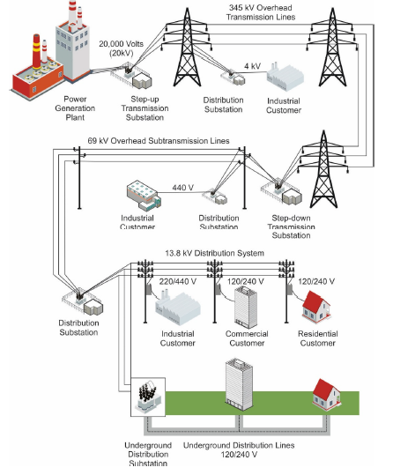

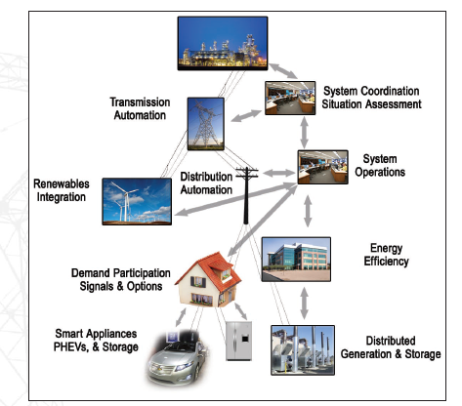

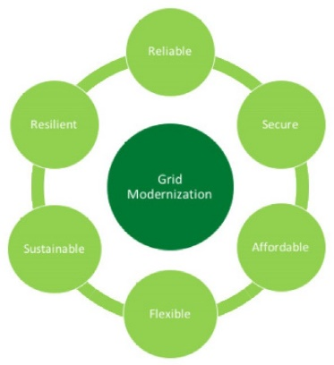
Figure 1. (a) The conventional view of the traditional electric power system along with a schematic consistent with the modern electric power system that is expected to be required in the future.
(b) Six key attributes of the modernized electricity grid that must be balanced. Figure 1a (top) is from Maintaining Reliability in the Modern Power System, US Department of Energy, December 2016;.Figure 1a (bottom) is from Smart Grid Systems Report, US Department of Energy, July 2009.

SENSING AND MEASUREMENT STRATEGY
One of the GMLC projects is a $3 million, 3 year effort toward a sensing and measurement strategy begun in April 2016. The project team includes Oak Ridge National Laboratory, Pacific Northwest National Laboratory, National Renewable Energy Laboratory, National Energy Technology Laboratory, Sandia National Laboratories, Argonne National Laboratory, Lawrence Berkeley National Laboratory, Lawrence Livermore National Laboratory, and Los Alamos National Laboratory. The relationship between this project and other funded projects within the GMI is illustrated below in Figure 2.
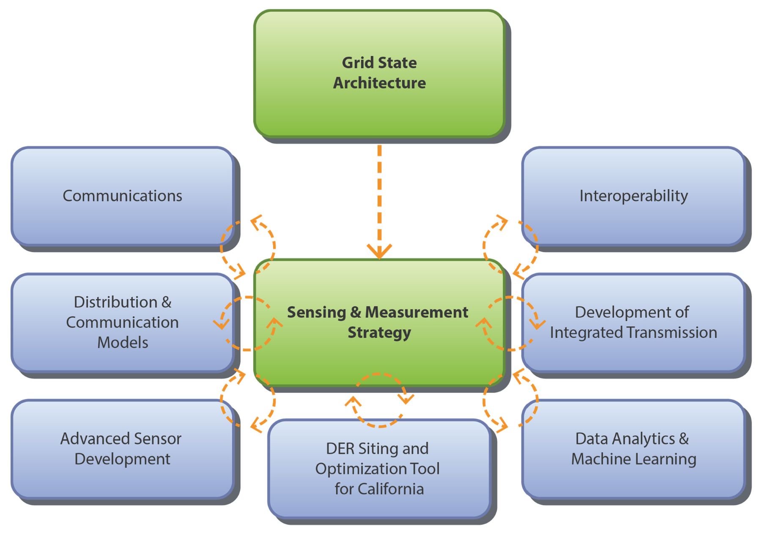
Figure 2. Graphical illustration of the relationship between the Sensing and Measurement Strategy effort and other funded GMI projects.
The US electric power system is undergoing a major transformation with the increase and integration of new devices, such as distributed energy resources (e.g., DG, electric vehicles, energy storage); a major shift in generation mix, including more renewable non-firm power resources; an aging infrastructure; and greater customer involvement, including demand-responsive systems and programs. The transformation requires greater determination (“visibility”) throughout the electric power system to manage the capabilities of its increasing number and diversity of assets. Ideally, advanced sensors and measurement systems will be able to determine the real-time state of the power system during normal operation as well as abnormal conditions. The management of these data will provide the ability to forecast future states with sufficient accuracy and lead times to avert deviations from normal operations (i.e., self-heal for disturbances) and to facilitate rapid recovery and restoration. Meeting this goal will require the capability to measure and characterize the state of the power system with greater speed, accuracy, and precision than ever before—from generation to transmission, distribution, and finally end- use. And as the electric power system has begun the paradigm shift from a centralized and deterministic system—characterized by large-scale generators and one-way power flow to its delivery system—to a fundamentally distributed and hierarchical power system, clear demarcations between the conventional definitions of transmission and distribution (T&D), as well as source and load, have begun to blur. The sensing and measurement devices and approach for such a complex and distributed system must also undergo a paradigm shift. For all of the reasons stated, a comprehensive strategy is needed to prioritize the research, development, and deployment activities of the GMI for this sensing and measurement area.
The goals of the grid sensing and measurement strategy are as follows:
Identify parameters to measure in a future grid paradigm.
Develop approaches and technologies to measure these parameters.
Define what communications requirements are needed to transfer sensor data in a timely and secure manner.
Identify what is needed to manage, analyze, and convert data into actionable information for both operators and control systems.
Develop a placement tool to optimize the sensor and measurement system.
Work with industry and technical and standards organizations to ensure the usefulness, interoperability, and accuracy of sensor and measurement technology.
Four key tasks are under way to address the different aspects of the overall grid sensing and measurement strategy. A schematic illustration of the overall project effort is presented in Figure 3, and the four tasks are described in more detail in the following paragraphs.
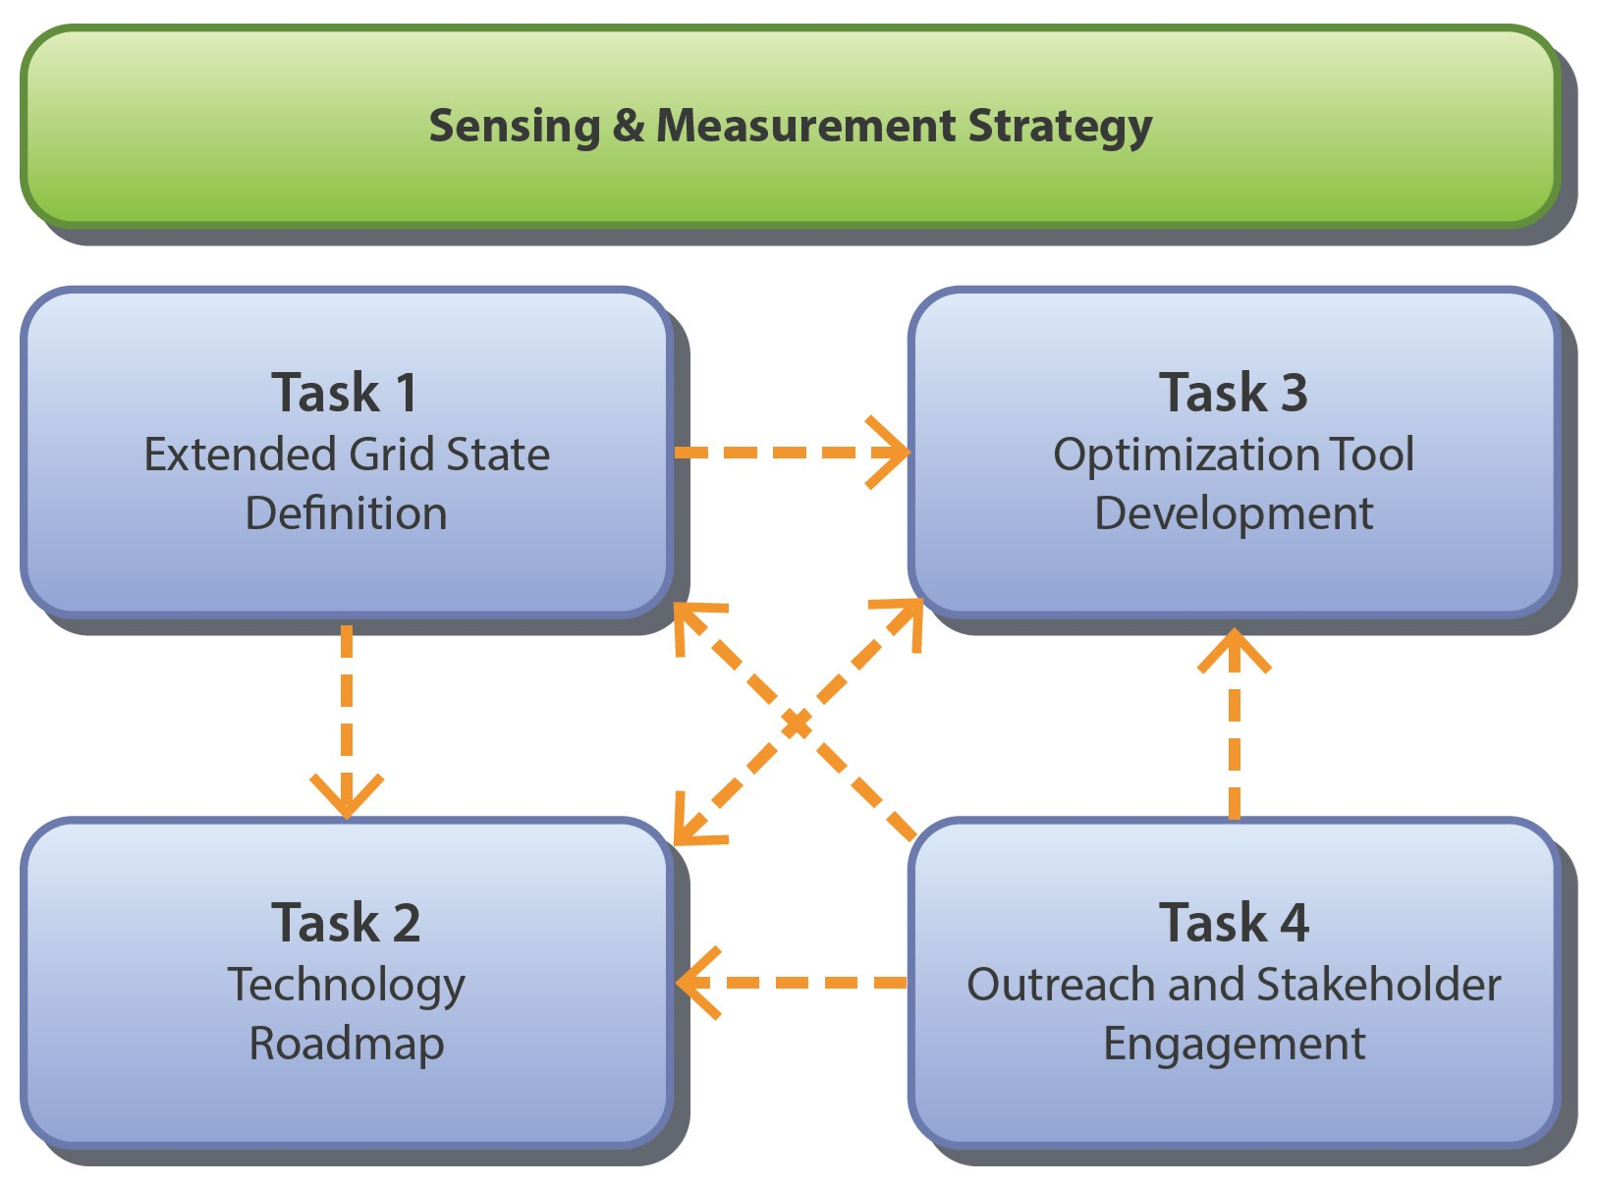
Figure 3. Graphical illustration of the overall sensing and measurement effort along with the relationships among its four key tasks.
Task 1. Define the Extended Grid State—The extended grid state (EGS) definition, which includes both utility and customer assets in the distribution system and connectivity with the transmission system, will be created and validated through theoretical analysis, modeling, and simulation. The definition will include measurement requirements needed for distribution power system operations and planning, and information connectivity to transmission system operations and planning. The EGS definition will drive extensions in standards for sensors and measurements, support the development of frameworks for sensor strategy development and allocation to provide grid visibility, and enhance the interoperability of devices, controls, and analytics.
Task 2. Develop Technology Roadmap—A technology roadmap will be created by (1) assessing the current state of the art in sensors and needed essential communications and data analytics and (2) conducting a gap analysis based upon the EGS definition of Task 1 to identify measurement requirements that are not met by currently available or deployed state-of-the-art sensing and measurement technologies and methodologies. The Technology Roadmap will identify the technical objectives of future grid planning and operations; identify measurement requirements, along with communications and data analytics requirements, essential to sensing and measurement technology; and identify the tools needed to prioritize R&D funds for future sensor and measurement technology development.
Task 3. Develop Sensor Allocation and Placement Optimization Tool—An optimization tool will be developed to optimize sensor allocation on distribution system feeders based on the EGS definition and roadmap developments. The allocation will meet the measurement and monitoring requirements of power system operators and planners. The tool is intended for use as a platform by utility stakeholders to develop their own sensing and measurement strategies and roadmaps.
Task 4. Outreach to Technical and Standards Organizations and across GMLC Areas—The project team will communicate with industry partners and stakeholders via meetings and workshops to ensure that the work is useful and practical to the industry. The team will communicate with technical and standards development organizations and other power industry organizations dealing with advanced grid technologies, functions, and architecture with regard to incorporating the EGS definition into appropriate domestic and international standards. The outreach will also involve coordinating with other relevant GMLC efforts related to sensors and measurements and will cross-walk gaps and challenges with parallel efforts in communication and data management/analytics.
The current document represents early output of the work performed under the Technology Roadmapping (Task 2) activity and consists of a technology review and summary of existing and emerging sensing and measurement technologies. This document was produced as a collaborative effort across the multiple-laboratory project team and serves as a foundation for the team’s future efforts to engage with industry, utility, and government agency stakeholders to ultimately identify key opportunities and priority areas for new federally funded sensing and measurement technology development to achieve GMI goals.
One key input to the Technology Roadmap development is the parallel efforts being pursued under the EGS work (Task 1). The primary objective of Task 1 is to create an EGS definition and taxonomy that includes both utility and customer assets in the distribution and transmission systems. This definition was created and validated through expert input and review as well as theoretical analysis, modeling, and simulation. Figure 4 provides a schematic illustration of the first working version of the EGS definition. In this version, the highest-level states were identified as the (1) electrical, (2) topological, (3) component, (4) ambient, (5) convergent network, and (6) building states. In addition, more detailed states within each of these high-level classifications were developed to capture the hierarchical and complex nature of the EGS definition. The EGS framework and methodology provided the Technology Roadmap effort with a clarified understanding of the complex nature of the state of the system and informed the prioritization and classification of key technology R&D initiatives to be highlighted in the Technology Roadmap. The latest version of the EGS will be made available to the public.
The remainder of the current document consists of the following major sections:
- Sensing and Measurement Devices
- Communications Requirements
- Data Management and Analytics Requirements
- Use Cases
Conclusions
This report organization represents the generation and flow of information, from sensors to data needed by operators and control systems. Sensing and measurement data are generated by sensors; the data are moved to data management systems and other devices through communications technologies; and finally, data management systems and analytics receive and convert the sensor data to actionable information used by operators and control systems.
The Sensing and Measurement Devices section includes a review of current and emerging sensing and measurement technologies for (1) conventional generation sensing to improve the ability to operate with greater flexibility, (2) current and predictive weather monitoring to better forecast renewable generation, (3) T&D power flow monitoring and grid state estimation, (4) dynamic load monitoring, and (5) monitoring of assets to better assess their health and performance as well as fault diagnostics.
Equally important is the ability to communicate sensing and measurement data to other devices, data management systems, and operators. The Communications section therefore includes a review of current and emerging communication technologies applicable to sensing and measurement systems for a modern power system. Current and emerging communications networks, architecture, and standards are also reviewed.

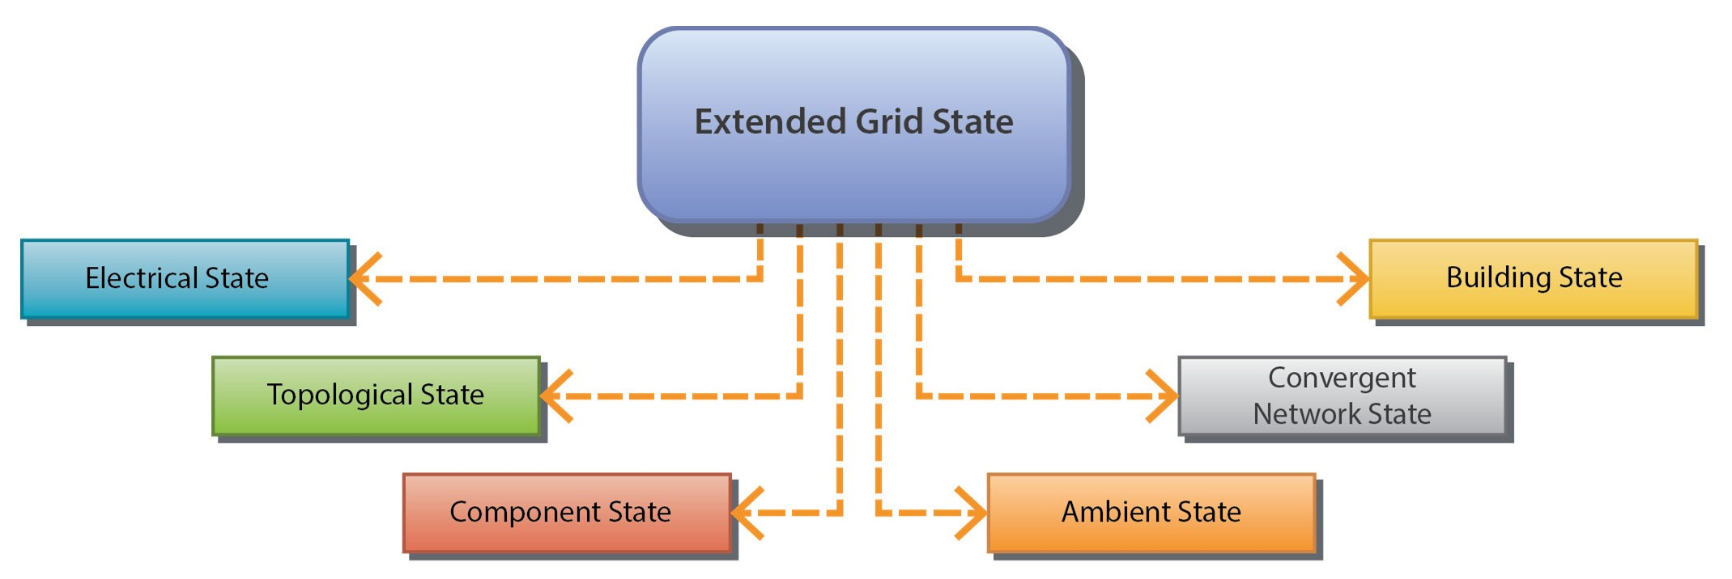
(a)
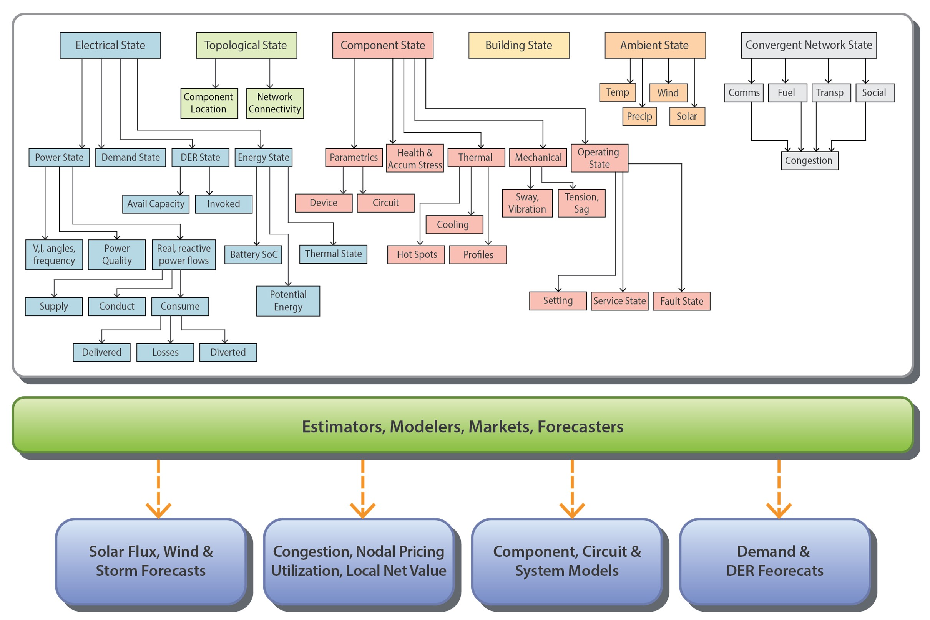
(b)
Figure 4. First working version of the EGS architecture, including (a) the various high-level states (electrical, topological, component, building, ambient, and convergent network) identified and (b) detailed lower-level states within the hierarchical EGS architecture.

Data management and analytics are vital to convert sensing and measurement data to actionable information for use by operators and control systems. Key aspects of data management and analytics include dealing with different types of data, and performance requirements to convert data to actionable information. In the Data Management and Analytics section, the existing state of the art is reviewed.
Use cases are important to understand the performance of sensing/measurement, communications, and data management/analytical systems under normal and abnormal conditions. Careful analysis of use cases often can identify possible conditions in which failure of a single component can have disastrous consequences; doing so affords designers and engineers opportunities to develop solutions before any failure occurs in the field. The section on Use Cases describes examples that can provide useful insights, learning, and guidance to the team as the Technology Roadmap effort progresses.
A fifth section addresses the Overall Conclusions and Summary of this first phase of the effort. It also outlines the team’s subsequent path toward the ultimate goal of performing a detailed gap analysis and development of a Technology Roadmap document.

SENSING AND MEASUREMENT DEVICES

INTRODUCTION AND OBJECTIVES
Sensing and measurement devices that perform core measurement functions serve as the foundation of a strategy for increased visibility of the distribution and transmission systems. While a wide range of sensing devices, measurement technologies, and methodologies are currently available for application throughout the electrical grid, rapid developments in new technology will also play an important role. Of particular interest are new and emerging technology platforms for which the device attributes are compatible with the requisite environmental and operational conditions of interest for distribution systems, assets, and loads.
This section summarizes relevant information gathered by the team early in the effort regarding (1) current practices and device technologies applied to the electrical grid infrastructure, (2) opportunities for improving upon the current practices through improved sensors and measurement technologies, and (3) new and/or emerging sensing device technologies and platforms with relevance for achieving increased visibility within the distribution system and into the transmission system. These findings serve as a foundation and starting point for engaging with a broad range of stakeholders to determine their needs and key R&D gaps in the area of new sensing and measurement devices, which can be addressed through new federal investments in this space.
The team identified a number of related but distinct application domains for advanced sensing and measurement devices that are relevant for the electricity grid of the future. They include
- Conventional generation sensing for more flexible operation
- Renewable generation sensing and weather monitoring
- T&D power flow and grid state monitoring
- Asset monitoring and fault diagnosis
End-use/building monitoring for more responsive loads
While some overlap and synergies naturally exist between these various application domains, the requirements and needs are sufficiently distinct to justify separate discussions in subsequent sections. Key critical factors determine the optimal sensor device technology, and these factors are highly specific for any given application. Requirements including parameters to be measured, calibration and testing, accuracy, precision, range, stability, reproducibility, sensing frequency, installed costs, maintenance costs, longevity, energy consumption, safety factors, and many other considerations must all be accounted for (Figure 5). For this reason, a full analysis of all existing and emerging sensing device technologies within the electrical grid is clearly impractical and beyond the scope of the current effort. Instead, this document seeks to highlight key trends and needs within each application domain. The goal is establishing a framework for subsequent stakeholder engagements to assist in identifying the highest-value R&D initiatives for which federal investments should be pursued. As appropriate, the team’s preliminary findings regarding new and emerging sensing device technologies with the potential for a significant impact on the GMI’s objectives and aims are also presented and discussed briefly.
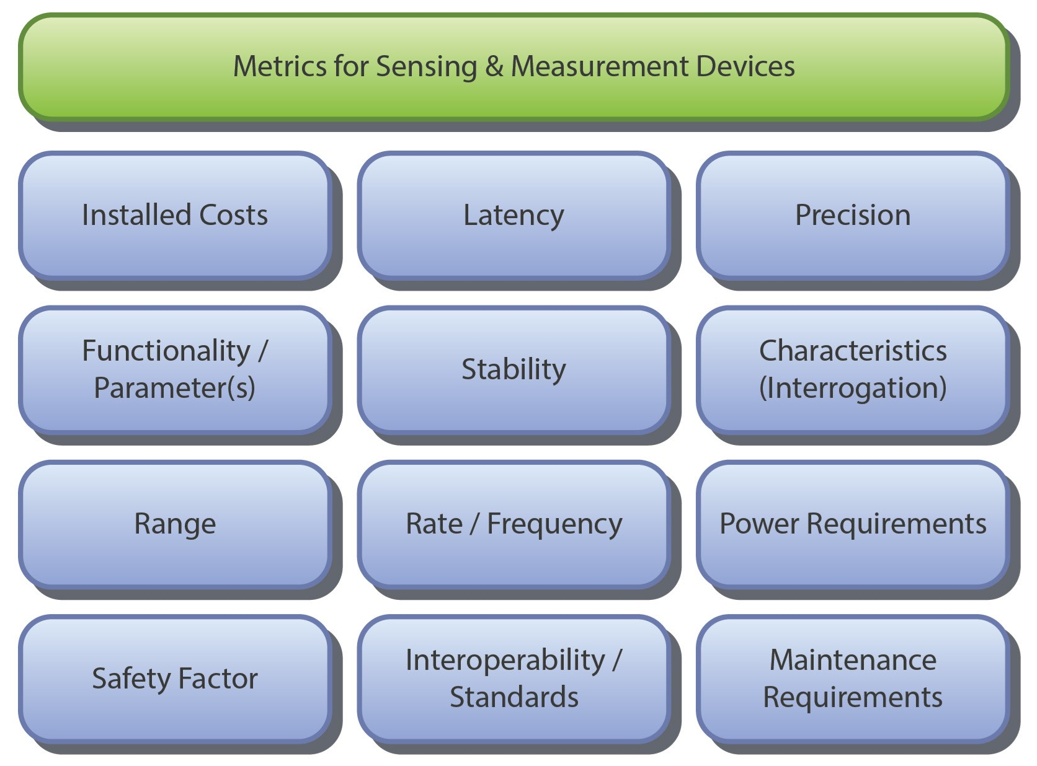
Figure 5. Examples of metrics of sensing and measurement devices.

CONVENTIONAL GENERATION SENSING FOR MORE FLEXIBLE OPERATION

Overview of Sensing and Measurement Needs
Sensing and measurement for flexible operation of conventional power plants refers to the potential of fossil and nuclear energy to serve applications other than their traditional baseload operations as part of the grid modernization strategy. In addition to providing baseload power, conventional fossil power plants can
- follow the variability of load and renewable energy
- provide ancillary services
- provide spinning and non-spinning reserve capacity
- reduce peak load
interact controllably with newer grid assets, such as energy storage and demand response
In addition to large, central plants that provide baseload power, small conventional plants can be located in the distribution system and provide the services listed. These new services will require that plants can be flexibly operated over a larger range of operating capacities, and for more severe increasing and decreasing power ramp rates, while maintaining reasonable costs, reliability, emissions, energy efficiency, and component lifetimes.
There are many types of fossil fuel-based power generation plants, some of which require further R&D. This is also the case for the following:
- newer, smaller nuclear power generation plants
- advanced coal-fired plants
- natural gas–fired plants that generate AC power using steam turbines
fuel cells that convert chemical energy from a fuel to DC power
All types of conventional power plants contain four main systems:
- Fuel conversion
- Heat dissipation/recovery
- Emissions control
Power generation
The stresses of flexible operation will have varying effects on the controllability, performance, and operational life of the many types of equipment in these systems. Each system uses a variety of sensors and measurement devices for
- Situational awareness of plant performance
- System operations and control
Compliance with environmental standards
In many cases, high temperatures and harsh environmental conditions—including highly reducing and oxidizing gas species and corrosive environments—present significant challenges for conventional instrumentation. In nuclear power plants, radiation hardening of sensor instrumentation is an additional challenge.

Summary of Critical Parameters to Be Measured
Flexible operation of conventional power plants at both centralized- and distributed-generation implementation scales will require a different strategy from power plants operating under baseload conditions. In flexible operation, it is a greater challenge to ensure generation matches load through the automatic generation controller (AGC). Sensing and measurement devices will include those traditionally used for control of a baseload plant (e.g., thermocouples, pressure transducers, electrochemical oxygen sensors, voltage, and current transducers), but they may be installed in additional locations with sensor data being collected and acted upon more frequently. Traditional measurement parameters relevant for conventional generation systems include temperatures; pressures; chemical compositions; solid, liquid, and gas flow rates; and electric generation properties such as voltage, current, phase angle, and frequency. For example, conventional generators include governors, that automatically adjust electricity output within seconds in response to frequency to correct out-of-balance generation to load conditions. There is also a need for more detailed process information to support maintaining or extending the lifetimes of fossil-based power systems under variable generation operational conditions. Obtaining this information will require access to the most aggressive conditions within the power system, such as boiler interiors, gas turbine combustion zones, or the anode and cathode streams of operational solid oxide fuel cells. Rotating machinery—such as pumps, steam turbines, and the electric generator—also requires condition monitoring to ensure problems are detected well before equipment failure occurs. For example, strain, temperature, and vibration data and even electrical signature analysis over time can detect abnormal equipment operation readings and deteriorating equipment conditions (Table 1).

Table 1. Generator sensing and measurement parameters.
States/parameters | Directly measured or calculated from  measurements | Sensors/meters required | Description and note
Temperature | Measured | Thermocouple, infrared, acoustic pyrometry | Specialty thermocouples for extreme environments (e.g., high temperature, oxidizing/reducing, corrosive, tight dimensional  spaces)
Pressure | Measured | Pressure transducers, bourdon tube,  piezoelectrics, diaphragm  gauge | Specialty pressure transducers for extreme environments (e.g., high temperature, oxidizing/reducing, corrosive); includes steam pressure
Chemical composition | Measured | Electrochemical gas sensors (e.g., O₂), optical diagnostics including  pyrometry and OH-planar laser induced fluorescence as well as laser absorption spectroscopy (LAS) (e.g., tunable diode LAS), catalytic bead | Optical access is challenging for diagnostics  Techniques, and gas sensors must operate under aggressive conditions; many techniques are extractive rather than real time
Environmental emissions | Measured | Chemical-resistive gas sensors and spectroscopy-based techniques  Particulates—optical opacity  Carbon in ash—microwave | Particulate, CO₂, SO_{X},  NO_{X}, mercury and other hazardous air pollutants,  coal solid byproducts, air emissions, water quality, and other liquid discharge
Material flow rates | Measured or calculated | Flowmeters, optical- and microwave-based diagnostic tools, tomography-based techniques | Gas, liquid, solid phases
Level | Measured | Laser, magnetic, ultrasonic
Rotating machinery state (i.e., steam turbine) | Measured or calculated | Valve position—linear variable differential transformer  Blade tip timing and clearance —optical, eddy current, capacitive
Heat flux | Measured | Heat flux sensors, thermocouple arrays, resistive thermal detector  arrays
Flame characteristics | Measured | Optical Imaging, spectral analysis, optical spectroscopy
Vibration | Measured | Microphones or accelerometers | Externally mounted, important for equipment health monitoring
Line current | Measured | Current transducer (CT) and phasor measurement unit (PMU) | Phasor
Voltage | Measured (Instantaneous), calculated (RMS, phasor) | Voltage transducer (VT) and PMU | Phasor or scalar
Frequency | Calculated | VT or CT, and PMU | Scalar
Changing ratio of frequency | Calculated | VT or CT, and PMU | Scalar
Generator real power | Calculated | VT, CT, and PMU | Scalar
Generator reactive power | Calculated | VT, CT, and PMU | Scalar

Emerging Sensing and Measurement Technologies
A range of new sensing and measurement technologies specifically targeted for power generation applications is currently being developed by the DOE Fossil Energy Advanced Research (Crosscutting) program, the Electric Power Research Institute (EPRI),, and others, including industry. The DOE Nuclear Energy Enabling Technologies program is also developing instrumentation for harsh power system environmental applications. In the Advanced Research program, the emphasis has been on developing instrumentation compatible with the extreme high temperatures and harsh environmental conditions encountered in probing and measuring characteristic parameters. Although cost is a major driver, to ensure widespread deployment for successfully developed technologies, sensing platforms must first be demonstrated to be stable and to allow for successful telemetry under the operational conditions relevant for power generation systems. A broad array of sensors is under development. They include those for measuring physical parameters (e.g., strain, temperature, pressure) under extreme conditions, including temperatures as high as 1000–1500°C as well as chemical sensing under moderately high-temperature conditions approaching 1000°C. In nuclear applications, new instrumentation with the capability for radiation monitoring is being developed, in addition to sensor instrumentation hardening to be capable of withstanding radiation. An opportunity may exist for broader deployment of proxy-based monitoring tools, such as acoustic and vibration sensors, along with appropriate data analytical methods to understand abnormalities of the power generation processes. In situ, near–real-time sensors are becoming more important for control of an increasingly dynamic and complex modern power system.

Existing Sensing and Measurement Technologies
Current sensing and measurement technologies comprise traditional sensors, which include thermocouples, resistive thermal detectors, and optical pyrometers for high-temperature measurements, as well as pressure transducers and electrochemical-based oxygen sensors for combustion monitoring. Laser-based diagnostic techniques are also employed for monitoring high-temperature flames, and combustion environments. Many performance measurements continue to be based on extraction of a sample followed by analysis. For some applications, such as verification of environmental emissions, extractive sampling and analysis is acceptable. For other measurements tied directly to operational efficiency and flexibility, in situ real-time monitoring is preferred. Electrical parameters associated with generators can be monitored by current transducers (CTs) for current, voltage transducers (VTs) or potential transducers (PTs) for voltage, and phasor measurement units (PMUs) for voltage and current phasors (magnitude and angle) and frequency. These sensing devices are capable of operating under the high-voltage and/or high-current conditions relevant for utility scale and even distributed conventional generation systems, since PTs and CTs convert high voltage and current values to lower DC values for measurement systems such as remote terminal units (RTUs) used in supervisory control and data acquisition (SCADA) systems and PMUs used in synchrophasor systems.

RENEWABLE GENERATION SENSING AND WEATHER MONITORING

Overview of Sensing and Measurement Needs
The increasing penetration of highly variable, weather-dependent renewable energy sources impacts the operation of the US electrical grid. Although wind power plants tend to be large and connected to the transmission network, solar power is equally split between large commercial plants and smaller residential or behind-the-meter systems. Installed capacities of solar photovoltaic (PV), concentrating solar power (CSP), and wind energy have grown significantly in recent years to the point that they have a significant impact on generation profiles. For example, solar generation causes significant midday reductions in net load (load minus generation) so that the daily net load profile has come to resemble a duck; this phenomenon is referred to as the “duck curve.” Grid integration of these renewable energy systems now, and to an even greater degree in the future, benefits from operational awareness provided by real-time sensing. The mix of wind and solar resources with traditional energy production assets benefits from forecasting of weather conditions over time scales of from 0–5 minutes to 24–48 hours ahead. Additionally, weather forecasts provide valuable information for forecasting electricity consumption.

Summary of Critical Parameters to Be Measured
Sensing related to renewable energy generation is generally either related to (1) direct measurement of power output and other electrical quantities and/or (2) weather measurement to evaluate system performance or predict power output in the absence of direct measurements (Table 2).
Table 2. Summary of critical parameters to be measured.
States/parameters | Directly measured or calculated from measurements | Sensors/meters required | Description and notes
 | Wind energy
Wind speed | Measured | Anemometers or lidar remote wind sensors | Measures the resource available for wind turbines
Air temperature | Measured | Thermocouples | Impacts turbine performance year-round,  can indicate risk of plant shutdown for icing
Power (per turbine) | Measured | Current and voltage transducer or PMUs | Measured at the turbine bus bars
Power (plant) | Measured | Current and voltage transducer or PMUs | Measured at point of revenue metering
 | Solar energy
Irradiance (GHI) | Measured | Pyranometersª | Measures the resource available for the system but needs to be transformed to the plane of array
Irradiance (plane of array) | Measured | Pyranometers, reference cells^{b} | Measures the resource available for panels
Air temperature | Measured | Thermocouples | Second-order impact on panel performance

Table 2. Summary of critical parameters to be measured (continued).
States/parameters | Directly measured or calculated from measurements | Sensors/meters required | Description and notes
Cloud properties^{c} | Measured | Satellites or total sky  imagers | Used for real-time and short-term power prediction
Power (per panel) | Measured | Power transducer or inverter
Power (plant) | Measured | Point of revenue metering
ª Measures irradiance across the whole solar spectrum.
^{b} Measures power output using a sensor that has the same spectral response as the photovoltaic solar energy panel to be installed.
^{c} Cloud microphysical properties that dictate solar radiation transmittance: optical depth, particle size, water path; cloud macrophysical properties that inform shadow location; cloud top height/pressure; cloud geometric thickness; and parallax corrected cloud location.

Existing Sensing and Measurement Devices
Electrical measurements at large renewable energy installations (10s to 100s of MW) include both real and reactive power at the point of interconnection. Available measurements vary depending on whether the installation is a wind or solar energy facility. Wind plants typically measure voltage and current at the turbine and at the point of revenue metering (usually the point of interconnect to the transmission network).
Since large solar PV plants are modular, with several inverter blocks making up the whole plant, there are typically more granular measurements of AC and DC current and voltage at each inverter. DC voltage and current input are measured, as well as AC voltage, current, and power output. PV arrays consist of multiple modules wired in series to create a string of modules. As a result, sometimes there are also string-level voltage and current measurements, which can be especially useful for detecting damaged or underperforming PV modules. Even in small residential PV systems (a few kilowatts), inverters often measure DC and AC voltage and current. Grid frequency is often monitored by inverters to detect islanded conditions, which occur when the grid protection system—i.e., reclosers, circuit breakers, or other protection equipment—separates the PV system or systems electrically from the grid power and frequency source because of a fault. When this occurs, the PV system inverters will detect the loss of the grid frequency.
The most important measurements for weather-driven renewable energy resources are wind speed (for wind turbines) and solar irradiance (for solar systems). Wind speed should be measured at the wind turbine hub height and preferably at more heights across the rotor (where the turbine blades attach to the turbine-generator) . Solar irradiance should be measured at least in the plane of the receiver (i.e., solar panel) and should account for the component of solar irradiance that can be absorbed (e.g., concentrating solar systems are impacted only by direct solar irradiance, whereas flat-plate PV modules can additionally absorb diffuse and ground-reflected irradiance). Additionally, for a large-scale modular PV farm, the modularity can help quantify farm-scale PV variability resulting from “broken” cloud shadow distributions. Several other second-order weather measurements are also important for monitoring renewable energy production.
Wind generation: The performance of an individual wind turbine is a complex function of wind speed, directional sheer, wind turbulence, air temperature, and atmospheric pressure (among other factors). Of these, wind speed is the first-order driver, turbulence is a second-order effect, and temperature and pressure are third-order influences. Turbine power curves are derived from upwind measurements of wind speed at the hub or across the rotor disk, which may be obtained from cup or sonic anemometers on tall towers or from lidar and sodar remote sensing. Direct and remote sensing are used for resource assessment before a site is built. Operational sites use reference towers instrumented with cup anemometers for lower-cost monitoring. Turbine performance is monitored using nacelle-mounted cup or sonic anemometers. A nacelle transfer function is required for converting nacelle-mounted cup or sonic anemometer data to upwind, freestream conditions. Remote sensing is often used to check performance on an ad hoc basis. Forward-looking nacelle-mounted lidar is used for feed-forward turbine control and to adjust turbine yaw. Plant-wide remote wind sensing by scanning lidar or radar is transitioning from an R&D tool to operational deployment for plant-level performance monitoring and control. Table 3 lists the parameters measured at a wind plant.
Table 3. Parameters required for monitoring and forecasting the performance of a wind plant.
Parameter | Measured by | Applications | Maturity (TRL)
Wind speed | Cup anemometers | Resource assessment, turbine performance assessment, plant monitoring | 9
Wind direction | Wind vanes | Resource assessment, turbine performance assessment, plant monitoring | 9
Wind speed and direction | Sonic anemometers | Resource R&D, turbine control | 8
Wind speed and direction | Remote sensing by sodar, lidar, or radar | Resource assessment, turbine performance assessment and modification, turbine control, plant control | 8
Temperature | Thermocouple |  | 9
Barometric pressure | Barometer |  | 9
Turbine power | Current and voltage transducers | Plant monitoring | 9
Plant power | Current and voltage transducers | Plant monitoring | 9
TRL = technology readiness level
Wind observations and forecasts have other applications for renewable energy. An example is using forecasts as inputs to dynamic line ratings (DLR). DLR temporarily changes the current-carrying capacity of a transmission line depending on conductor temperature, ambient temperature, and line clearance. The use of DLR can result in increased transmission capacity/rating in high-wind events or rain conditions (as a result of increased line cooling), reducing curtailment risk. At the same time, lower capacity during zero- to low-wind conditions can be determined.
Solar generation: The performance of solar PV systems is primarily a function of the solar irradiance incident on the plane of array (POA) of the PV modules, although secondary effects include temperature (as PV module efficiency changes with temperature and is typically measured with a thermocouple) and spectral mismatch due to changes in atmosphere and air mass reference. The POA irradiance can be either directly measured or indirectly derived from related measurements or estimates of direct, diffuse, and ground-reflected irradiance., Table 4 lists the main states and parameters required for operating and forecasting the performance of a solar panel or plant.
Table 4. Parameters required for monitoring and forecasting the performance of a solar panel or plant.
Parameter | Measured by | Applications | Maturity (TRL)
Plane of array irradiance | Thermopile or photodiode pyranometers, reference cells | PV performance assessment | 9
Global horizontal irradiance (GHI) | Thermopile or photodiode pyranometers, indirectly by satellite channels  (geostationary for short-term, polar-orbiting for long-term  forecasting) | Resource assessment, site prospecting, PV performance  assessment when combined with DHI or DNI | 9
Diffuse horizontal irradiance (DHI) | Thermopile or photodiode pyranometers with shade  disks | PV performance assessment when combined with GHI or DNI | 9
Direct normal irradiance (DNI) | Pyrheliometers | Concentrating solar performance assessment, PV performance assessment when combined with GHI or DHI | 9
Temperature | Thermistors, thermocouples, or resistance temperature  detectors | PV performance assessment, component monitoring | 9
TRL = technology readiness level; PV = photovoltaic; GHI = global horizontal irradiance; DNI = direct normal irradiance.
Three main types of devices are used for direct POA measurements: thermopile pyranometers, photodiode pyranometers, and reference cells. Thermopile pyranometers are highly accurate at measuring solar irradiance but respond slowly (many seconds) to changing irradiance conditions and are expensive. Thermopile pyranometers include the Kipp & Zonen CMP21 and the Eppley precision spectral pyranometer. Photodiode pyranometers have lower accuracy but fast response times (milliseconds) and are less expensive than thermopile pyranometers. Photodiode-based pyranometers include the LICOR LI-200 and the Apogee SP-110. Reference cells are PV cells made of the same material as the PV modules under consideration (e.g., monocrystalline silicon), and a POA irradiance measurement is derived from the reference cell’s short circuit current. Reference cells have the same spectral, thermal, and angle-of-incidence responses (second-order impacts on PV power production) as PV modules, so reference cells are more closely related to PV power output pyranometers.
In addition to POA measurements, global horizontal irradiance (GHI), diffuse horizontal irradiance (DHI), and direct normal irradiance (DNI) are often used. GHI and DHI are measured with the same thermopile or photodiode-based pyranometers used for POA measurements. For DHI measurements however, a shade disk is used with the pyranometer to block out direct irradiance.
DNI measurements are particularly relevant for concentrating solar power plants, which rely on focusing the direct irradiance onto a small point for more efficient electrical (concentrating PV) or thermal energy (concentrating solar thermal) generation. To collect DNI measurements, a pyrheliometer is used. Pyrheliometers, such as the Kipp & Zonen CHP1, are similar in design to thermopile pyranometers; but in order to measure DNI they use a tube pointed at the sun, so they collect photons only on a direct path from the sun to the receiver.
Additionally, a surface-based lidar system is used at times to ascertain the aerosol optical depth that is important for measuring DNI accurately or quantifying uncertainties.
Complete global weather monitoring is done through two types of satellites—geostationary operational environmental satellites (GOES) for short-range observations and warnings and polar-orbiting satellites for longer-term forecasting. Although they do not directly measure irradiance, visual channels of Earth-viewing environmental satellites can be invaluable resources to indirectly derive solar irradiance based on the reflectance in the image. Other satellite channels can also be used to improve performance, such as infrared channels that better distinguish between clouds and snow in images.
Temperature measurements are also relevant to renewable energy systems, especially solar PV systems for which efficiency is inversely related to cell temperature and concentrating solar thermal plants in which material must be designed and monitored to withstand extremely high temperatures. For ambient air temperature measurements, thermistors, thermocouples, or resistance temperature detectors can be used. For monitoring of components such as PV cells, thermocouples are commonly used.
Precipitation is important for PV and wind performance because it contributes to both panel and blade cleaning or fouling. Together with temperature, it can also indicate potential icing conditions in wind plants. Precipitation can be measured by tipping bucket rain gauges that provide an absolute measure of precipitation rate or by solid-state devices.
On coarser resolution scales, surface-based radar and satellite-based radar/passive-microwave sensors can be used. Radar is useful for assessing large hail (e.g., exceeding 65 dBZ threshold), which can damage PV panels both at solar farms and at behind-the-meter installations on household rooftops. Radar also can be used to model PV health or availability in reliability assessments. Finally, lightning may be monitored for safety and operational purposes. Information about the risk or presence of lightning may be required to safely perform outdoor activities in a wind or solar plant, while data about lightning strikes may be used to initiate wind turbine blade or equipment inspections or support insurance claims. Devices used to monitor lightning include electric field sensors and radio-based national lightning detection networks. In many cases, lightning can also be a proxy for, or an indicator of, precipitation.
The correction calibration, installation, and maintenance of weather monitoring instruments is a considerable challenge. To mitigate these challenges, the International Energy Agency (IEA), International Electrochemical Commission, International Organization for Standardization, and American Society for Testing and Materials have drawn up international standards for wind and solar resource measurements. Some of these standards also provide guidance on interpreting the data. The reliability of sensing instruments and their measurements is typically related to the best practices followed in installing, measuring, communicating, and processing the data. In addition, grid operators may impose data quality standards to ensure received monitoring and forecast data meet acceptable formats, availability, and quality.
A summary of the types of instruments (mostly in situ, except for satellites and lidar) that are commonly used for renewable generation sensing and weather monitoring is given in Table 5.
Table 5. Summary of instruments used for renewable energy generation sensing and weather monitoring.
Instrument | Typical applications | Advantages | Disadvantages | Notes
Cup or sonic anemometers | Wind speed | Mature technology with large number of  supporting standards  and best practices | Prone to damage and icing
Wind vane | Wind direction | Mature technology | Prone to damage and icing
Barometer | Air pressure | Mature technology
Pyranometer | Irradiance sensor (GHI or POA) | Mature technology | Accuracy and uncertainty very sensitive to  correct installation and maintenance
Pyrheliometer | Irradiance sensor (DNI) | Mature technology | Accuracy and uncertainty very sensitive to  correct installation and maintenance
Reference cell | Irradiance sensor (POA) | Removes the need to convert from irradiance  to power | Relatively new technology, limited acceptance  Accuracy and uncertainty very sensitive to  correct installation and maintenance
Thermocouples | Temperature sensor | High reliability
Table 5. Summary of instruments used for renewable energy generation sensing and weather monitoring (continued).
Instrument | Typical applications | Advantages | Disadvantages | Notes
Tipping bucket | Precipitation | High reliability | May freeze Slow data rate
Solid-state rain  gauge | Precipitation | High data refresh rates | Relative measurement of precipitation intensity
Electric field sensor | Lightning risk and detection | Existing national sensor networks | Cost  Difficulty of interpreting  data from some systems
Satellite  (geostationary or polar-orbiting environmental) | Visible color spectrum and cloud properties in satellite  images | Multi-purpose, highly scalable technology for large footprint  applications  High temporal and spatial resolution data | Might benefit from validation using surface  measurements (e.g.,  to reduce parallax),  unavoidable data  latency (but the effects can be mitigated with continuous data streams)
Lidar remote sensor | Wind vectors  Aerosol extinction profile for solar DNI | High level of acceptance for some applications  Does not require a fixed tower or mast flexibility | Developing technology, financiers are sometimes  reluctant to accept data  Limited international  standards describing  their use

Emerging Sensing and Measurement Devices, Trends, and Data-Driven Weather Phenomena or Renewable Resource Modeling
The following are emerging sensing devices and/or technology applications for weather monitoring and renewable energy forecasting.
Temperature monitoring uses an infrared camera, which can help detect hotspots in PV modules that may indicate defective PV cells.
Solar and wind plant site inspections are performed by unmanned aerial vehicles (UAVs), enabling faster, more frequent inspections. Research is ongoing regarding the best way to use this information, since mitigating dirt on panels/turbine blades or repairing damage can be costly. UAVs (e.g., drones) operated in the vicinity of solar farms could provide a local-scale view of the surface albedo, useful for POA calculation.
Remote sensing of wind from the ground or nacelle using Doppler wind lidar is becoming cheaper and more popular within the wind industry. Questions about how to best use wind lidar for wind energy applications are being investigated through international collaborations, such as IEA Wind Task 32. Wind lidar on fixed or floating platforms is increasingly seen as a cost-effective solution for offshore wind plants. An initiative called OpenLidar has been launched to develop modular wind lidar for R&D applications that can be adapted to different measurement needs. The same is true for solar DNI measurement, which is beginning to use lidar-based aerosol extinction profiles.
Devices are also being designed as integrated solutions, such as the solar variability datalogger, which incorporates a PV cell, a GPS, wireless communication, battery power, and data storage into one small device that can easily, simply, and inexpensively be deployed to autonomously measure solar irradiance. Similar devices have recently been developed by instrumentation manufacturers. These capabilities, depending on the application, will also offer the ability to perform distributed or local data analytics (instead of sending the data to a centralized location for analytics, smart sensors with onboard data analytics send information rather than data).
Use of environmental satellites is increasing—including the latest GOES-R series in the United States (GOES-16 for the East and GOES-17 to be launched for the West^{48,,})—combined with advanced physics-based cloud advection and machine learning techniques to provide probabilistic short-term solar power and ramp forecasts. Demonstrations of effective integration of such probabilistic forecasts into grid operations will be crucial for economic and reliable integration of variable renewables.
Future research will include harnessing large amounts of data. These data are available via publicly accessible repositories (through public-private partnerships) and other high-resolution data are available from ground stations and mesonets. The data can be used for improved renewable energy resource forecast modeling and for determining operational status visibility (adapting to regional and local uncertainties) at both T&D levels. Additionally, resources deployed in harsh terrains or weather environments and in remote locations will benefit from updated forecasting models that take into account a myriad of weather-related factors, such as mountain wakes and marine pushes, that impact the local environment.
Further evolution in sensing and measurement technologies may include advanced communication and data aggregation. As sensors become ubiquitous (e.g., 100,000s of residential PV inverters, higher-resolution mesonet and satellite data, sky imagers possibly at every substation), understanding and processing the large amounts of data in real time will be imperative for finding actionable decisions in the data for various applications. This will enable embedding more intelligence into physical systems and improving system performance, robustness against a multitude of situations, and resilience against unforeseen critical situations.
Furthermore, with increasing penetrations of variable renewables in remote or grid edge locations, such as offshore wind farms or behind-the-meter customer-owned PVs, there will be greater need for weather sensor deployment. For instance, improved sensing of the lower atmosphere for weather models to forecast many of the atmospheric phenomena that affect wind power production will be important, including at taller hub heights for slow-speed wind farms, in offshore locations,, and in challenging terrains., Analogously, there is a dearth of high-quality ground-based sensors for model verification and development for solar power forecasts and uncertainty quantification. Methods that can harness all the existing resources (mesonets, satellite data, National Weather Service stations), in addition to strategically and cost-optimally allocating newer sensors, will be key for effective grid integration of these renewables in a smart grid environment.
Finally, for reliable integration of variable renewables into the grid, weather monitoring sensors will be essential. Combining information from weather sensors with grid electrical parameter sensors, such as SCADA measurements, meters, and PMUs, will also be important. This is especially true for distributed behind-the-meter PV devices. Power generation or power flow information from customer-sited PVs, along with the net-load data at houses (via smart meters) or distribution feeder heads or substation head, will be valuable for validating and developing accurate models of distributed PV power forecasts.

TRANSMISSION AND DISTRIBUTION SYSTEM POWER FLOW AND GRID STATE MONITORING

Overview of Sensing and Measurement Needs
Power grid T&D systems transfer electric power from generation sites to loads, which may be located far away. To ensure power transfer is reliable, secure, and efficient, the system operator must know the states of the systems at all times during operation. Doing so requires that a number of system states and parameters describing different physical characteristics of the systems be measured and monitored accordingly.
“Power flow” refers to the amount and direction of real and reactive power flowing in the T&D networks. It is one of the key grid states that are crucial to grid operation and that must be continuously monitored and controlled over the entire grid to achieve optimal operation. Real power is the power generated by generators and sent through T&D systems to loads to do real work. The generation and consumption of real power must be balanced at any given time to maintain a system with a stable frequency. Real power is closely coupled to the phase angle between the three bus voltages. Balancing the injection and consumption of the real power in the grid is very important for frequency regulation and stability. Reactive power is due to energy that is stored in the electric and magnetic fields in the system (generators, T&D, and loads) and does not do actual work. Reactive power enables the transfer of real power in the grid and is strongly coupled with the magnitude of bus voltages. Insufficient reactive power injection at a bus will cause voltage drop and, in extreme cases, voltage collapse.
Other grid states crucial to T&D grid operation that can be measured/monitored in existing practice include bus voltage (magnitude or phasor), line current (magnitude or phasor), system frequency, and rate of change of frequency (ROCOF). Along with power flow, they are used in a wide range of basic and advanced power grid operation, control, and protection applications, such as state estimation, dispatch, AGC, voltage regulation, frequency regulation, and protection relay coordination.
Although they are not clearly differentiated in the preceding description, transmission grids and distribution grids have different monitoring needs. For power flow and grid state monitoring, the focus of operation and the challenges encountered are different. Transmission grids are better monitored and modeled than distribution grids. The complexity of network configurations and cost leads to insufficient monitoring in existing distribution grids. Existing and emerging challenges seen in distribution grid operation include, but are not limited to, increasing penetration of distributed energy resources (DER), higher power quality requirements for new types of loads (e.g., data centers), better situational awareness for advanced distribution management systems (DMSs), and the impact of complex demand response (DR) programs. Monitoring and measurement needs to address these challenges are shown in Figure 6.
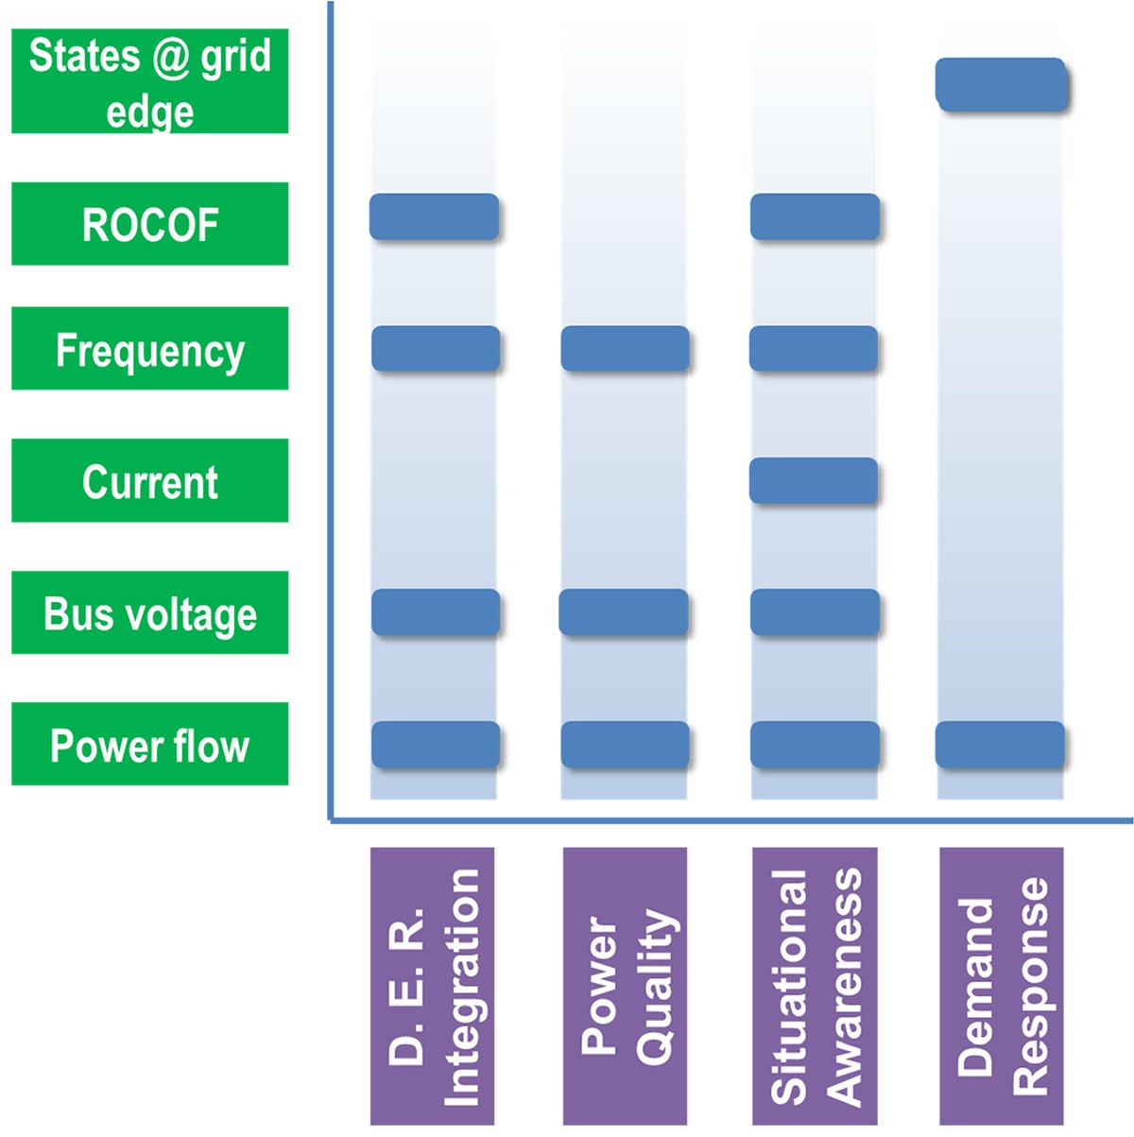
Figure 6. Existing and emerging challenges in distribution grids and monitoring/measurement needs.
Traditional SCADA of power systems does not have the capability of phasor measurement. The basic parameters measured for system monitoring and control include the magnitudes of bus voltage, and line current and real and reactive power at the generators, loads, and both ends of each transmission line. These values are fed into energy management systems that optimize power flow throughout the entire grid network. Specifically, based on the measurements, state estimation (SE) is used to estimate the magnitudes and phase angles of the voltages at the buses without measurement in order to solve the power flow. These measurements are obtained from various types of electromechanical and digital meters. These meters are connected to the secondary sides of sensors such as VTs, PTs, and CTs. The high-rating (voltage or current) signals to be measured are input from the primary sides of the VTs and CTs and converted into low-rating analog signals that can be directly used by the meters.
PMUs are enabled by digital signal processors that use discrete waveform data to calculate the magnitudes, phase angles, and frequencies of important grid parameters. Using a precise timing source, such as GPS signals, a time stamp is added to each of the calculated values. All time stamps reference a common time source for synchronization. Synchronization enables real-time measurements to be obtained from multiple remote measurement points for more accurate SE. PMUs transmit data at rates of 30 to 60 samples per second. PMUs that have been time-stamped by GPS or some other precise time signal are called synchrophasors. Synchrophasors enhance data fed into SCADA systems as inputs for various applications, such as SE, power flow analysis, and adaptive protection relay setup.
In a synchrophasor network with PMUs dispersed throughout the system, communication links enable data transfer to phasor data concentrators (PDC). PDCs are used to collect data from PMUs, assemble and aggregate the data into useful information, and feed it to a historian and various synchrophasor-based applications at the control center. One of the most important applications of PMUs is in the wide-area measurement system (WAMS), in which a phasor measurement network enabled by PMUs becomes the backbone for wide area monitoring and visualization of the power grid. WAMS provide much better visibility of system states across a large portion of the transmission system in real time. Besides improved SE and power flow analysis, the operation and control functionalities that can be realized by WAMS are expanding, especially in real-time power flow control and protection areas. The technology, in combination with power flow control equipment such as flexible AC transmission systems, has the potential to change the economics of power delivery by allowing increased power flow over existing lines. Synchrophasor data could be used for dynamic transmission line rating (“dynamic rating”), which might alleviate congestion., In addition, there is increasing interest in applying PMUs in distribution systems (e.g., MicroPMU) for applications both specific to distribution systems and similar to those in transmission systems. The extent of deployment of distribution system PMUs will be largely driven by the ultimate cost per unit that can be achieved, making cost a key metric for consideration in any technology development program.
DLR enables transmission operators to make more informed decisions regarding the maximum capacity rating of transmission lines without violating safety codes, damaging conductors, or negatively impacting reliability. In some DLR applications, real-time line current magnitude is also measured along with temperature to calibrate the temperature-current characteristics of line conductors and calculate dynamic ratings. Current magnitude measurements in DLR applications are realized with commonly used instrument transformers. There are other ways to accomplish that objective through emerging sensor device platforms with a number of inherent advantages; those are introduced and discussed in more detail later in this report.
Table 6 summarizes the states and parameters measured and/or calculated for T&D monitoring.
Table 6. States/parameters directly measured in a phasor network for power flow applications.
States/parameters | Directly measured or calculated from  measurements | Phasor or scalar | Sensors/meters required | Description and notes
Bus voltage | Measured | Phasor | VT and PMU | Only magnitude measured in traditional  SCADA
Line current | Measured | Phasor | CT and PMU | Only magnitude measured in traditional  SCADA
Frequency | Calculated | Scalar | VT or CT, and PMU | Measured by electromechanical meters in traditional SCADA

Table 6. States/parameters directly measured in phasor network for power flow applications (continued).
States/parameters | Directly measured or calculated from  measurements | Phasor or scalar | Sensors/meters required | Description and notes
Changing rate of frequency | Calculated | Scalar | VT or CT, and PMU | Measured by electromechanical meters in traditional SCADA
Generator real power | Calculated | Scalar | VT, CT, and PMU | Measured by electromechanical meters in traditional SCADA
Generator reactive power | Calculated | Scalar | VT, CT, and PMU | Measured by electromechanical meters in traditional SCADA
Load real rower | Calculated | Scalar | VT, CT, and PMU | Measured by electromechanical meters in traditional SCADA
Load reactive power | Calculated | Scalar | VT, CT, and PMU | Measured by electromechanical meters in traditional SCADA
Line end real rower(s) | Calculated | Scalar | VT, CT, and PMU | Measured by electromechanical meters in traditional SCADA
Line end reactive rower(s) | Calculated | Scalar | VT, CT, and PMU | Measured by electromechanical meters in traditional SCADA

Existing Sensing and Measurement Devices
Instrument transducers (VTs and CTs) are required for power flow measurement and grid SE. Several types of commercial instrument transformers are available:
- Ferromagnetic core–based VTs and CTs
- Coupling capacitor voltage transformers (CCVTs)
- Rogowski coil current transformers
- Electro-optical effect–based VTs (EOVTs)
Magneto-optical effect–based CTs (MOCTs)
Some characteristics of these instruments are compared in Table 7.

Table 7. Comparison of different types of instrument transformers.
Instrument | Typical applications | Advantages | Disadvantages | Notes
Ferromagnetic-core VT | Metering and protection | Good high-voltage performance  Low output variation with temperature  Not sensitive to conductor position | Narrow frequency band  (< 50 kHz)  Bulky  Environment impacts:  oil-insulated types  Medium cost
CCVT | High voltage, protection | Excellent high-voltage performance  Low output variation with temperature  Wider band (>1 MHz)  Environmentally friendly  Low cost | Sensitive to conductor position Requires specially designed shielding
EOVT | Metering and protection | Better electrical isolation from the primary side  Wider band (>1 MHz)  Environmentally friendly Lightweight | Sensitive to conductor position  Temperature dependent Requires specially designed shielding  Expensive
Ferromagnetic-core  CT | Metering and protection | Low output variation with temperature  Simple structure | Saturation at high current  Narrower bandwidth  (< 50 kHz)  Bulky  Environment impacts:  oil-insulated types  Safety concern: open secondary voltage
Rogowski coil | Metering and protection | No saturation  Low output variation with temperature  Wider band (>1 MHz)  Lightweight  Safe: small open secondary voltage  Low cost  Environmentally friendly | Coil resonance  Sensitive to low frequency magnetic field  Requires specially designed shielding  Sensitive to conductor position
MOCT | Metering and protection | No saturation  Immunity to electromagnetic interference | Temperature dependent  Sensitive to conductor position

Emerging Sensing and Measurement Devices
Although existing commercial products are currently available, electromagneto-optic phenomena-based instrument transducers should also be considered as emerging technologies because the technology itself is still under R&D. First emerging around 2010, commercial EOVTs and MOCTs are evolving rapidly and their performance is improving., Deployment of these products at scale remains very limited. Issues such as temperature dependency, reliability, cost, and others must be addressed, and the long-term operational performance must be further validated.
Behind the secondary sides of instrument transformers, PMUs complement the traditional metering and data processing systems at critical points in the power grid to provide accurate and high-sampling-rate synchrophasor measurements of voltage and current as well as power flow and grid state. Phasor measurements over wide areas have become a necessity for advanced monitoring, protection, and control applications in a smart grid. The maturity of PMU-based WAMS is making these feasible in a cost-effective way. However, PMU technology is still advancing. The areas R&D is addressing include low-cost PMU devices for the distribution system,, PMU devices based on timing systems other than GPS,, and better algorithms for phasor measurement.
The geographic extent of the transmission system can easily reach hundreds of miles. Location-wise, in the existing practice of T&D system operation, key power flow states are mostly measured at substations, i.e., ends of lines. These data points are largely sufficient for regular grid applications in a centralized system with predominantly one-way power flows. However, alternative and emerging applications require such measurements with much higher spatial resolution, including within the distribution system and in remote areas out of the reach of paved transportation and communication channels. For example, to accurately locate high-impedance ground faults, power flow measurements in the middle of the line would be of great value. However, significant technical challenges exist, including the required harsh environmental operational conditions and the need for sensors/devices with attributes that enable low cost (for large-scale deployment), high reliability (low-maintenance or maintenance-free operation), self-sustainability (harvesting of energy from the ambient environment), and capability for localized action and coordination with other sensors in the network.

ASSET MONITORING AND FAULT DIAGNOSIS

Overview of Sensing and Measurement Needs
Asset monitoring includes monitoring parameters that indicate the functional performance of the asset, monitoring the health condition of the asset, and diagnosing causes of abnormal performance or condition. Assets can include different types of generation, energy storage, and load, as well as the electrical hardware of the power system (e.g., conductors, switches, reclosers, transformers, capacitors, voltage regulators, inverters, transmission/distribution poles), including emerging technologies.
This section focuses on electrical grid assets that are not inherently generation assets (the former are discussed in the generation sections in the context of their relevance to the GMI). Electrical grid assets require monitoring to ensure that they are adequately performing their designed functions and to properly maintain the assets to avoid unanticipated failure while in operation. For clarification and for the purposes of this document, assets described in this section do not include communication assets; that is, monitoring the communication network is outside the scope of this document. However the state of the communications network is important for understanding the grid state and will become an increasingly important part of the system as a shift occurs to a more modernized electrical grid.
A number of benefits can be derived from improved visibility of the condition, health, and functional performance of grid assets:
increased reliability and resilience through prevention of catastrophic failures of critical assets
delayed build-out of new transmission and other grid assets through more effective asset utilization
more rapid detection and correction of critical and incipient fault conditions
implementation of condition-based maintenance programs, which may include predictive diagnostics and prognostics, as a substitute for run-to-failure or scheduled maintenance
A number of major investments have been made in the area of transmission asset monitoring, resulting in successful technology developments. However, comparatively fewer solutions exist at a suitable price point for application throughout the distribution system. A number of emerging trends span increased penetration of DER, including intermittent renewables, emergence of power electronics-based controllers and power conversion systems, DR, and increased penetration of electric vehicles. As a result, the need for increased visibility of the operational condition and health of relevant grid components throughout the distribution system has increased. For newer grid components, such as grid-scale energy storage and power electronics converter devices, new sensing technologies are also required. Widespread deployment of new sensor technologies will require advanced sensor device technology development with an emphasis on low-cost sensing platforms and with device attributes suited for the application requirements of the T&D system.
One of the challenges of asset monitoring in a modern power system is redefining “normal” conditions for the assets and parameters being monitored. Another challenge is the need to gain a better understanding of the boundary between acceptable and “high-risk” conditions because of the increased dynamic nature of power flows in the modern power system. The increased number of assets; variable power from renewable energy; influx of DER, including energy storage; and emergence of both AC and DC microgrids all create a power system with two-way power flow. This could increase the range within which a monitored parameter is considered normal. This increased normal range of operations could increase the stress on grid assets, which makes it particularly important to monitor their health.
Traditionally, expensive components, such as larger power–rated transformers, were monitored for health condition. Other components operated until failure and were replaced with spares. With movement toward a power system in which the number of distribution assets and interdependent system operations/transactions are increasing, the probability of failure also increases. Reducing cost, enhancing performance, and increasing the deployment of asset monitoring sensors will improve grid asset monitoring.

Summary of Critical Parameters to Be Measured
Functional Performance of Assets: The parameters to be monitored for functional performance are largely electrical properties such as voltage, current, phase angle, and frequency. These parameters are used to calculate other power parameters, such as real power, reactive power, harmonics, and power quality. Requirements for the accuracy, precision, and frequency of measurements are driven by how the information will be used for operation and maintenance of the power system. In some cases, the usefulness of the measurement depends on how quickly the sensing and measurement data can be produced, integrated with other data, and converted to actionable knowledge. In other cases, the precision and accuracy of the measurement are more important. In all cases, particularly for distribution assets, the cost of the sensor will play a critical role in dictating the potential for widespread deployment and hence the ultimate impact on the electrical grid infrastructure. In addition to electrical parameters, physical parameters—such as position (open or closed) and cumulative number of activations of switches, reclosers, breakers, fuses, and so on—can also be considered to be related to the functional performance of assets.
Health Condition of Assets: In some cases, electrical parameters monitored for functional performance can also provide useful information about the health condition of the asset. However, instantaneous electrical parameter measurements are often lagging indicators of the onset of conditions for which asset maintenance is required. For this reason, monitoring alternative types of parameters can be more valuable for providing early indications of conditions for which timely maintenance can avoid impacts on functional performance and extend the operational lifetime of assets. Examples of such measurements include chemical, mechanical, and thermal measurements and their changes with time—either abruptly or over extended time durations—which can reveal potential health issues of assets, enabling condition-based maintenance programs. Predictive diagnostics are derived from a range of metrics that can be based upon measurements including cumulative stresses, total operating time, and operating time under a subset of operational conditions (e.g., elevated temperature, overload). Prominent examples of parameters that fall within this category and their associated applications include the chemical changes that occur in the gases above and dissolved within the insulating oil for large power transformers as well as the internal oil temperature. Strain, temperature (air, wire), and line sag measurements on conductors as they stretch and contract with changes in weather and electrical loading conditions are also needed (Figure 7, Table 8).
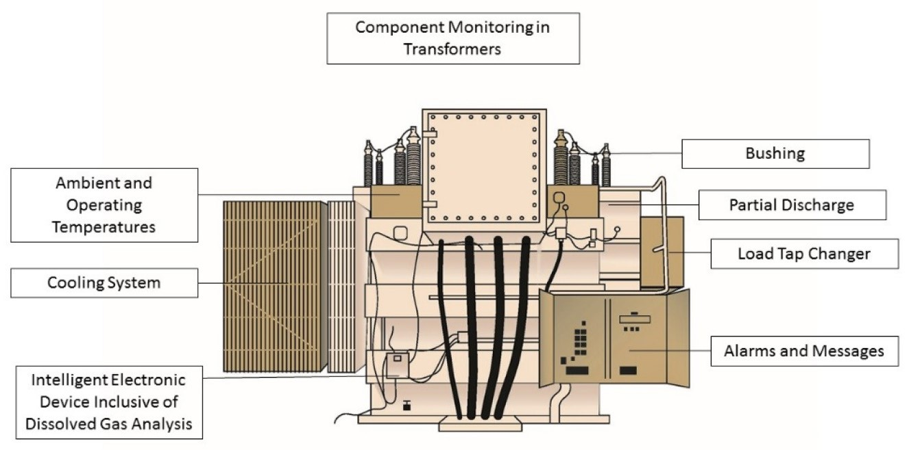
Figure 7. Power transformer component monitoring schematic showing examples
of instrumentation and measurements of interest.

Table 8. Key states and parameters relevant for electrical transmission and distribution system asset monitoring and fault diagnosis.
States/parameters | Directly measured or calculated from  measurements | Sensors/meters required | Description and notes
Visual inspection | Measured | Photography, video monitoring, ultraviolet imaging | Deployed by drones, robots, manual
Temperature | Measured | Thermocouples and other point temperature sensors, infrared imaging (IR) techniques | Point sensors identify single temperature locations while imaging tools, such as IR imaging, can also identify component hot spots while quantifying local temperature
Chemical analysis | Calculated | Dissolved gas analysis | Presence of N₂, O₂, H₂, CO₂,  CO, CH₄, H₂, C₂H₆, C₂H₄, C₂H₂ in transformer insulating liquid or above the transformer oil in the gas phase
Tension | Calculated | Strain sensor, level or height monitoring | Can be inferred from direct strain sensors or indirect  measurements, such as line sag for transmission lines
Motion | Calculated | Vibration sensor, strain sensor, imaging-based techniques | Camera imaging-based methods with associated data analytics and  motion proxies, such as vibration or strain sensors
Electrical equipment parameters | Calculated | Voltage and current transducers | Volt, current, phase angle; see previous sections on power flow and electrical grid state
Electrical discharge and corona | Calculated and Measured | Direct or calculated leakage current, local radio frequency and static electric fields | Important for medium- and high-voltage energized assets including  transformer bushings, transmission lines, and so on
Load tap changer position | Measured | Mechanical relay switch position
Insulation oil level monitoring | Measured | Direct imaging or level indicator measurements

Existing Sensing and Measurement Devices
A wide range of sensing and measurement technologies are currently employed for monitoring grid assets. One prominent example is dissolved gas analysis (DGA) techniques, which are commonly employed for diagnosing the operational health and condition of power transformers. DGA is costly and time-consuming because it requires manual sampling and laboratory analysis. The benefits, however, outweigh the costs for large power transformers that are in operation for decades and represent major social, economic, and opportunity costs if they must be replaced because of unanticipated and often catastrophic failure. For particularly critical transformer assets, real-time diagnostic methods have been developed for online DGA, but they are far too expensive for widespread deployment. For lower voltage- and power-rated transformers such as distribution transformers, even conventional DGA is cost-prohibitive. Therefore, lower-cost, robust sensing devices are of interest for real-time monitoring of the most important parameters associated with dissolved gases, including species such as H₂, CH₄, acetylene, ethane, ethylene, N₂, O₂ CO, CO₂, and others. In addition to DGA, sensors commonly employed for transmission transformers include those for bushings, oil temperature and level, and tap position. Transformer bushings also represent a major source of catastrophic failure in transmission substations, and measurements of electrical parameters may be used to assess bushing health. Circuit breaker monitoring is another area in which existing technology solutions can be identified and can include gas temperature, pressure, and leak rate, as well as mechanical systems.
DLR is another area within asset monitoring that is related to power flow in T&D systems. This technology combines real-time measurement of local ambient conditions, such as temperature, wind speed, and solar radiation, with measurements of transmission line conditions (i.e., temperature, tension, sag, and clearance). These measurements enable transmission operators to make more informed decisions regarding the maximum capacity ratings of transmission lines without violating safety codes, damaging conductors, or negatively impacting reliability. In some DLR applications, real-time line current magnitude is also measured for calibrating the temperature-current characteristics of line conductors and calculating dynamic ratings. These real-time measurements of local ambient conditions and conductor conditions are analyzed (usually at control centers) and converted to a maximum dynamic line capacity rating for the specific conductor and environmental conditions.
Use of DLR technology usually results in a maximum capacity rating for the transmission line that is higher than the static rating. The static rating normally assumes a worst-case scenario of high temperature and high solar radiation coupled with low wind speed. DLR technology has the benefit of improving transmission efficiency, improving the utilization of existing transmission infrastructure, decreasing transmission congestion costs, facilitating integration of renewable energy farms, and improving the situational awareness and operational flexibility of the transmission system.

Emerging Sensing and Measurement Devices
A number of sensing and measurement technology platforms are currently under development to address needs in asset monitoring.,, For example, EPRI has developed a robust set of programs seeking to address sensing and measurement needs for transmission and substation applications. Examples of sensing technologies currently under development include
Radio frequency sensors to monitor a broad range of relevant parameters for conductors, including disconnections, fault currents associated with lightning, geomagnetic induced currents, temperature and inclination, motion and vibration, and proximity and tampering for security
Optical diagnostic methods to monitor vibration and information about gas phase composition, such as acetylene species surrounding high-temperature bushings
Local hydrogen and other chemical composition sensors for power transformers
UAV and robotic systems for inspection of overhead and underground transmission lines
Unconventional sensors such as vibration, weather, acoustic, infrared, and others that are not traditionally used to detect issues and anomalies associated with assets
A key challenge associated with new and emerging sensing and measurement technologies required for asset monitoring is the need for compatibility with electrically energized components. In the case of applications within the distribution system, cost is also a key factor that will drive new technology development for new lower-cost sensing solutions. The importance of sensor cost cannot be overstated. Sensing technologies exist for the vast majority of parameters relevant for asset health monitoring, but deployment is limited by the cost of the new sensor (including device, installation, and maintenance) and the direct value to the asset owner. To further enable ubiquitous deployment of sensor technologies that provide enhanced visibility across a broader range of electrical assets, multifunctional sensor device platforms are needed. Multi-modal sensor nodes reduce cost by increasing the value per sensor node. Implementation of extremely low-cost proxy sensors may also offer an opportunity to monitor indirect parameters, which can provide early notification to asset owners and managers regarding abnormal asset operating conditions.
For geographically dispersed grid assets ranging from components to T&D lines, deployment of UAVs instrumented with onboard sensing, imaging, or diagnostic capabilities is of interest. Data management and storage, combined with analytics applied to local sensor data, show significant potential for wide area infrastructure monitoring. Similarly, satellite and wide area monitoring electromagnetic techniques, such as lidar, are expected to be implemented on a larger scale in the future.

END-USE/BUILDING MONITORING FOR RESPONSIVE LOADS

Overview of Sensing and Measurement Needs
For decades, the meter infrastructure of end uses/building consisted of analog meters that required meter readers to travel to the meter site, collect data, and write it down or enter it into handheld recording devices. Readings were typically collected on a monthly basis. In some cases, data collection would be delayed because of locked gates, heavy foliage, unrestrained dogs, or inclement weather. As a result, data resolution was one energy usage data point per billing cycle, typically monthly.
Smart grid initiatives have changed the situation by deploying smart meters/advanced metering infrastructure (AMI) with digital meters. As of July 2014, more than 50 million smart meters had been deployed in the United States, covering over 43 % of US homes. Smart meters are able to measure consumption accurately in near real time and enable remote meter reading. More importantly, smart meters provide an interface between the end user and the service provider. This interface facilitates several capabilities:
- bi-directional control mechanisms
- DER integration
- smart pricing and DR
- enhanced outage management and restoration
- improved distribution system monitoring
accurate load characterization
In addition, many smart meters have the capability to communicate with in-home appliances, programmable thermostats, and other controllable loads. In the future, smart meters will be designed to access all building controllers (e.g., thermostats, lighting controllers, battery controllers, DG controllers, general purpose controllers) to allow remote configuration of most (if not all) controller configuration parameters (e.g., set points, schedules, limits, time values). Emergence of sub-meters within buildings (e.g. appliance level) can also provide greater resolution of energy consumption that can be leveraged within demand response and load forecasting schemes.

Summary of Critical Parameters to Be Measured
Table 9 summarizes the states and parameters to be measured and/or calculated at the end use/building level.
Table 9. States/parameters measured/calculated at end use/building level.
States/parameters | Directly measured or calculated from  measurements | Phasor or scalar | Sensors/meters required | Description and notes
Service voltage | Measured | Phasor | VT | Measured by smart meter only
Service current | Measured | Phasor | CT | Measured by smart meter only
Frequency | Calculated | Scalar | Frequency monitoring network devices | Calculated by smart meter only
Real power | Measured/ Calculated | Scalar | PQNode, Smart Meters | Measured by electromechanical meters/ Calculated by smart meter
Reactive power | Calculated | Scalar | PQNode | Calculated by smart meter only
Power factor | Calculated | Scalar | PQNode | Calculated by smart meter only
Power quality | Calculated | Scalar | PQNode | RMS voltage, THD and phase balance
Temperature | Measured | Scalar | Thermometer | Measured
Luminance | Measured | Scalar | Illuminometer | Measured
Indoor air quality | Measured | Scalar | Integrated health sensor | Measured CO₂, H₂O, etc.
Occupancy | Measured/ Calculated | Scalar | Moving sensors | Measured by moving sensors or calculated with other  measures

Existing Sensing and Measurement Devices
Electricity meters operate by continuously measuring the instantaneous voltage (in volts) and current (in amperes) to monitor energy usage (Table 10). Generally, electricity meters fall into two basic categories, electromechanical, and electronic or smart meter.
The traditional analog meter is an electromechanical induction watt-hour meter that operates by counting the revolutions of a nonmagnetic but electrically conductive metal disc that is made to rotate at a speed proportional to the power passing through the meter. The equipment and maintenance costs of an analog meter are very low. However, the analog meter must be read manually.
Table 10. Comparison of different types of instruments at end use/building level.
Instrument | Typical applications | Advantages | Disadvantages | Notes
Electromechanical meter | Measuring voltage and current, calculating  frequency, real  power, reactive power, power factor, and so on | Low cost | Narrow frequency band  (< 50kHz)  Bulky  Environmental impacts:  oil-insulated types  Medium cost
Electronic meter | Less maintenance | Measures kWh | Sensitive to conductor position  Requires specially designed shielding
Thermometer | Manual reading | Better electrical isolation from the primary side  Wider band (>1 MHz)  Environmentally friendly Lightweight | Sensitive to conductor position  Temperature dependent  Requires specially designed shielding  Expensive
Illuminometer | Metering and protection | Low output variation with temperature  Simple structure | Saturation at high current Narrower bandwidth  (< 50 kHz)  Bulky  Environmental impacts:  oil-insulated types  Safety concern: open secondary voltage
Occupancy sensors | Metering and protection | No saturation  Low output variation with temperature  Wider band (>1 MHz)  Lightweight  Safe: small open secondary voltage  Low cost  Environmentally friendly | Coil resonance  Sensitive to low-frequency magnetic field  Requires specially designed shielding  Sensitive to conductor position

Compared with the analog meter, electronic meters not only measure energy usage but also record other parameters of end users, such as voltage, currents, instantaneous and maximum rate of usage demands, power factor, reactive power used, and power quality. Generally, an electronic meter has a power supply, metering electronics , processing and communication electronics (i.e., a microcontroller), and other add-on modules such as a real-time clock, liquid crystal display, communication ports/modules, and so on. The metering system is given the voltage and current inputs from the secondary side of the PT and CT and has a voltage reference and samplers, followed by an analog-to-digital converter section to yield the digitized equivalents of all the inputs. These inputs are then processed using a digital signal processor to calculate the other metering parameters, such as real and reactive power, frequency, power factor, and other power quality indices.
The measured data can be automatically transmitted to remote distribution system operation centers for time-of-use billing, distribution system monitoring, outage management and restoration, as well as other advanced functions. With two-way communication capability, the electronic meter can also send control signals or price signals to controllable home appliances, such as heating, ventilation, and air-conditioning systems or to a home/building energy management system, with the latter deciding DR actions.
The thermometer and illuminometer are usually embedded in the thermostats and lighting controllers. Programmable thermostats and lighting controllers are currently available in the market. They can be directly configured by users or home/building energy management systems.
Occupancy sensors, commonly referred to as motion sensors or motion light sensors, are also available in the market for commercial and residential applications. These sensors use passive infrared, ultrasonic, or combined multi-sensing technology.

Emerging Sensing and Measurement Devices
With the deployment of smart meters, the visibility of distribution systems in terms of their load characteristics has been significantly improved. These smart meters provide utilities with the ability to monitor the status of the distribution system, such as outage areas, as well as the end users’ consumption in very high temporal resolution. However, with the higher penetration of DG and electric energy storage by the end user, much faster and higher resolution (e.g., milliseconds) sensors are needed for DG and energy storage control, system dynamics and possible islanding operation of homes/buildings.
High-resolution distribution sensors (e.g., milliseconds) that are developed will need to be low in cost for wide deployment. Micro-PMU or distribution PMUs can provide the enhanced visibility needed for the future distribution system and end uses/buildings. Micro-PMUs can facilitate advanced applications, such as “transactive” control, islanding operation, and resynchronization. At low enough costs, PMU functionality could be incorporated into new appliances and other building equipment to improve understanding of load dynamics and characteristics.

COMMUNICATION NEEDS

IMPACT OF GRID MODERNIZATION ON UNDERLYING COMMUNICATION SYSTEMS SUPPORTING SENSING AND MEASUREMENTS
The emergence of large-scale deployment of distributed sensing and measurement devices in grid modernization poses great challenges to the scalability, availability, network latency, and interoperability of the underlying communication infrastructure that delivers the measurements and control commands for monitoring and control. The communication requirements for supporting different types of power system monitoring and control applications that use these sensors—e.g., latency, bandwidth, quality of service (QoS), security, interoperability, and so on—are diverse. In this section, we will specifically discuss how grid modernization developments will pose challenges to the underlying communication systems supporting sensing and measurement in major power systems applications, including
- WAMS
- DER integration
- AMI
- DR and demand-side management
distribution grid management
WAMS consist of metering device systems and communication links that enable functions such as monitoring, operation, protection, and control of the power grid over large geographical areas. At its core, the interconnected AC power system is a large phasor network with all its phasor quantities (e.g., magnitudes and phase angles of bus voltage and line current) time synchronized. There are many grid monitoring and control applications requiring time-critical information regarding the systems that are geographically extended. Gathering the measurements that are geographically dispersed and aligning them in a common reference frame is one of the biggest challenges. Until WAMS technology is matured (currently applications of WAMS are within control rooms, with limited functionality), power system monitoring and protection are often done locally because of the limited data acquisition functions of traditional SCADA systems. The PMU, a metering device capable of measuring phasors, is the backbone technology of WAMS. PMUs can time-tag all the phasor measurements they make referring to a common time reference (usually, GPS time). In that way, the phasor measurements obtained at different locations can be aligned chronologically, which makes them synchrophasors. With synchrophasors, wide-area, time-critical applications such as inter-area oscillation monitoring become feasible in practice. If the communication links allow timely data transfer, data for the entire system at the same moment can be obtained and analyzed at one place. WAMS enable the two key functions—collecting the right data (synchrophasors by PMUs) and sending the data to the right place in a timely manner (through appropriate communication links)—to realize more advanced monitoring and control applications for modern power systems.
WAMS can employ various architectures for methods of feeding data from PMUs into different applications. One type of WAMS architecture by NASPInet is shown in Figure 8.⁵⁷ In this architecture, PDCs are used to collect and process data from single or multiple PMUs and then report the data directly to the SCADA systems in control centers or to other applications. The links between the nodes represent the communication channels. Besides the architecture in Figure 9, other alternatives are defined in NASPInet. For example, the PMU data can be directly sent to WAMS or load-serving entity applications in utilities without PDCs. In some cases, PMU data are sent to more than one entity.
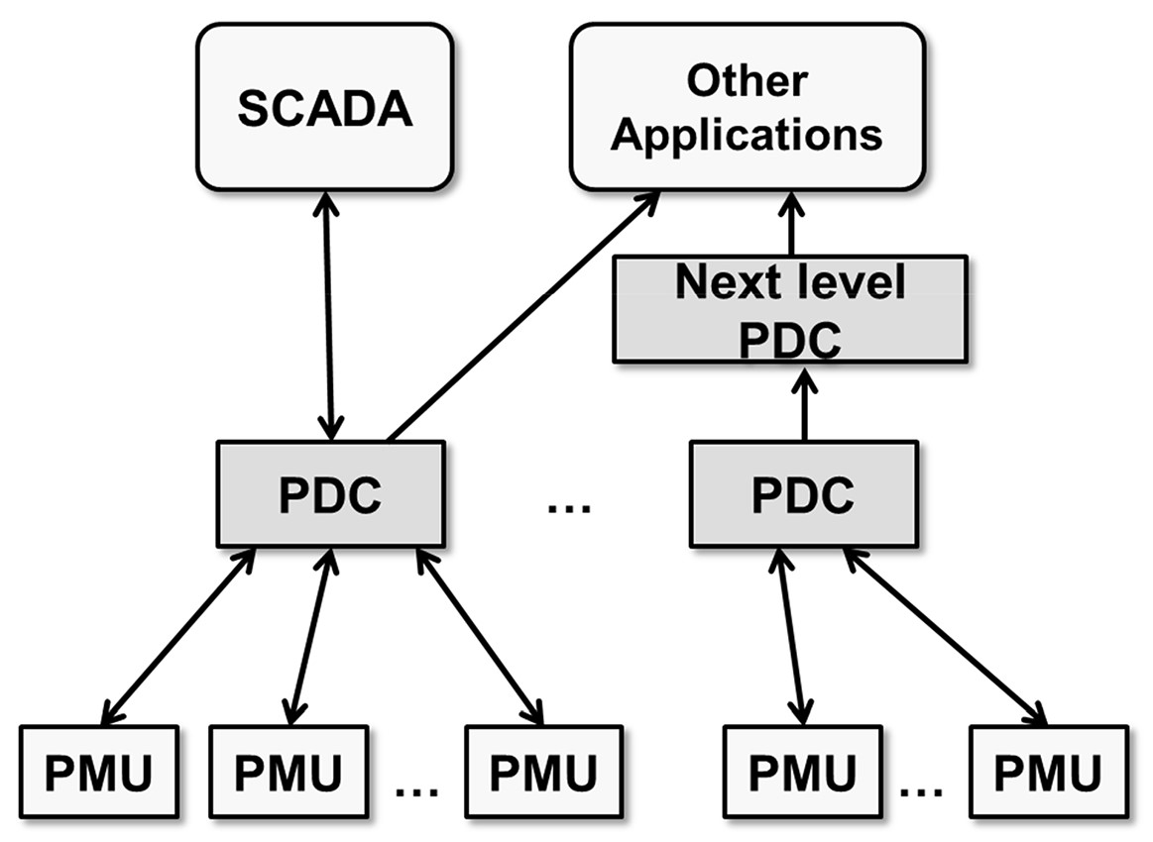
Figure 8. One type of WAMS architecture with PMUs.
In many cases, the available communication links become the determinative factor that defines the capability boundaries of WAMS applications. On the one hand, the bandwidth, scalability, latency, reliability, and so on of the communication links determine what types of applications are applicable. On the other hand, the unique features of the various WAMS applications bring different challenges to the communication links and may require special modifications to the links. To fully understand these challenges, it would be helpful to first look at the characteristics of WAMS applications.
WAMS are based on synchrophasor measurements; thus the data structure of PMU output becomes the basis of analyzing the communication needs. Figure 9 depicts the PMU output data specifications defined in IEEE Standard C37.118. Basically, a single phasor output contains 38 bytes of data, including 8 bytes of frequency information and 22 bytes of overhead (for definitions of ID, data type, and so on). A PMU typically outputs phasor measurements at a rate of 30 to 60 measurements per second, i.e., up to 1680 bytes per second. Currently, because the number of installed PMUs is still limited, the channel capacity for transmitting the aggregated PMU data is not very large. However, once there is a large number of PMUs, the aggregation of the PMU data stream will pose high-volume, low-latency data flow requirements that significantly exceed most utilities’ current experience and expectation.
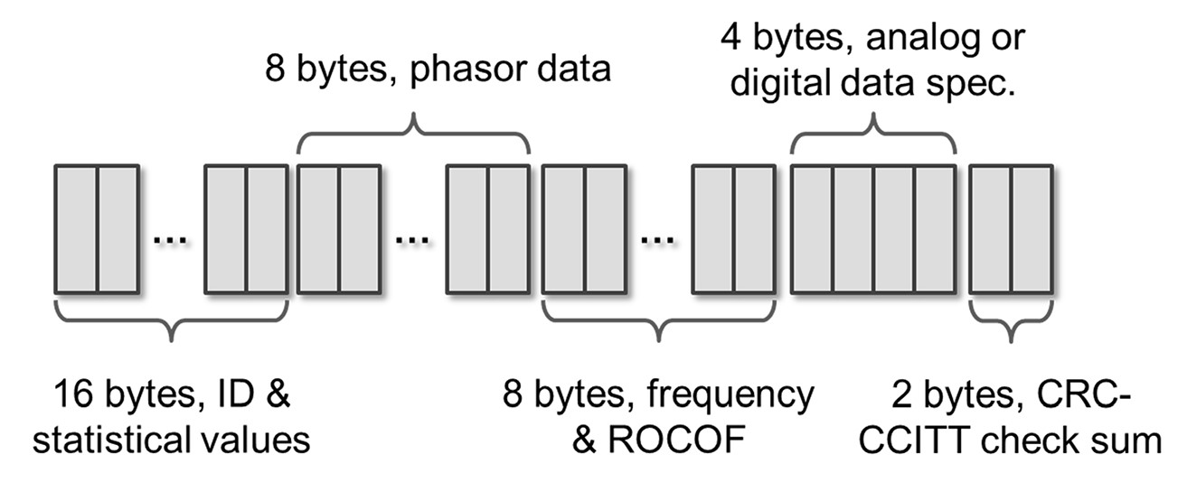
Figure 9. Data structure of a PMU output with 16-bit floating point format phasor and frequency data.
The communication needs for different WAMS applications vary significantly. A number of frequently used WAMS applications and their communication needs are summarized in Phadke and Thorp’s positioning paper. The following are five representative applications, in terms of communication characteristics.
SE is one of the basic functions of traditional SCADA, which uses the scalar measurements of system parameters (such as bus voltages; line currents; and real/reactive power of generators, loads, and lines) that are measured at a rate of one measurement per 4–10 seconds. Since PMUs have a report rate of 30–60 measurements per second, adding phasor measurement data into the existing SE or replacing it with an all-phasor SE will significantly increase its speed. This PMU-reinforced SE will require enhanced communication between the PMUs, RTUs, and SCADA.
Adaptive protection scheme adaptively sets the control logics of the protection system to balance the dependability and security of a protection system at critical locations based on situations. When an abnormal state is detected, a signal will be sent to the critical relay devices to change the preference of dependability and security. Since the size of the data set to be transferred is small, and the data are not relevant to any system transients, the communication requirements of this application are not strict.
Protection relay parameter monitoring informs relay engineers via PMUs about relay setting changes if a need is detected. Relay characteristics, such as apparent impedance for distance protection, are determined based on assumptions of system conditions, which are rather dynamic in operation practices. There is a need to review and adjust these characteristics according to the concurrent system states. This approach is not applicable in existing operations because of the costs for changing the settings of a vast number of relays in the system. The data to be transferred are minimal, and the communication requirement is not strict.
Adaptive out-of-step protection can be enhanced by using WAMS because the synchrophasors (especially phase angles) from PMUs can be used to track centers-of-angles of different generator groups and detect out-of-step situations. Signals to island coherent generator groups will be sent out if the system is predicted to be unstable after an event is detected. The latency requirement is relatively high for this application because a significant amount of data must be transferred.
Adaptive loss-of-field protection shields the generators when the excitation field is subject to loss. The protection settings are determined based on the reactance of the generators and the network’s Thevenin’s equivalent. During a cascading power system failure, the network equivalent seen by a generator keeps changing and must be dynamically considered; the settings of the loss-of-field relays will no longer be correct. WAMS help to identify the variation of the equivalent circuit and determine the new settings, which will be sent to the relay devices. Thus, the communication latency is critical to the application.
More details regarding the communication requirements of these applications are summarized in Table 11, where N represents the number of phasor measurements to be transferred in the corresponding time period.

Table 11. WAMS Applications and corresponding communication requirements.
Application | Data size | Latency requirement | Other communication characteristics
State estimation | N × 38 bytes/second | Not restricted | Bi-directional comm. is not required.
Adaptive protection  scheme | < 100 bytes | Not restricted | Requires bi-directional comm. Data transfer burden is modest, can tolerate large latency.
Protection relay parameter monitoring | < 100 bytes | Not restricted | Bi-directional comm. is not required.  Low data-reading rate, can tolerate large latency.
Adaptive out-of-step protection | N × 38 × 30 bytes/ second | 50 ms | Bi-directional comm. is not required.  Needs timely data transfer when an event is detected.
Adaptive loss-of-field protection | < 100 bytes | 50 ms | Requires bi-directional comm. and timely data transfer when an event is detected.

In general, given the current number of PMUs installed, the channel capacities required for most WAMS applications are modest, excluding the scalability of communication media from the limiting factors. The real challenges are often latency and reliability issues, especially for time-critical protection or control applications.
Figure 10 shows the delays in WAMS with the structure as depicted in Figure 8. As with any application that uses communications, communication delays in WAMS depend on the type of communication medium used. For example, the internet protocol (IP) -based network typically has three types of packet delays, including serialization delay, propagation delay, and switching delay. These delays are common for all IP-based network applications and are not peculiar to WAMS.
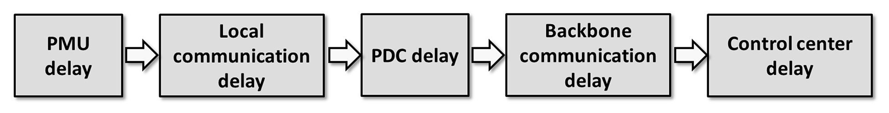
Figure 10. Major delays in WAMS.
However, delays are introduced into communication links by particular WAMS applications. For example, to reduce the packet loss at the PDC receiving port, a time-out scheme is implemented by intentionally adding a time-out to the data buffer. The time-out is applied to wait for all the PMU packets with the same time stamp to arrive; they may not arrive at the same time because of the uncertainty of the data transmitting system. Another example is the static protection and dynamic recovery of communication adopted into WAMS communication links, which are required by the resilience-differentiated quality of services model. These additional delays induced by particular WAMS applications or characteristics must be carefully analyzed. For applications that require low latency, the communication measure must be selected and modified if necessary to accommodate those special delays.
In addition to delay/latency issues, reliability is a critical factor because it can be affected by WAMS. The ambient conditions in WAMS may have impacts on the communication links in the system. One obvious example is the electromagnetic environment around the communication links. Electromagnetic interference induced by the high voltage or current sources, which is very likely around the WAMS communication channels, may couple into the channels, cause data transmission loss, and even interrupt the communication. Some specially designed shielding or mitigation measures may be required to address this issue.

Distributed Energy Resources Integration
Integration of DER, most of which currently are distributed PV, is a key motivating force for the transformation of the electric power grid from the present centralized, static, rigid system toward a more distributed, dynamic, flexible system. However, it is challenging to manage the large scale and dispersed locations of DER so that their benefits can be achieved while mitigating the negative impact to the utility grids. While the present electric power grid is well monitored and controlled by system operators at the T&D substation levels, very little visibility and control are available beyond distribution substations. The lack of visibility raises serious concerns about system reliability in integrating certain DER, like solar generation, at large scales because of the variability of generation and reverse power flows. For reliable grid operation, electric power grid operators and planners need timely and accurate information about DER and distribution systems.
According to a DOE report, the bandwidth required for DER integration will be along the same lines as that required for AMI, i.e., 9.6 kbps to 56 kpbs; the bandwidth requirement will be allocated by individual distributed source. Because of various aspects of DER connections (e.g., protection, monitoring and control, energy management, and post-event analysis), the QoS requirements may differ in terms of data quality and communication latency. The opinions regarding required latency differ, however. Estimates start as high as 15 seconds; other estimates suggest that latency will need to be in the 300 millisecond to 2 second range, and at least a latency of 20 ms will be needed during faults when protection devices are switching. The data quality (accuracy) can be increased by using error correction and acknowledgment feedback mechanisms for data transmission. The communication latency can be lowered by increasing the transmission priority. The communication protocols should have mechanisms to adjust the accuracy and latency of data transmission to accommodate the various QoS requirements for DER connections. To effectively and safely use DER, reliability will need to be in the 99 to 99.99% range, and security should be high.
The integration of large-scale, dispersed DER may require that communication networks be scalable as the number of DER connected to the network increases to meet the needs of various applications. According to the DOE Office of Energy Efficiency and Renewable Energy, the long-term objective is that the communication network be able to support 1 million nodes associated with distributed behind-the-meter solar integration. The architecture of the network should be designed to cope with this challenge. In general, hierarchical network architecture is desirable because of its flexibility and expandability in incorporating new types of data and applications. This network design can enable “near-user” data processing and distributed control, which significantly reduces the communication and computation burden at the control center or data center for DER integration.
Cybersecurity is essential in communication network design for DER connections, since high penetration of DER would have significant impacts on distribution grid operation. As a result, a cyberattack on DER communication networks could result in severe consequences for power grid operation. According to DOE guidelines, the cybersecurity requirements for DER communications should generally be high. The general technical security requirements for information technology (IT) should be tailored to the unique features of the DER connections. The general cybersecurity requirements for a smart grid can be found in NIST report 7628, and a detailed mapping of cybersecurity requirements tailored for DER connections can be found in the recent EPRI NESCOR report.
The communication protocols for DER should also comply with the existing standards for distribution systems, including Modbus, SEP2, DNP3, and International Electrotechnical Commission (IEC) 61850. Special attention should be paid to Part 90-7 of IEC 61850, which describes the information model for inverter-based DER in the communication networks. The design of the communication protocols should be interoperable with these widely accepted standards.

Advanced Metering Infrastructure
AMI is a smart metering system that is presently used to wirelessly retrieve customer usage data for billing. A typical use consists of a wireless mesh network between the individual smart meters on residential or commercial power utility meters. Other uses include software updates and remote disconnect/reconnect. It is unclear to what extent the software update is used in real deployments. A central neighborhood gateway aggregates the data packets to a backhaul network that proceeds to a central repository location. The data are typically recorded at 15-minute intervals, although sometimes recording is more or less frequent, and sent to the utility (usually the billing department) either in a batch or in various time internals, depending on the applications. The communication standards are proprietary to the specific manufacturer of the meters, although there have been recent efforts to standardize the AMI specifications and communication standards.
Originally conceived to operate as hubs for home area networks (HANs), many of the smart meters in use include other protocols such as ZigBee. In practice, most of these applications and networks were never enabled outside of select test cases, for security and privacy reasons. It is also likely that most of the communication envisioned would come through side channels, such as regular internet traffic, rather than through the smart meter mesh networks.
Billing applications do not pose stringent timing requirements on the AMI system; they merely require that data be returned before the bill is sent out, typically monthly. Most systems attempt to return the data at least daily, if not hourly. Even with the small amount of data involved, this approach results in several orders of magnitude more data than were previously used in billing and a much more fine-grained picture of energy consumption. Recent applications are starting to use metering data for outage management. To be useful in this application, at least some data must be returned on a more frequent basis, or the system must have the ability to periodically probe the meters. In the original design, smart meters were expected to be receivers of price information for price-responsive loads, and people could have their loads adjusted automatically via the HAN. The value proposition of this application is unclear, and there are few, if any, examples of this making economic sense.
The mesh network for AMI is typically slow and low in bandwidth compared with the number of devices on it. It will not support real-time applications, although it may support near real-time applications, such as outage management, for which the definition of real time is much less stringent. The backhaul network is typically quite capable and often consists of fiber optic lines, so it could support high-bandwidth applications or time-critical real-time control.
Security is a concern with the AMI system. The meters are access points into a utility network, and they are likely hackable. Utilities have generally isolated the AMI network from any other control network to limit the effects of any sort of attack. Data are typically encrypted at the meter; or at least most meters are capable of encrypting at the meter to protect customer privacy and to ensure reliable data transmission, since the data contain billing information.
Many applications have been proposed for smart metering data and smart meters themselves, including energy diagnostics and load profiles, outage reporting and localization systems, theft detection, and demand-side management. The data collected by such systems could also be used as a diagnostic check on other types of distribution monitoring systems. All of these applications can serve to improve the efficiency of the grid or reduce costs and improve the customer experience. Some are dependent on near–real-time communication; while other applications rely on large-scale analysis of archived data, and therefore the communication time is much less critical.

Demand Response and Demand-Side Management
The Federal Energy Regulatory Commission defines DR as “changes in electric usage by end-use customers from their normal consumption patterns in response to changes in the price of electricity over time, or to incentive payments designed to induce lower electricity use at times of high wholesale market prices or when system reliability is jeopardized.” DR techniques have proved to be a viable tool to tackle this challenge by introducing opportunities on the demand side.
DR programs can be implemented at both the wholesale and retail levels. Wholesale DR programs are typically operated by independent system operators and regional transmission organizations, and retail programs are run by utilities. Current DR techniques fall into two categories: direct load control (DLC) and pricing-based approach, as shown in Figure 11.
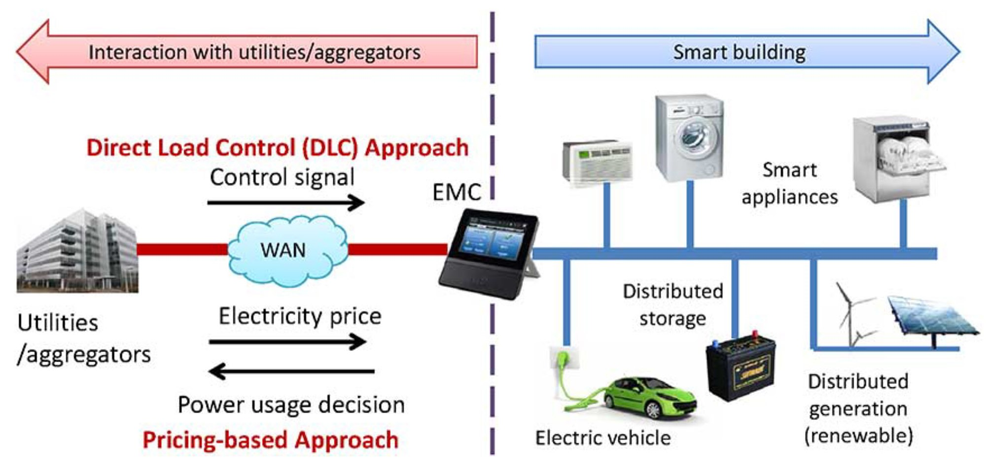
Figure 11. Two types of approaches for demand response.
Direct load control: Current DLC programs provided by utilities are usually contract-based, i.e., by signing up for the contract, customers give utilities the option to remotely shut down appliances during high-demand periods or power supply emergencies and receive credit on electricity bills for this participation. These programs have been implemented by several utilities.,
Pricing-based approaches: In this approach, the electric utility controls customers’ appliances indirectly by sending pricing signals. Specifically, variations in wholesale electricity prices are integrated into retail electricity prices and thus eventually affect customers’ electricity bills. Time-varying prices may encourage customers to make energy use/demand decisions, e.g., shift some power usage from high-price periods to low-price periods. In such cases, customers save money while the utility benefits from peak demand reduction. Examples of implementation of this approach include the programs provided by Ameren Illinois and ComEd.
The communication requirements of DR applications can be diverse, depending on the sophistication of the system. For the basic application, e.g., DLC, DR simply sends a shut-off command to an appliance, such as an air conditioner or hot water heater; bandwidth requirements for this type of application are quite low and are easily handled by existing infrastructure. As suggested by a DOE report, it is estimated that future bandwidth requirements range from 14 kpbs to 100 kbps per node/device, similar to AMI, or perhaps even higher. Estimates of the DR latency requirements fall into a wide range, from as little as 500 ms– 2 seconds, to as much as several minutes; the difference is due to the various potential DR applications. If DR is truly intended to avert imminent emergencies, such as overload events, relatively lower latencies may be necessary. Because utilities using DR will likely depend on it as a grid management tool, reliability will be important. Estimates of reliability range from 99 to 99.99%.
With the grid modernization progress, more advanced demand-side management would involve load shaping strategies, which make adjustments to load shapes over both short and long time horizons. This is a direct extension of traditional DR, which curtails the load to avoid using the most expensive peaking units. There is more and more load variation resulting from large-scale penetration of renewable energy and to other operating considerations, such as large plant trips or transmission losses. New control strategies from the demand side will be used to provide low-cost ancillary services to the electric grid at different time scales and to improve grid operational reliability, efficiency, and resiliency. These control strategies may include both indirect control using price signals and direct control of these distributed devices. As emphasized in a recent DOE ARPA-E Funding Opportunity Announcement, short-term magnitude variation and time shifting of fast-acting loads would facilitate large-scale coordinated control of net load. These methods would provide fast-acting synthetic regulation and contingency reserve services to the grid while minimally affecting customer QoS. Long-term magnitude variation and time shifting of loads that can respond to grid reserve signals within minutes and maintain the required net-load magnitude targets for few hours would facilitate large-scale coordinated rescheduling of net load to provide fast-acting synthetic ramping reserve services to the grid. Unlike the ancillary services provided by controlling the generator side, the future demand-side management will pose challenges to the underlying communication system, due to the large amount of distributed load/appliances dispersed in the distribution grid.

Distribution Grid Management
With the development of distribution automation (DA), utilities can remotely monitor and control assets in their distribution networks to make management of the distribution grid more efficient and reliable. DA includes control center–based control and monitoring systems, such as distribution SCADA, and DA field equipment ranging from RTUs to intelligent electronic devices (IEDs)—such as circuit breakers, reclosers, switches, capacitors, and transformers that can be remotely monitored and controlled. These new resources provide the potential for utilities to lower operation costs (e.g., lower line losses via network reconfiguration) while maintaining the voltage levels at each node, as well as enable improved fault detection, isolation, and restoration functionality, which in turn will help reduce the frequency and duration of power outages.
According to suggestions by DOE, in most cases, DA represents one of the smart grid applications with the most stringent latency requirements—less than 1 second of latency for alarms and alert communications and below 100s of milliseconds for messaging between peer-to-peer nodes inside radio frequency mesh configurations. The maximum latency for certain more latency-tolerant DA applications will not exceed 2 seconds. Bandwidth requirements will be in the range of from 9.6 kbps to100 kpbs, and the required level of reliability will be 99 to 99.999%. With more and more visibility and controllability of distribution grids, especially to handle the large-scale integration of DER, more and more monitoring and control devices will be installed. These will place a huge burden on communication networks because the size of the communication networks will increase substantially.
To enable substation automation (SA), SCADA equipment is installed at each substation. SCADA provides voltage and current measurements at critical grid nodes every 2 to 4 seconds. SCADA systems require minimal latency. As DOE reports, operating companies require latency levels of less than 100 ms for command and control applications for SCADA. The bandwidth requirements for SCADA-like operations may grow with smart grid deployments. SCADA reliability requirements are high.

STATE-OF-THE-ART COMMUNICATION SYSTEMS ENABLING SENSING AND MEASUREMENT FOR ELECTRIC POWER GRID

Communication Network Technologies
With the fast development of communication technologies, especially wireless communications, in recent years, many communication technologies can be employed to enable monitoring and control of electric power grids. The following sections discuss some typical communication technologies being used in current smart grid implementation.

ZigBee
ZigBee is a wireless communication technology that is relatively low in power usage, data rate, complexity, and cost of deployment. Based on IEEE standard 802.15.4, ZigBee is specifically designed for low-power and low-cost monitoring and control applications. It is a proper candidate technology for smart building-related applications—e.g., smart lighting, energy monitoring, home energy management—that avoids the prohibitive cost and disruption of installing wires. ZigBee and ZigBee Smart Energy Profile (SEP) are viewed by NIST as the most suitable communication standards for the smart grid residential network domain. ZigBee integrated with smart meters can communicate with and control ZigBee integrated devices. ZigBee SEP allows utilities to send messages to homeowners, and homeowners can have access to information regarding their real-time energy consumption.
ZigBee technology has many advantages—simplicity, mobility, robustness, low bandwidth requirements, low cost of deployment, operation within an unlicensed spectrum, easy network implementation, and being based on IEEE 802.15.4—make it desirable for metering, home/building energy management, and DR. However, it is subject to interference with other communication standards sharing the same unlicensed spectrum, such as the IEEE 802.11 Wireless Local Network. Before actual application and deployment, this interference issue must be properly resolved.

Wi-Fi
Wi-Fi is a very mature technology with established worldwide adoption for home applications. Based on the IEEE 802.11 family of standards, Wi-Fi has a higher data rate and a larger coverage area than ZigBee but also consumes more power. Wi-Fi operates on unlicensed bands, thus incurring no spectrum cost. Additionally, ongoing technological innovations are bringing tremendous improvements to Wi-Fi power dissipation profiles and significant reductions in chip cost.

Cellular Communications
Cellular networks can be an option for communication between smart meters and utilities and between distant nodes. One advantage of cellular networks is their long-distance communication range, which enables the deployment of smart metering and DR spread over a wide area. In addition, by using the existing communications infrastructure, utilities can avoid the expense and time required to build a dedicated communication infrastructure by themselves. The cellular communication technologies that are for smart metering and demand-side management deployment are 3G (including WCDMA, CDMA2000, EDGE, UMTS, and HSPA+) and LTE. However, cellular communication may not be suitable for time-critical applications because the networks are shared with cellular phone users and may experience network congestion or deterioration in network performance.

Power-line Communication
Power-line communication (PLC) uses existing power lines to transmit data signals. PLC is considered a promising technology for smart building and demand-side management also, because the existing electric power infrastructure can reduce the installation cost of the communication infrastructure. The efforts to standardize PLC networks; their cost-effective, ubiquitous nature; and the widely available infrastructure of PLC are reasons for its popularity.⁹³ However, a major issue for PLC is reliability, since the noise injected by leakage of radio frequency signals from other electrical equipment can degrade communication quality.

Digital Subscriber Lines
Digital subscriber line (DSL) is a high-speed digital data transmission technology that uses the wires of the voice telephone network. The existing DSL infrastructure can reduce installation costs. Widespread availability, low cost, and high-bandwidth data transmission are the most important reasons that DSL technology is promising for implementing smart grid applications. However, the level of reliability and potential downtime of DSL may not be acceptable for mission-critical applications. Distance dependence and the lack of standardization also may cause implementation problems.

Fiber Optic Communication
To overcome communications obstacles, optical fiber products are used in communication with protection, monitoring, and control devices. Fiber optics are the best transmission medium for medium- and low-voltage applications, because they are robust and not susceptible to electromagnetic disturbances or capacity constraints. Thus grid operators who choose this technology will be well prepared when their communication needs multiply in the future. Fiber-optic cables are laid underground to connect individual substations.

Public Switched Telephone Network
The public switched telephone network (PSTN) is the aggregate of the world’s circuit-switched telephone networks that are operated by national, regional, or local telephony operators, providing infrastructure and services for public telecommunication. The PSTN consists of telephone lines, fiber optic cables, microwave transmission links, cellular networks, communication satellites, and undersea telephone cables. All of these are interconnected by switching centers, allowing most telephones to communicate with one another. Originally a network of fixed-line analog telephone systems, the PSTN is now almost entirely digital in its core network, and it includes mobile and other networks as well as fixed telephones. The utilities can lease the network resource of the PSTN to enable smart grid communication.

Twisted Pair
Twisted pair cabling is a type of wiring in which two conductors of a single circuit are twisted together to cancel electromagnetic interference from external sources, for instance, electromagnetic radiation from unshielded twisted pair cables, and cross-talk between neighboring pairs. Twisted pairs are the cheapest form of cable available for networking purposes and are easy to handle and install. Some utilities have run their own dedicated twisted pairs from control centers to substations and distribution devices.

Wireless Mesh Network
A wireless mesh network (WMN) is a communication network made up of radio nodes organized in a mesh topology. It is also a type of wireless ad hoc network. WMNs often consist of mesh clients, mesh routers, and gateways. The mesh clients are often laptops, cell phones, and other wireless devices. The mesh routers forward traffic to and from the gateways, which may be, but need not be, connected to the internet. The coverage area of the radio nodes working as a single network is sometimes called a “mesh cloud.” Access to the mesh cloud depends on the radio nodes working in harmony with one another to create a radio network. A WMN is reliable and offers redundancy; when one node can no longer operate, the rest of the nodes can still communicate with each other directly or through one or more intermediate nodes. WMNs can self-form and self-heal. They can be implemented with various wireless technologies, including 802.11, 802.15, and 802.16 cellular technologies, and need not be restricted to any one technology or protocol.

Communication Network Architectures
In the current rapidly transforming energy industry, utilities are focused on modernizing the electrical grid with an integrated communications infrastructure. However, interoperability concerns, legacy networks, disparate tools, and stringent security requirements all add complexity to the transforming grid.
The model of Figure 13 is a starting point for creating utility-specific designs and offers guidance on deployment of grid-specific applications. It also lays out a framework for designing and deploying comprehensive management and security solutions across the grid. This will help utilities lower the total cost of ownership of their communication infrastructure, as well as create additional value by helping enable new utility services.
The key to modernizing grid communication is to provide a common, multi-service network infrastructure for the entire utility organization. Such a network would serve as the platform for current capabilities while enabling future network expansion to accommodate new applications and services.
As the number of sensing and measurement devices deployed in the smart grid increases, the monitoring and control task poses significant challenges for the underlying communication networks. Generally, it is inefficient or even impossible to design a single communication network to meet all of the requirements; instead, a hierarchical architecture with different layers of communications is desired. A hierarchical architecture of communication networks has the following advantages:
More scalable to manage a large number of smart sensing and measurement devices.
More flexible and expandable to incorporate new types of data and applications without much modification of the existing network.
More efficient to take advantage of the unique features of different communication technologies, e.g., ZigBee is suitable for low-cost short-range communication in the home area, while LTE is suitable for long-distance communication between the buildings and the utilities.
Lower latency with more distributed data processing and control, which significantly reduces the communication and computational burden of the control center.
Depending on the geographical range, a hierarchical communication network architecture can be generally divided into HANs, neighborhood area networks (NANs), field area networks (FANs), and WANs. Figure 12 shows an example of a hierarchical communication network architecture for a power system with smart meters integrated.
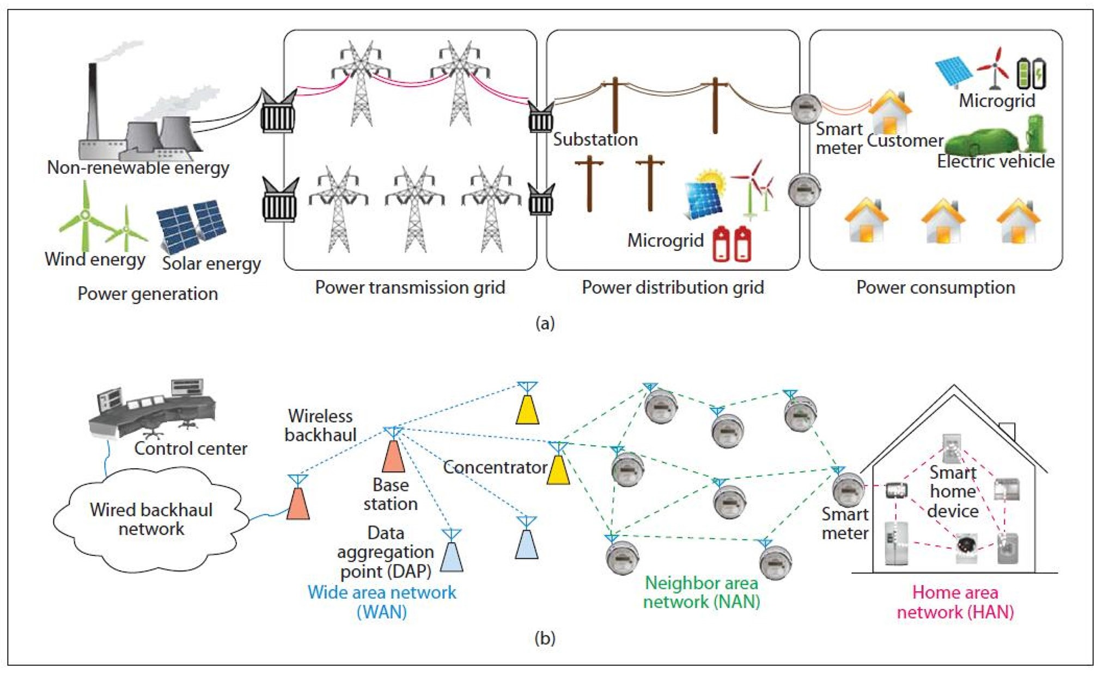
Figure 12. An example of a hierarchical communication architecture for power systems
with smart meters.

Home Area Network
In a HAN, sensor information is collected from a variety of smart appliances in a home and is sent to the home energy management system. Control signals are also sent to the devices to perform different kinds of DR, such as load shaving and shifting. Smart meters are installed at consumer sites and work as communication gateways to connect the HANs and NANs. Typically, HANs need to cover areas of up to 200 m² and support 10 to 100 kb/s. Wireless networks provide a promising solution for HAN implementation. Several wireless standards are currently used in HANs, including Wi-Fi, ZigBee, Z-Wave, and Bluetooth; however, despite the emergence of many wireless standards for HANs, there is no clear winner at this point. It is up to the system designer to select a wireless technology that best fits the application while addressing the potential problem.

Neighborhood Area Network
A NAN is responsible for smart meter communications that enable information exchange and coordination among customers and utility companies. The number of smart meters in each NAN cluster can vary from a few hundred to a few thousand, depending on the power grid topology and the communication technology/protocol. NANs usually need to cover an area of several square kilometers, and each smart meter may need 10 to 100 kb/s.
NAN implementation can use both wireline networks (e.g., PLC) and wireless networks (e.g., Wi-Fi or cellular communications), depending on the communication requirements, costs, and interoperability considerations. In addition, the NAN could enable distributed control and data processing (e.g., distributed DLC), which is a promising solution as the number of distributed smart buildings keeps increasing.

Field Area Network
A FAN aims to automate the distribution network to enable DA, substation automation, DG, and AMI. The electrical sensors on the distribution feeders and transformers, IEDs capable of carrying out control commands from a DMS, DER in the distribution systems, electric vehicle (EV) charging stations, and smart meters on customer premises are the main sources of information to be monitored and controlled by the DMSs at control centers. The power system applications operating in the distribution domain use FANs to share and exchange information.
These applications can be categorized as either field-based (e.g., related to transmission lines, sensors, voltage regulators) or customer-based (e.g., related to end customers, like houses, buildings, industrial users). Field-based applications include, for example, outage management systems, SCADA applications, and DER monitoring and control. Customer-based applications include, for example, AMI, DR, load management system (LMS), and meter data management system (MDMS). These two classes of applications operating in the distribution domain have different critical requirements. For example, customer-based applications require the communication network between the utility and the customer to be highly scalable. Scalability would allow the addition of more applications and customers in the future. Time sensitivity is not much of an issue for such applications. Field-based applications, on the other hand, are more time sensitive in nature. Hence the utilities have a choice of adopting either communication networks dedicated to each class of applications, or a single shared communication network for both classes. A shared field area network would be able to minimize development costs and issues, while a dedicated network would have the advantages of real-time communication capability and additional security.
A broad spectrum of technologies can be applied for FANs, e.g., Long Term Evolution, DSL, WMN, and fiber optics. The network design should ensure that the FAN interoperates seamlessly with NANs and WANs to serve varying applications with different requirements.

Wide Area Network
A WAN forms the communication backbone that aggregates the data from multiple NANs and sends them to the utility companies’ control centers. It also enables long-haul communication among different data aggregation points of the power plants, substations, and DER stations. Utility companies use WANs for wide area grid operational control (e.g., voltage and frequency control) and demand-side management. WANs may cover a very large area (i.e., thousands of square kilometers) and could aggregate thousands of supported devices that require 10–100 Mb/s of data transmission.
The implementation of WANs requires long-distance and high-speed communication network technologies. Typically, the fiber optics IP-based network will serve as the backbone network. Utility companies can rent the infrastructure from the cellular carrier or build their own communication infrastructure, which will be expensive.

Cisco GridBlocks Architecture
Many utilities still rely on complex environments formed of multiple application-specific, proprietary networks. Information is siloed among operational areas, substations, and regulatory authorities. This arrangement prevents utility operators from realizing the operational efficiency benefits, visibility, and functionality of integrating operational information across grid applications and data networks. The key to modernizing grid communication is to provide a common, multi-service network infrastructure for the entire utility organization. Such a network will serve as a platform for current capabilities while enabling future expansion of the network to accommodate new applications and services.
A platform based on the Cisco GridBlocks Architecture integrates utility networks into a single highly secure and reliable communication infrastructure across the various levels of utility operations. By supporting multiple applications on a converged network, it also provides a framework for integrating new technologies and utility-specific applications. At the same time, its modular approach enables implementation of projects over time, allowing utilities to plan their investments and flexibly adapt to rapidly changing business circumstances. This extends the life of existing infrastructure investments as part of a grid modernization roadmap.
Figure 13 shows the GridBlocks Reference Model, which partitions the electrical power communication infrastructure into eleven logical tiers that support networking the entire power delivery chain and define interaction across the tiers. This design provides a finer level of granularity than is available in other models to support unique tier requirements. It also supports tiers that represent networks owned and managed by different utility entities, while maintaining the necessary convergence and interoperability among them. This helps utilities understand the scope of upgrading a specific tier without impacting the others.
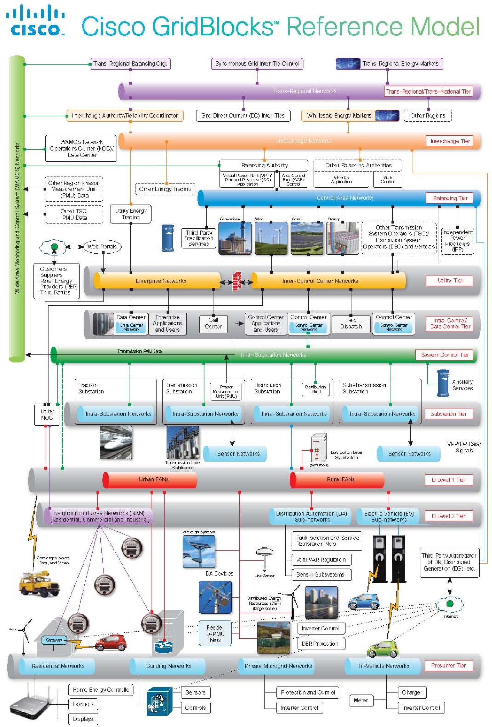
Figure 13. Cisco GridBlocks reference model.

Standards
Many communication standards or standards with communication specifications for the electric power grid have been or are being developed. The key challenge the effort faces is that the overall smart grid system is lacking widely accepted standards. This situation prevents the integration of advanced applications, smart meters, smart devices, and renewable energy resources and limits the interoperability among them. This subsection describes the major communication standards in the electric power grids corresponding to various power system applications. Table 12 provides brief summaries of the standards.
Table 12. Summary of the communication standards in electric power grids.
Standards | Details | Application
IEC 61970 | Provides Common Information Model (CIM) in the transmission domain | Energy management systems
IEC 61969 | Provides CIM in the distribution domain | Energy management systems
IEC 61850 | Flexible, future proofing, open standard, communication between devices in transmission, distribution and  substation automation systems | Substation automation
IEC 60870-6 | Data exchange between utility control centers, utilities, power pools, regional control centers | SCADA, energy management systems
IEC 62351 Parts 1-8 | Defines cybersecurity for the communication protocols | Information security systems
IEEE P2030 | A guide for smart grid interoperability of energy technology and IT operation within electric power systems | Customer-side applications
IEEE P1901 | High-speed power line communication | In-home multimedia, utility and smart grid applications
ITU-T G9955 and G.9956 | Contains physical layer specification and data link layer specification for narrowband powerline communication | Distribution automation,  AMI, energy management systems
OpenADR | Automated demand response using open standard, platform-independent, and transparent end-to-end technologies | Demand response, demand-side management
BACnet | Communication protocol developed by ASHRAE | Building automation and control
HomePlug Green PHY | Specification developed as a low-power, cost-optimized powerline networking specification standard for smart grid applications | HAN
USNAP (Universal Smart Network Access Port) | Defines the hardware interface, physical dimensions, data transfer, message contents and protocol specifics for interconnecting consumer products to multiple communications platform | HAN
DNP3 | Includes a set of communication protocols used between components between various types of data acquisition and control equipment | Energy management systems, SCADA
Table 12. Summary of the communication standards in electric power grids (continued).
Standards | Details | Application
SEP 2.0 | Aims to create a standard and interoperable protocol that connects smart energy devices in the home to the smart grid | HAN
ModBus | A serial communications protocol for industrial electronic devices. It is often used to connect a supervisory computer with an RTU in a SCADA system | SCADA
ISA100.11a | Open standard for wireless systems | Industrial automation
ANSI C12.22 | Defines a protocol for transporting ANSI C12.19 table data over networks | AMI
ANSI C12.18 | A standard for meter communications between meters and client via an optical port | AMI
ANSI C12.19 | A standard for utility industry end-device data tables for data transmission between an end device and a computer for utility applications | AMI
Z-Wave | A protocol for communication among devices used for home automation | HAN
M-Bus | A European standard for remote reading of consumption meters as well as various sensors and actuators | AMI
PRIME | An open, global powerline standard that provides multi-vendor interoperability | AMI
G3-PLC | A power-line communication specification to provide interoperability, cybersecurity, and robustness and reduce infrastructure costs | AMI
SAE J2293 | Standard for electrical energy transfer from electric utility to electric vehicles (EVs) | EV
SAE J2836 | Supporting use cases for plug-in EV(PEV) communication | EV
SAE J2847 | Supporting communication messages between PEVs and grid components | EV
SAE J | Requirements for physical and data link layer  communication between PEVs and their EV supply equipment | EV
IEEE C37.118 | Defines data communication protocol for synchronized phasor measurements used in electric power system | Energy management systems, SCADA

Energy Management Systems, SCADA, and WAMS

DNP3 (Distributed Network Protocol)
DNP3 is a set of communication protocols used between components in various types of data acquisition and control equipment. It plays a crucial role in SCADA systems, where it is used by SCADA master stations (or control centers), RTUs and IEDs. It is primarily used for communication between a master station and RTUs or IEDs. DNP3 has been adopted by the IEEE as IEEE Std. 1815-2012. IEEE 1815 was co-sponsored by the Transmission and Distribution Committee and Substation Committee of the IEEE Power and Energy Society, with additional input from the DNP Users Group.

IEEE C37.118
This IEEE standard defines synchronized phasor measurements used in electric power systems and provides a method to quantify measurements and tests to be sure that the measurements conform to the definition. It also defines data communication protocols, including message formats for communicating this data in a real-time system.

Modbus
Modbus is a serial communications protocol for industrial electronic devices. Modbus is often used to connect supervisory computers with RTUs in SCADA systems.

G3-PLC
G3-PLC is a PLC specification launched by ERDF and Maxim that aims to provide interoperability, cybersecurity and robustness and reduce infrastructure costs in smart grid implementations worldwide. G3-PLC facilitates high-speed, highly reliable, long-range communication over the existing power line grid. Because G3-PLC can cross transformers, infrastructure costs are reduced; and, with its support of IPv6, G3-PLC will support PLC into the future.

IEC 61970 and IEC 61968
IEC 61970 and IEC 61968 provide the Common Information Model (CIM) for exchanging data between devices and networks. IEC 61970 works in the transmission domain, and IEC 61968 works in the distribution domain.

OpenADR
Open automated DR (OpenADR) is an open and standardized way for electricity providers and system operators to communicate DR signals with each other and with their customers using a common language over any existing IP-based communication network, such as the internet. As the most comprehensive standard for automated DR, OpenADR has achieved widespread support throughout the industry.

Home-Area Energy Management and Building Automation

USNAP
The Universal Smart Network Access Port (USNAP) framework is now part of the ANSI/CEA-2045 standard that defines the hardware interface, physical dimensions, data transfer, message contents, and protocol specifics for interconnecting consumer products to multiple communication platforms.

Z-Wave
Z-Wave is a wireless communication protocol for home automation. It is oriented to the residential control and automation market and is intended to provide a simple and reliable method to wirelessly control lighting; heating, ventilation, and air-conditioning systems; security systems; and so on. Z-Wave was developed by a Danish startup called Zen-Sys that was acquired by Sigma Designs in 2008.

IEEE P1901
The IEEE P1901 Working Group, under the sponsorship of the IEEE Communications Society, developed the IEEE P1901 standard for high-speed PLC to meet in-home multimedia, utility, and smart grid application requirements. The IEEE P1901 standard has an important effect on communications technology by integrating PLC into wireless networks with extensive features.

BACnet
BACnet is a standard communication protocol developed by the American Society of Heating, Refrigeration and Air-Conditioning Engineers (ASHRAE) for building automation and control networks and to support the implementation of intelligent buildings with full integration of computer-based building automation and control systems from multiple manufacturers.

Smart-Energy Profile 2.0
Smart-Energy Profile (SEP) 2.0 is being developed to create a standard and interoperable protocol that connects smart energy devices in the home to the smart grid. Currently, a coalition of alliances has been formed (composed of Wi-Fi Alliance, ZigBee Alliance, HomePlug Alliance and HomeGrid Alliance) with the intent of developing an SEP 2.0 application-level interoperability testing and certification program. Even though the standard is still under development, it is expected to be widely adopted by electric utilities to implement their consumer-facing (e.g. hardware and software with user interface applications that directly interact with consumers) programs.

HomePlug Green PHY
The HomePlug Green PHY (physical layer) specification was developed specifically to support smart grid applications on HANs within customer premises. It is a low-power, cost-optimized power-line networking specification standard by the Smart Energy Technical Working Group within the HomePlug Powerline Alliance.

Advanced Metering Infrastructure

M-Bus
M-Bus is a European standard for remote reading of heat meters, and it is also usable for all other types of consumption meters as well as for various sensors and actuators.

PRIME
PRIME is an open, global power line standard that provides multivendor interoperability and welcomes several entities to its body. Advanced Digital Design, CURRENT Group, Landis+Gyr, STMicroelectronics, uSyscom, and ZIV Medida are some current companies that have extensive experience in PLC technology and smart metering.

ANSI C12.19
ANSI C12.19 is the American National Standard for utility industry end-device data tables. The standard defines a table structure for utility application data to be passed between an end device (meter) and a computer (meter communication module in AMI).

ANSI C12.18
ANSI C12.18 is an ANSI standard that describes a protocol used for two-way communication with a meter, mostly used in North American markets. The C12.18 standard is written specifically for meter communication via an ANSI Type 2 optical port and specifies lower-level protocol details. ANSI C12.19 specifies the data tables that will be used.

ANSI C12.21
ANSI C12.21 is an extension of C12.18 written for modem instead of optical communications, so it is better suited to automatic meter reading.

ANSI C12.22
ANSI C12.22 is the American National Standard for Protocol Specification for Interfacing to Data Communication Networks.

Substation Automation

IEC 61850
IEC 61850 is a communication standard for electrical substation automation systems. The abstract data models defined in IEC 61850 can be mapped to a number of protocols. Current mappings in the standard are MMS (Manufacturing Message Specification), GOOSE (Generic Object Oriented Substation Event), and SMV (Sampled Measured Values. These protocols can run over TCP/IP networks or substation local area networks using high-speed switched Ethernet to obtain the necessary response times below 4 ms for protective relaying.

General Applications

ISA 100.11a
ISA100.11a is a wireless networking technology standard developed by the International Society of Automation (ISA). The official title is Wireless Systems for Industrial Automation: Process Control and Related Applications.

ITU-T G.9955 and G.9956
G.9955 and G.9956 are next-generation narrowband PLC standards that will enable cost-effective smart grid applications. ITU-T recommendations are that G.9955 and G.9956 contain the physical layer and the data link layer specifications, respectively, for narrowband PLC transceivers based on OFDM (orthogonal frequency-division multiplexing). The family of standards will enable smart grid applications such as DA, diagnostic and fault location, smart metering, DR, energy management, smart appliances, grid-to-home communications, and advanced recharging systems for EVs.

IEEE P2030
Standard IEEE P2030 provides guidelines for understanding and defining the smart grid interoperability of the electric power system with end-use applications and loads. Integration of energy technology and information and communications technology is necessary to achieve seamless operation for electric generation, delivery, and end-use benefits to permit two-way power flow with communication and control.

Cybersecurity

IEC 62351
IEC 62351 is a standard developed by WG15 of IEC TC57. It was developed for handling the security of the TC 57 series of protocols, including the IEC 60870-5 series, IEC 60870-6 series, IEC 61850 series, IEC 61970 series, and IEC 61968 series. The different security objectives include authenticating data transfer through digital signatures, ensuring only authenticated access, preventing eavesdropping, preventing playback and spoofing, and detecting intrusions.

Electric Vehicle Management

SAE J2293/2
Society of Automotive Engineers (SAE) J2293/2 establishes communication requirements and network architecture for EVs and the off-board EV supply equipment (EVSE) used to transfer electric energy to an EV from an electric utility power system (utility) in North America.

SAE J2836 series
SAE J2836 establishes the instructions for the documents required for the variety of potential functions for PEV communications, energy transfer options, interoperability, and security.
SAE J2836/5 establishes use cases for communication between PEVs and the electric power grid for energy transfer and other applications. The use case scenarios define the information to be communicated related to customer convenience features for charge on/off control, charge power curtailment, customer preference settings, charging status, EVSE availability/access, and electricity usage. Also, it addresses customer information resulting from conflicts to customer charging preferences.
SAE J2836/3 establishes use cases for a PEV communicating with an energy management system as a DER.

SAE J2847
SAE J2847 establishes requirements and specifications for communication between PEVs and the electric power grid, for energy transfer and other applications.

SAE J2931 series
SAE J2931/1 establishes the requirements for digital communication between a PEV, the EVSE, and the utility or service provider, energy services interface, AMI, and HAN.
SAE J2931/4 establishes the specifications for physical and data-link layer communication using broadband (PLC) between a PEV and the EVSE DC off-board charger.
SAE J2931/6 establishes the requirements for physical and data link layer communication between PEVs and EVSEs. The requirements identify the equipment (system elements) and interactions to support a wireless charging protocol for PEVs.

Utility Use Cases
Utilities around the world are investing heavily in communication infrastructure to support the grid modernization trend. A recent survey by GTM research reveals that a majority of utilities have deployed and managed several communication solutions because of different bandwidth and latency requirements of grid applications. Figure 14 shows that, over the surveyed utilities, less than a quarter of them had just one communication network to manage; 58% of utilities reported that they had between two and six networks operating, 14% had seven to ten networks, and 4% had 10 or more networks.
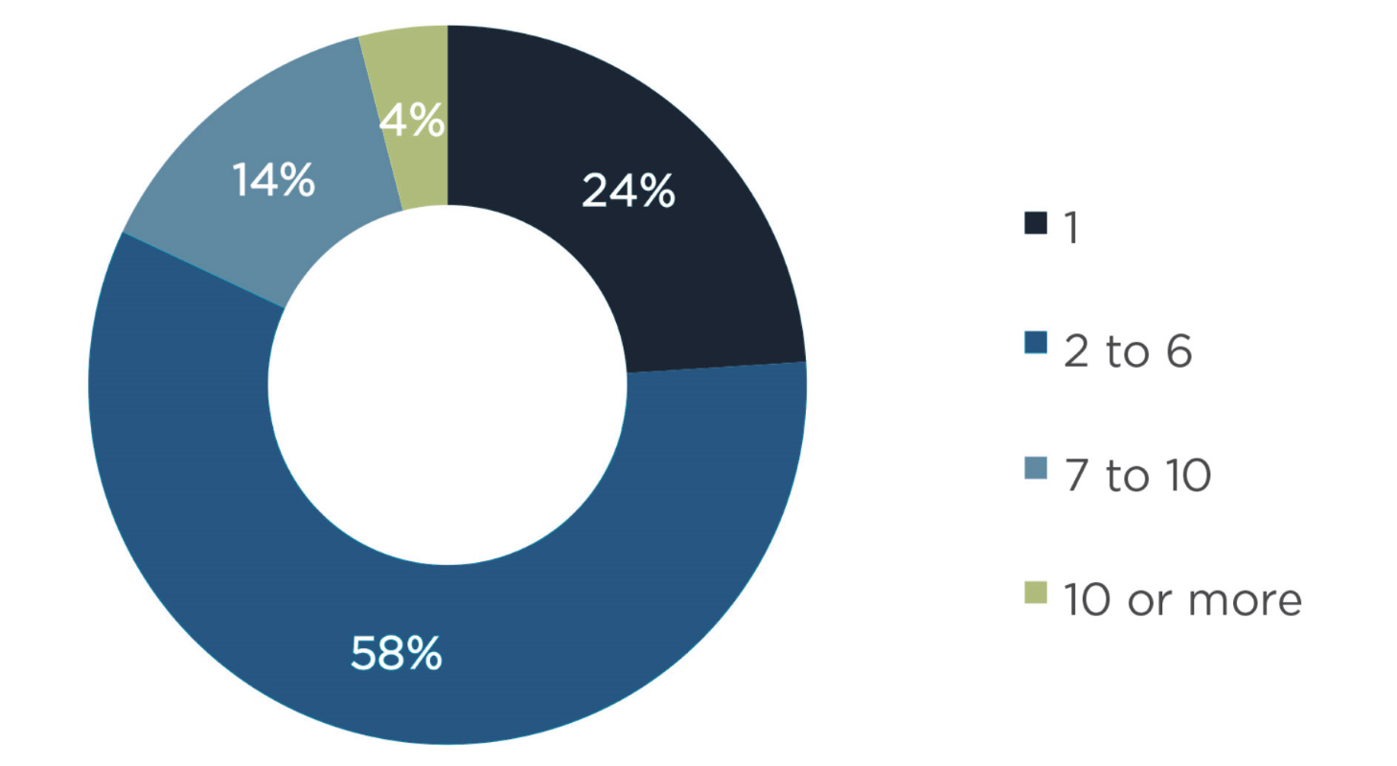
Figure 14. Number of communication networks operating at responding utilities.
Source: GTM Research
Utilities also have numerous communication platform and networking protocols operating in their networks. The majority of network communications still rely on private networks. The most widely deployed communications by utilities are telephone, fiber, copper, cellular, Ethernet, IP, IP virtual private network (IP-VPN), microwave, and T1/T3. The interoperability challenges of multiple networks have led many utilities to adopt IP-based networks, and media such as fiber optic cable and Ethernet—both of which are low-latency, high-bandwidth technologies and are being used in utility data backhaul. Figure 15 lists the types of utility communication technologies now in use.
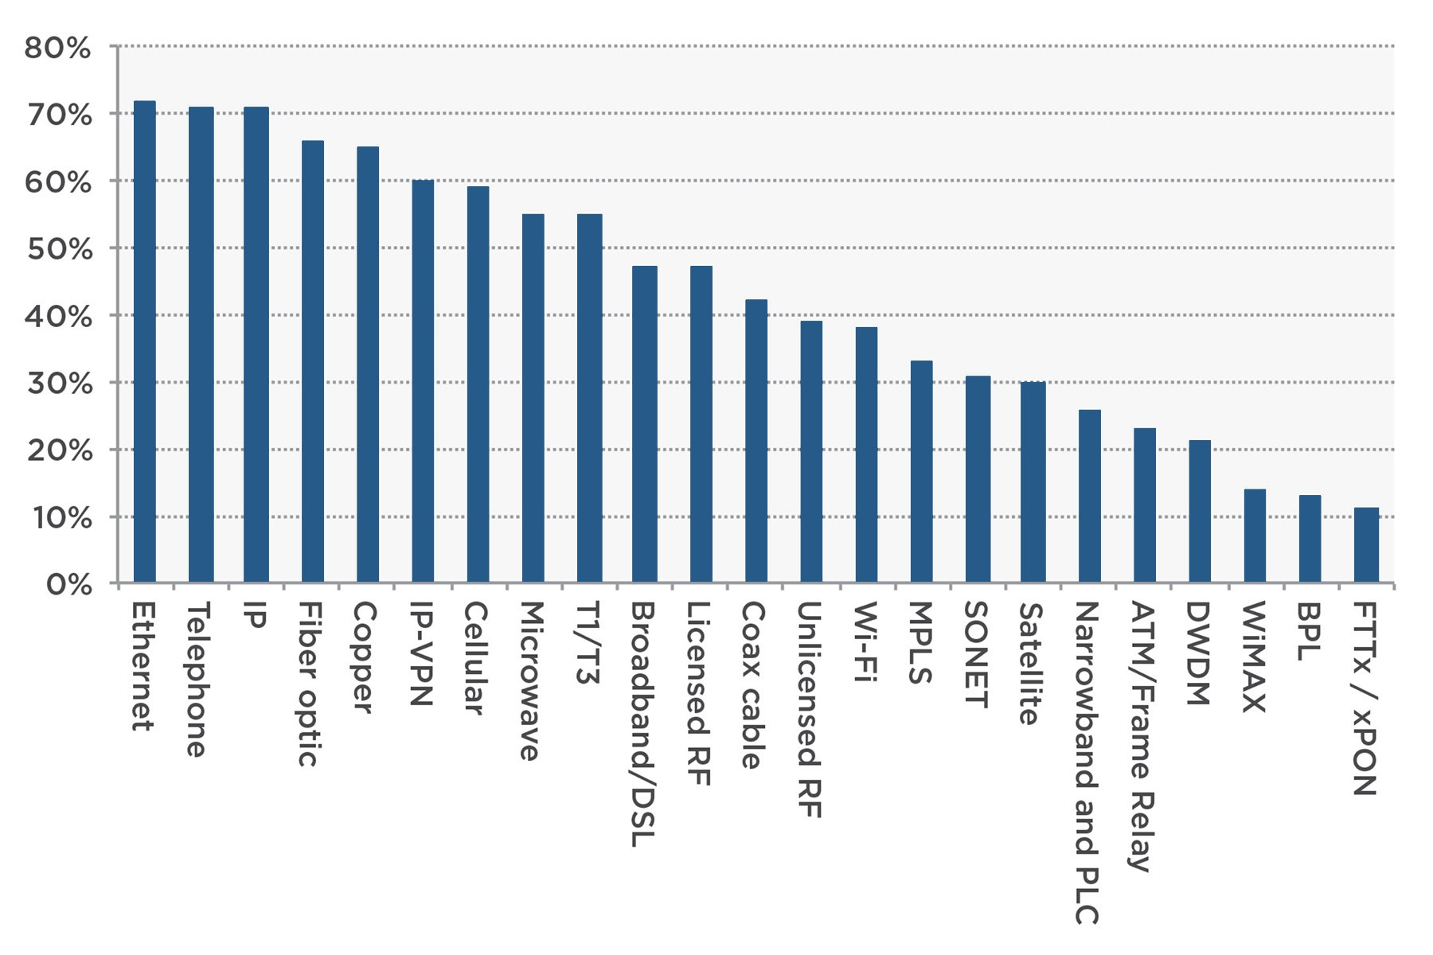
Figure 15. Types of utility communications technologies now in use.

CYBERSECURITY

CYBERSECURITY
Cybersecurity is an emerging issue for the electric power industry in light of the extensive use of information and communication technologies. Recent analysis of the electric grid current security posture has uncovered numerous inadequacies, and reports have addressed attackers targeting critical infrastructure., Currently, the electric power system does not have adequate measures to guarantee protection against malicious cyberattacks, making it highly vulnerable. Various incidents and security concerns in the past have indicated the extent to which the US power grid is vulnerable and the urgent need to protect it from cyberattack. Advanced threats, such as the virus “Stuxnet,” present highly sophisticated, stealthy, and evolving attacks that encompass both traditional IT and control system environments to target physical systems. A major cyber incident in the bulk power system, such as a 2015 attack in Ukraine, could have potentially serious consequences for grid operation including: socioeconomic impacts, market impacts, equipment damage, and/or large-scale blackouts. In addition, it is anticipated that within the next 10 years, sensors and associated systems will proliferate throughout the electric grid. Specifically, from a grid operation perspective, it is expected that sensors will be commercialized and deployed as “Internet of Things grid devices.” The deployment of these grid devices on a large scale will pose cybersecurity challenges.
Recent North American Electric Reliability Corporation (NERC) directives make it mandatory for utilities to perform cybersecurity risk assessments and to take preventive and corrective measures. In addition, the adoption of smart grid technologies will significantly increase cyber attacks, further underscoring the importance of cybersecurity and demands for more substantial information and communication dependencies. DOE has documented attack resiliency as a primary requirement for the next-generation grid. Intelligent cyberattacks can significantly affect power system security and adequacy by negating the effects of system redundancy and other existing defense mechanisms. A comprehensive approach to understanding security concerns within the grid must use cyber–physical system (CPS) interactions to appropriately quantify attack impacts and evaluate the effectiveness of countermeasures.
R&D efforts at the national level have been initiated, including a DOE cybersecurity roadmap for energy delivery systems, NERC Critical Infrastructure Protection standards, the NIST report NISTIR 7628, and a National Electric Sector Cybersecurity Organization Resource (NESCOR) report. These efforts are being undertaken to ensure that appropriate best practices, standards, and safeguards are put in place to enhance the security and resiliency capabilities of the electric power grid against sophisticated cyber threads.

CYBERSECURITY REQUIREMENTS
Although different power grid applications in various domains (e.g., generation, transmission, distribution, and customers) have distinct cybersecurity requirements, the requirements can be categorized into three fundamental types: availability, integrity, and confidentiality.
Availability is the guarantee that data are accessible and timely. It is vital to ensure continued access to necessary data for making operational decisions so as to adapt swiftly to dynamic conditions in critical circumstances. Because of the time-sensitive nature of data, any latency or loss of synchronization may hamper situational awareness and affect the operation of power grids.
Integrity is the assurance that data are trustworthy and accurate. The authenticity and consistency of data should be retained over the entire lifecycle, including collection by sensors, transmission via wired or wireless media, analysis in application servers, human-machine interface visualization, and storage in a database. Meanwhile, data should always represent the actual information under all operating conditions. In particular, any data alterations by unauthorized parties need to be thwarted to avoid adverse effects on functionality.
Confidentiality is protection of data from being accessed and comprehended by unauthorized parties. Any unexpected disclosure may reveal sensitive information, with devastating outcomes on grid operation.
These cybersecurity requirements are differentiated from those in the traditional IT domain. IT security is encumbered with the burden of ensuring anonymity and confidentiality for preserving user privacy, whereas the primary focus of cybersecurity in the power grid is to retain the quality and the continuity of power supplies, i.e., to keep the lights on. Accordingly, availability and integrity are generally prioritized over confidentiality to maintain timely and reliable data flows for authorized applications that govern power grid operations.

CYBER VULNERABILITIES
Cyber vulnerabilities are flaws or weaknesses of a system that is exposed to cyber threats. Determining cyber vulnerabilities for the power grid should consider unique features of grids, including high availability requirements, and dependencies on legacy systems and protocols. A comprehensive vulnerability analysis should begin with the identification of cyber assets, including software, hardware, and communication protocols. Then, techniques such as penetration testing and vulnerability scanning can be used to determine potential security concerns within the environment. Additionally, continued analysis of security advisories from vendors, system logs, and deployed intrusion detection systems should be used to determine additional system vulnerabilities. Common control system cyber vulnerabilities have been evaluated by the Department of Homeland Security based on numerous technical and nontechnical assessments. Table 13 lists these vulnerabilities and categorizes whether they were found in software products, configurations, or network infrastructure.
Table 13. Common control system cyber vulnerabilities.
Software security weakness | Configuration weakness | Network infrastructure weakness
- Improper input validation  - Poor code quality  - Permissions, privileges, and access control  - Improper authentication  - Insufficient verification of data authenticity  - Cryptographic issues  - Credentials management  - Configuration and maintenance | - Permissions, privileges, and access controls  - Improper authentication  - Credentials management  - Security configuration and maintenance  - Planning/policy/procedures  - Audit and accountability configuration | - Common network design weaknesses  - Weak firewall rules  - Network component configuration  (implementation) vulnerabilities  - Audit and accountability

In the NESCOR report, cyber vulnerabilities and the associated failure scenarios are organized into eight domains of the smart grid:
- AMI
- DER
- Wide-area monitoring, protection, and control (WAMPAC)
- Electric transportation (ET)
- DR
- Distribution grid management (DGM)
- Generation (GEN)
Generic
Failure scenarios include malicious and nonmalicious cybersecurity events, such as
- Failures due to compromise of equipment functionality
- Failures due to data integrity attacks
- Communication failures
- Human error
- Interference with the equipment lifecycle
Natural disasters that impact the cybersecurity posture

TYPICAL CYBERATTACKS
There are several types of sophisticated cyber threats, such as intrusions, denial of service (DOS), malware, insider threats, and other forms of targeted attacks that establish some sort of backdoor into the system for exploitation at a later point in time. In this report, the types of attacks that impact the integrity and availability of measurements and control data are discussed, since they are considered to have a direct impact on the reliability and security of the electric power system. These types of cyberattacks can be categorized as data integrity, DoS, timing-based, replay, or coordinated.

Data Integrity Attack
In data integrity attacks, data are corrupted in the control flow path. Specifically, an adversary attempts to corrupt the content of either the measurement or the control signals. A specific example of a data integrity attack is a man-in-the-middle attack, in which the adversary intercepts control or measurement signals and modifies them in transit, while maintaining communication with the original sender of the data and the receiver.

Denial of Service Attack
The DoS attack may attempt to introduce a denial of communication of measurement or control signals. The communication of a sensor or control device could be jammed by flooding the network with spurious packets. DoS attacks can happen at a variety of communication layers in a smart grid, such as the physical layer, medium access control layer, network and transport layer, and application layer.

Timing-Based Attack
Timing is a crucial component in any dynamic system, and control actions should be executed on the order of 100–150 ms after the disturbance. Because some power system applications are extremely time-sensitive, they cannot tolerate any type of delay and/or jitter in communication and thus are vulnerable to timing-based attacks. Timing-based attacks tend to flood the SCADA network with a large volume of traffic, slowing network performance and potentially even causing it to crash, both of which are detrimental to grid reliability and security. Also, timing-based attacks could target the jitter of SCADA communications, that is, variations in arrival times of network traffic, potentially leading to cases where stale data are considered along with new data to cause inconsistencies.

Replay Attacks
A replay attack is a special case of data integrity attack in which the attacker replays a previous snapshot of a valid communication packet sequence that contains either measurements or controls in order to deceive the system. Although executing a replay attack is very difficult—considering the difficulty of predicting sequence numbers and anti-replay features in modern communication protocols and IT systems—the possibility of a replay attack nonetheless exists, as certain legacy protocols are still being used. Also, measurement or control could be replayed in a man-in-the-middle attack, as the attack packets would contain valid measurements/control messages with the message’s data integrity remaining intact except for the time stamp information.

Coordinated Attacks
According to a DOE report on high-impact, low-frequency risks, coordinated cyberattacks present a major threat to the reliability and security of the power grid, capable of causing cascading blackouts on large portions of the system. The notion of coordinated cyberattacks represents a class of attacks in which the adversary coordinates attacks from either multiple points in space (spatial attacks) or in time (temporal attacks), or a combination of both. The coordinated attack vectors could take into account the system responses to initial disturbances and could cause secondary and tertiary events, which could steer the system into instability, eventually leading to a cascading failure scenario.
A coordinated data integrity attack on a key monitoring application like SE could be achieved by compromising the various meters that measure or transfer measurements to the control center. Such a coordinated spatial attack across a few substations could result in poor situational awareness of the power system and could also lead to inefficient and incorrect system operation, resulting in line overloading and market impacts in terms of uneconomical generation. Similarly, a coordinated data integrity attack on AGC involving a few tie-line and frequency measurements could cause an imbalance in system generation and load, resulting in frequency imbalance and reliability impacts. A coordinated attack on remedial action schemes involving two or three major substations could combine data integrity and DoS attacks on the protection relays and substation communication occurring in different locations, staggered in time. This type of attack could result in operational reliability impacts and has the potential to cause cascading outages, depending on the power system loading.

DEFENSE AND MITIGATION STRATEGIES
Grid security is different from standard cybersecurity in that there are a multitude of private and governmental organizations willing to test IT cyber systems. The grid represents a CPS (i.e., system in which physical and software components are tightly interwoven), meaning widespread sensing, communication, and control are used to operate physical devices and systems safely and reliably. In developing processes and procedures and ensuring that such devices are secure against cyber threats, it is imperative that testing of potential solutions be conducted not in an IT-centric framework, but rather in a system/situation in which an operational model/replication of a functioning electric utility is incorporated (i.e., in an operational technology environment).
CPSs are currently being contemplated as defining the rules for operating and integrating deployed network elements. Assurance of built-in cybersecurity for the grid cyber–physical network may take the form of additional security specifications at the beginning of the product development cycle, along with performance testing of developed systems. Specific technologies must be researched for grid sensors and systems with CPS being an absolute first principle, not an afterthought to an Internet of Things device.

Isolation
Although isolation is commonly used in utilities for cybersecurity solutions, cybersecurity needs to go beyond isolation. Air gaps (i.e., physical separation of networks) cannot be relied upon in practice. That said, there needs to be a significant change in the “we have a better firewall than you” mentality that is pervasive in the utility vendor view of cybersecurity. Figure 16 depicts an architecture in which specific utility operations—and utility-to-utility communications—are shielded from the internet via a wide assortment of technologies. In Figure 16, note that in a phased approach, initially the protected communications involve generation and T&D but specifically not the residence.
Discussions with and surveys of many utilities indicate that grid asset control functions and systems may be isolated from internet traffic and are configured to be far more secure than traditional IT architectures. There is a need for clear definitions of architectures (both physical and logical) appropriately sized for the various types of utilities. In other words, a toolkit is needed that consists of hardware, software, operations architectures, and appropriate business practices to determine the appropriate extent of internet connectivity for each business function.
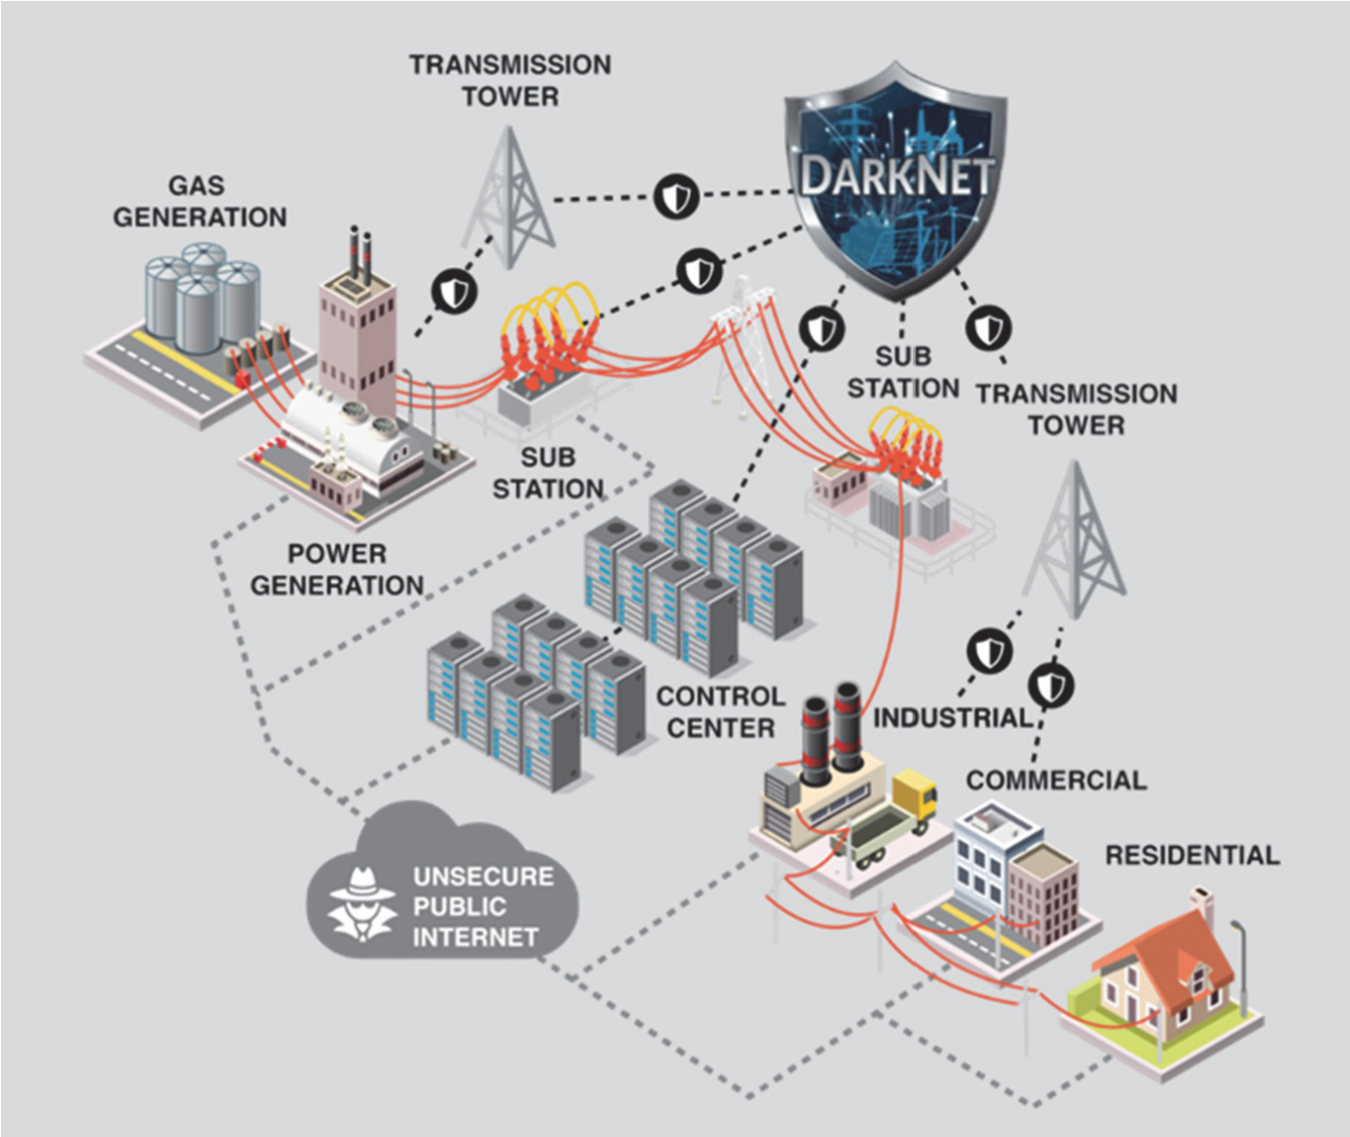
Figure 16. Reference architecture for scaling cybersecurity across various utility domains.
It is not anticipated that utility-customer communications such as telephone and email traffic will be taken off the public internet. However, it is expected that architecturally—in hardware and database structures—there needs to be a complete separation of that traffic from utility operation information sets.
The complete disconnection of a utility’s operations from the public internet is not economical or practical. Rather, it is envisioned that utilities, individually and collectively, will operate with communication connectivity within “enclaves.” For example, the inter–control center communication will operate within one enclave with certain operational characteristics, while another business operations function, such as telephone support, operates within a separate enclave with different operational characteristics. The various enclaves will function with security and operational characteristics tailored to the criticality of the business processes supported. The design is similar but not identical to the manner in which classified networks are deployed.

Defense-in-Depth Solutions
Transforming the “fault-resilient” power grid of today into an “attack-resilient” power grid of the future, capable of surviving sophisticated cyberattacks, requires an end-to-end comprehensive technical approach that incorporates both offline and online security measures across the cyber, control, and physical layers of the system, leveraging CPS properties at multiple levels for different attack classes. The electric grid’s cyber–physical properties, legacy attributes of control systems, and physical redundancies must be incorporated in the development of smart grids tailored by a CPS and resiliency approach.
To secure power systems against cyberattacks, people typically explore security solutions in two directions. One direction is to apply commercial off-the-shelf internet security techniques, such as firewalls or anti-virus or anti-spyware software; the other direction is to exploit redundancy in the power system application layer (e.g., bad data detection in power system SE). However, neither direction alone can achieve effective and efficient attack-resilient solutions. Solutions like a firewall can only provide fine-grained protection at single devices, and individual devices can suffer from misconfigurations that result in severe global conflicts. In addition, because communication network systems cannot tolerate even short-term transient outages, they must be continuously available; therefore, the system-wide properties of the power system must be integrated and held correct at any instant in time. Furthermore, communication network systems cannot afford complex security solutions because of their mission- and time-critical upper-layer power system applications. However, detection and mitigation techniques that are located only in the power system application layer will not be effective, especially when the system measurement redundancy is not sufficiently high. In this case, coordinated attacks could be launched by intelligent attackers who have obtained electric grid information, such as grid topology and transmission line parameters. In this sense, the integration of both network layer behaviors and power application layer features designed into a cross-layer cybersecurity solution is necessary to realize a defense-in-depth approach.

Device-Level Solutions
Fingerprinting technologies measure the physical aspects of the performance of individual electronic components that make up devices (e.g., threshold voltage, voltage offsets, leakage currents). Because of manufacturing variability, every device has a unique set of measurements for the performance of the components. Fingerprinting variation in the performance or matching of two or more devices (e.g., threshold voltage matching, current matching) and the specific performance of larger circuits—such as memory, oscillators, and amplifiers—provides a set of results allowing unique chip identification. Careful design of these readout and monitoring technologies can be used to amplify variations, resulting in a highly unique (secure) signature or fingerprint. An example is device authentication that uses physically unclonable functions (PUFs) within existing memory structures to secure device transactions, providing encryption-key management.
The use of watermarking technologies, such as patterned radiation exposure of electronics, could also be employed to impart spatially programmed device offset voltages for identification of a single chip or runs of chips. This technology would be undetectable with known imaging technologies but would be easily decoded with incorporated and hidden readout electronics.
Both fingerprinting and watermarking technologies have broad application to any hardware system using integrated circuits. Power grid Internet of Things (IoT) hardware could broadly incorporate this technology to verify undesired supply chain component tampering, including replacement. This is particularly important in sensitive or high-reliability applications. A commercially available example is IntrinsicID, which is targeted primarily at the IoT for microprocessor-based applications. Samsung is also involved in fingerprinting for device authentication. This type of technology will be a major part of the IoTs as time progresses.

Blockchain Technology
Blockchains are distributed databases used to record transactions on “blocks” of data/information and to make modifications to previously recorded blocks. This enhances the security of the block. This approach is currently being used for HIPAA (Health Insurance Portability and Accountability Act) compliance in patient record transport and in financial transactions and is being considered for utility use, initially for financial transaction security. Blockchain would be a valuable tool for verifying extended grid state (EGS) sensor readings before they are accepted by the utility’s SCADA. Using a blockchain concept for sensor-SCADA transmission does not ensure that the reading itself is correct, but blockchain can be used to validate/verify the message envelope within which the encrypted sensor reading is placed. Note that this is not a replacement for a VPN, but rather a method of using other sensors to validate sensors deployed in the utility’s infrastructure (or the grid itself).
Evaluating the energy infrastructure of a concept such as this involves initially modeling the networks, simulating traffic flow patterns from deployed sensors, and verifying that the software built within the sensor operates according to the rules established for this specific blockchain. A deployment of actual devices within a real-time digital electric grid simulator would be used to verify operation, ending in a deployment of actual devices within a segment of an operational utility network.

CYBERSECURITY FOR SENSING AND MEASUREMENT
The power system already uses multiple layers of sensors (e.g., electrical, mechanical, chemical), transducers (PTs and CTs), and actuators (e.g., circuit breakers, capacitor banks, voltage regulators). These actuators via the data from the sensors change the power flow, voltage levels, and power quality from generation through the T&D system to the end loads. Sensors already must balance the following three nonorthogonal dimensions.
Application requirements: These are dictated by the optimal resolution and accuracy needs to support decision-making frameworks at utilities.
Integration requirements: These are dictated by utility operational frameworks on procedures for deploying new sensors into existing infrastructure with the least disruption to reliability, as well as their integration and interoperability with existing sensing and control infrastructures.
Cost requirements: Adoption of new technologies at cost-effective scale, particularly into legacy electric grid assets, drives sensor cost requirements, which vary at different levels of grid infrastructure (e.g., monitoring transmission assets vs. distribution assets vs. end use).
With the increased importance of cybersecurity of power networks, sensors need to add CPS awareness and support to these requirements, so that they can detect and mitigate complex cyber threats in the power grid.
A representation of the 5-tier control system architecture can be used to describe the interaction between the operational technology (OT) and IT components of energy systems, as shown in Figure 17. Often, tiers 3–5 constitute the IT system and tiers 0–2 constitute the OT system. Although the OT system elements are frequently secured via an assortment of authentication certificates and keys and secure provisioning tools and practices, end users deal with the practical details of the OT-IT differentiation. As an example, consider Figure 18, which illustrates ExxonMobil’s approach to OT-IT partitioning layered over the aforementioned 5-tier design structure. It is immediately apparent that the two facility operations have different areas of control but share the common value that cybersecurity of the information flow from tiers 0 to 4 must be maintained. New practices of bridging IT and OT networks or connecting OT devices to the internet has exposed new attack vectors to the power system.
Of specific note is the fact that cybersecurity network designs found in best practice documents such as NIST 800, and illustrated in Figure 17 and Figure 18, have an overwhelming reliance on firewall segmentation between the networking layers. Firewalls are traditionally IT-system focused and are not invulnerable; OT-IT systems require a unique set of defenses that accommodate their combined architecture. Although firewalls are generally a good practice, current R&D is emphasizing a different approach with focused minimization of internet connectivity—even with device upgrades.
This activity includes building cybersecurity measures into the software code for the sensors’ microcontroller VPN capability, thereby securing a transport tunnel into different layers of the overall framework. In addition, device authentication to a SCADA/distributed control system—validating the device via blockchain with the network, but not the actual information (measurement)—is being developed. Placing additional capabilities into the sensors at the grid’s edge potentially increases the grid’s cybersecurity.
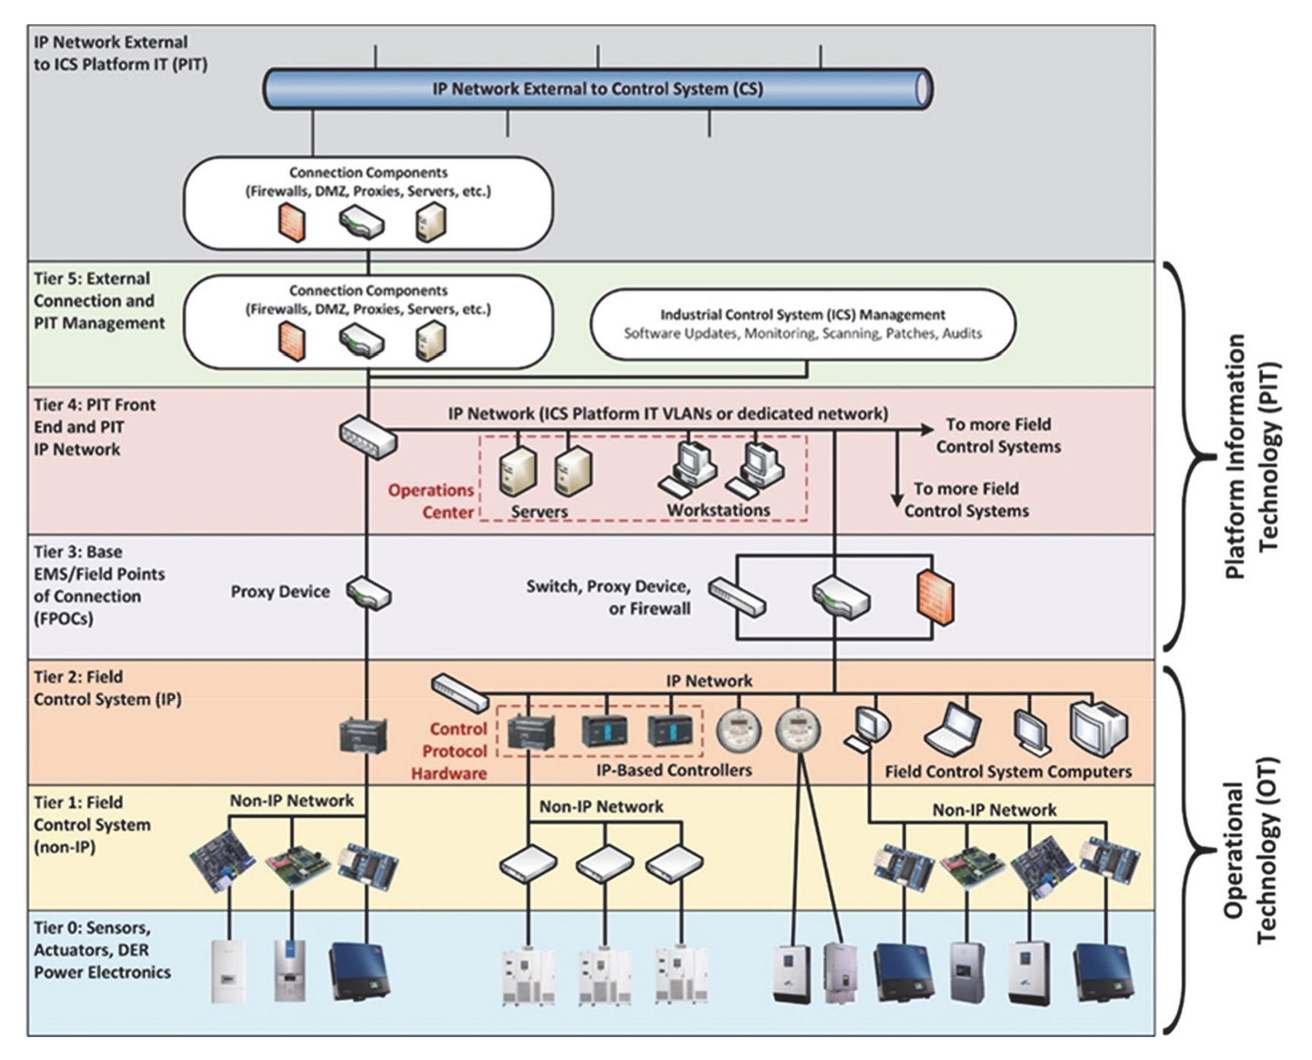
Figure 17. Five-tier industrial control system architecture.
Sensors represent both an opportunity and a risk for power system cybersecurity. On the positive side, sensors are critical instruments for detecting and mitigating cybersecurity threats to the power system infrastructure. Sensors designed to measure and analyze communication systems are useful for intrusion detection systems and intrusion prevention systems. These tools can alert IT or OT network operators of adversarial actions or provide reconnaissance. For instance, firewalls can log all traffic from external IP addresses and warn or block traffic when specific protocols are used. Similarly, data analytics can be used to compare power system measurements with network communications; for example, a relay may report that its associated breaker is closed, but the downstream voltage is reading zero, which indicates that the breaker is open and the relay hasn’t operated the breaker. This could indicate that the relay was involved in a spoofing attack.
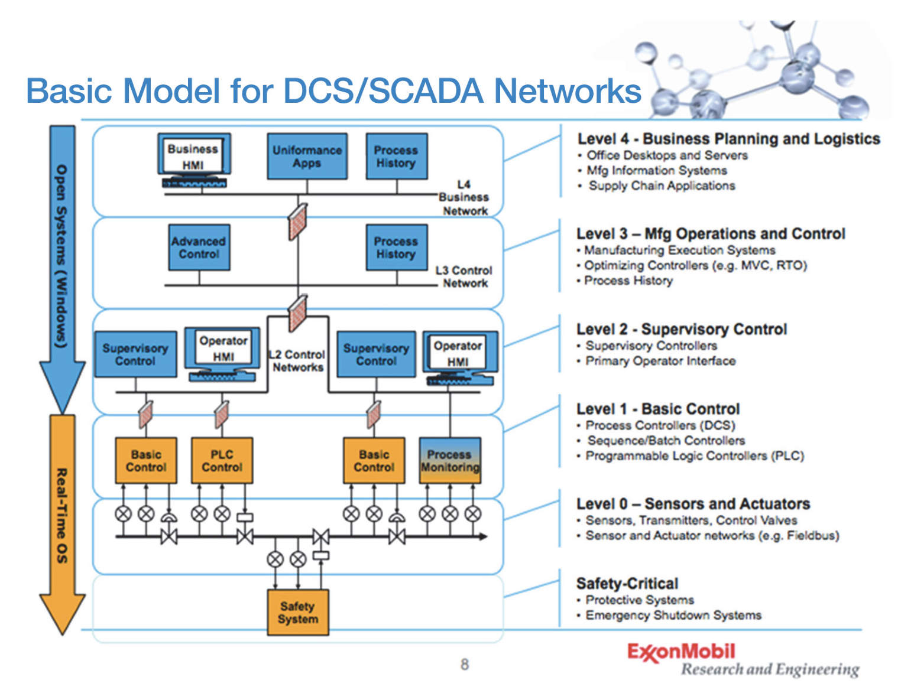
Figure 18. ExxonMobil system architecture illustrates a clear demarcation between OT and IT.
Unfortunately, sensors are also vulnerable to cyberattacks, including spoofing, DOS, man-in-the-middle, and so on. For example, it is possible, that a PT in the scenario mentioned above is actually the device providing the manipulated data. Often, sensor communications are simple serial or other unrouteable (tier 2) protocols that are unencrypted until they reach measurement, analyzing, or processing equipment that has more computing capability (tier 2 in Figure 18). At any point in data gathering or transfer, a cyberattack could occur and corrupt the data. The sensor measurements could be manipulated or falsified through various transduction attacks, e.g., ultrasonic proximity sensors. Low-level sensor measurements, e.g., a 0–10 V signal, could be physically or remotely modified before reaching the measurement and processing equipment. Also, processed or measured data could be changed either at the data concentrator or when reported back to the industrial control system/plant information system. Each of these attack modes should be considered for robust, cybersecure sensor deployments.
Additional, hardware-based cybersecurity approaches exist and are in various stages of research. Resource-constrained devices, such as sensors and sensing applications, are vulnerable to invasive attacks that are designed to steal keys stored in nonvolatile memory (NVM); and NVM adds cost to these low-cost devices. PUFs are novel hardware security mechanisms that provide an alternative key storage mechanism that does not require NVM but rather derives the key from small analog variations that exist from one copy of a chip to another. Therefore, the key is not stored in digital form anywhere; is derived on the fly as needed; and is tamper-evident, i.e., any attempt to steal the secret destroys the PUFs and the ability of the chip to regenerate them. Moreover, a special class of PUFs, called “strong PUFs,” is able to generate an exponential number of reproducible secret bits that can be used to harden security protocols further. Moreover, strong PUFs can reduce area and energy overheads by reducing the number and types of cryptographic primitives and operations.
A bewildering array of cybersecurity threat and attack scenarios may be associated with the various tiers in a SCADA/digital control system realm. Numerous associations of end users, vendors, academics, and other parties are involved in examining such scenarios. Within DOE, the Cybersecurity for Energy Delivery Systems program Roadmap for Cybersecurity provides a robust intersection with GMLC sensing and measurement activities.

DATA MANAGEMENT AND ANALYTICS
Measurement and operations data collected from distributed grid sensing technologies have the potential to generate value beyond current applications. Conventionally, these data are collected and aggregated by utilities or other network interests for billing, operations, and planning. The data are often siloed in disparate repositories and not well coordinated, preventing the extraction of the full value of the data (Figure 19).
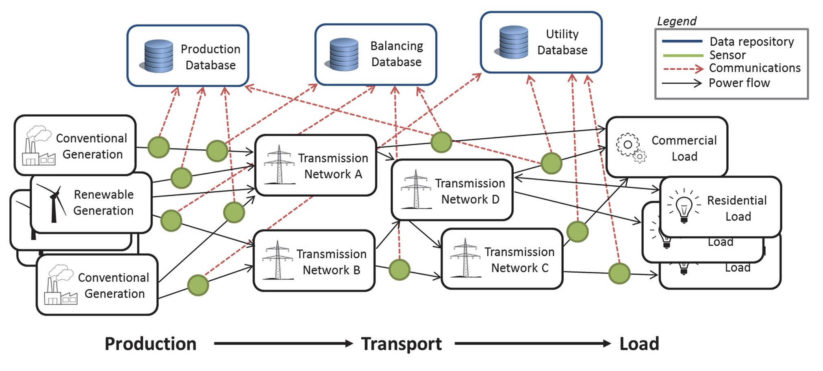
Figure 19. Existing electrical power system data flows and independent repositories.
The purpose of this document is to identify the stakeholders and the key considerations for future power grid data management systems and identify particular barriers that need to be addressed to exploit the full value of the data being collected. This process will be carried out by
Gaining feedback from stakeholders
Distilling that feedback to a few key criteria and metrics by which potential solutions and systems can be judged
Identifying the data and data characteristics that future data management systems must manage
Describing current systems and technologies and their ability to meet the required system goals identified by stakeholders in summary discussion and a few example use cases of how current technology meets or doesn’t meet stakeholder needs
Identifying a set of critical barriers and gaps that is preventing the full realization of the value of grid data

BACKGROUND
According to the Data Management Association,
Data Resource Management is the development and execution of architectures, policies, practices and procedures that properly manage the full data life cycle needs of an enterprise. It comprises all the disciplines and techniques necessary to treat data as a valuable resource.
For the power grid, there is growing recognition that data are a valuable resource and that data are key to understanding and controlling the grid and doing so in a cost-effective, reliable, resilient fashion. Data from the power grid are diverse in scales, complexity, and utilization. And, as the power grid is undergoing a period of transition, the systems that manage the data generated from the grid must evolve to keep pace and provide needed insight in a timely and effective manner.

STAKEHOLDERS
The organizations and parties that have an interest in the power grid and data associated with it are varied and diverse. The power grid impacts every facet of society and is ever present in our lives, so it makes sense that many parties have an interest in the data and systems that manage the data of the power grid. To understand the important stakeholders, it is useful to visualize how value flows within the grid system. Figure 20 demonstrates a value network for the various stakeholders. The primary purpose of the grid is to supply electricity to customers, who can use it to create value in other forms. The customer–utility interaction represents the dominant value flow in the energy system. Many other stakeholders interact through various means, including researchers, suppliers, regulators, and governments.
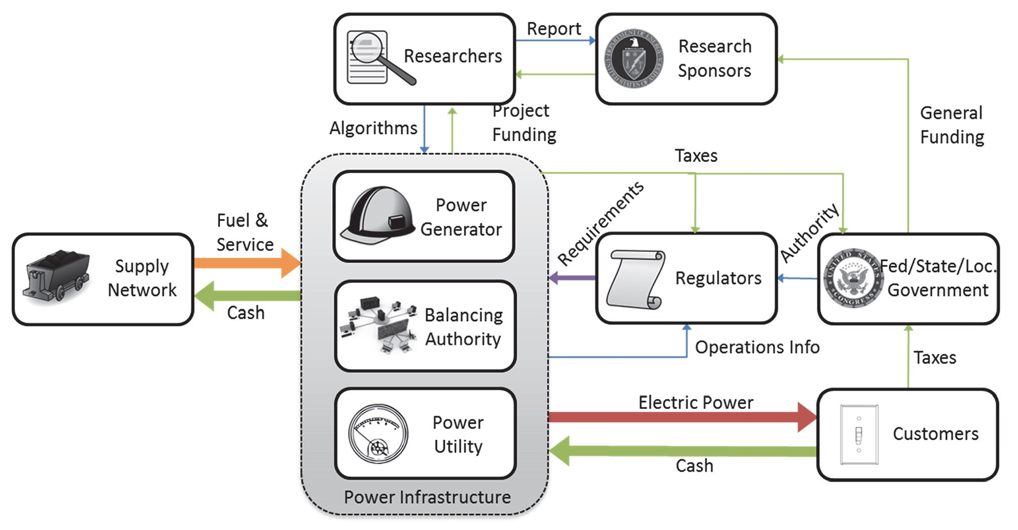
Figure 20. Utility grid stakeholder value network.
As part of this process, we obtained feedback from a number of stakeholder representatives via reference documents originating from a given entity, listening to presentations, direct interviews, or past experience of the authors.

Utilities
As evidenced by Figure 21, utilities (and other grid operational entities) are at the core of any value network. They are the originators, maintainers, and users of much of the data. They are entities responsible for maintaining the grid and operating it efficiently and reliably. There is great variety in the sizes and needs of utilities and, with that diversity, widely varying needs and requirements for data management. Based on conversations, reports, and presentations, utilities deal with many issues related to and have many concerns about data management.
Several common themes were apparent in the input from utilities. The two key drivers were customers and cost. The customers’ needs must be met, and customers are demanding safe, reliable, affordable, resilient, flexible, and environmentally friendly power. In addition, a portion of customers want to interact with the electric systems as “prosumers (producers of electric power) for example.” On the cost side, all advances and new systems must recover costs and be beneficial to both utilities and customers; otherwise, they are not justified. Specifically on issues associated with data management, several issues were highlighted.
- Current system description data are generally poor, especially for distribution networks.
- Data are often siloed and it is tough to get them to the people who need them.
Regulation at the federal, state and local levels is an additional key driver.
Several previous roadmapping efforts,, and surveys have been performed by consulting or trade groups highlighting many of the concerns from utilities. Figure 21 shows a chart of the relative frequency of concerns.
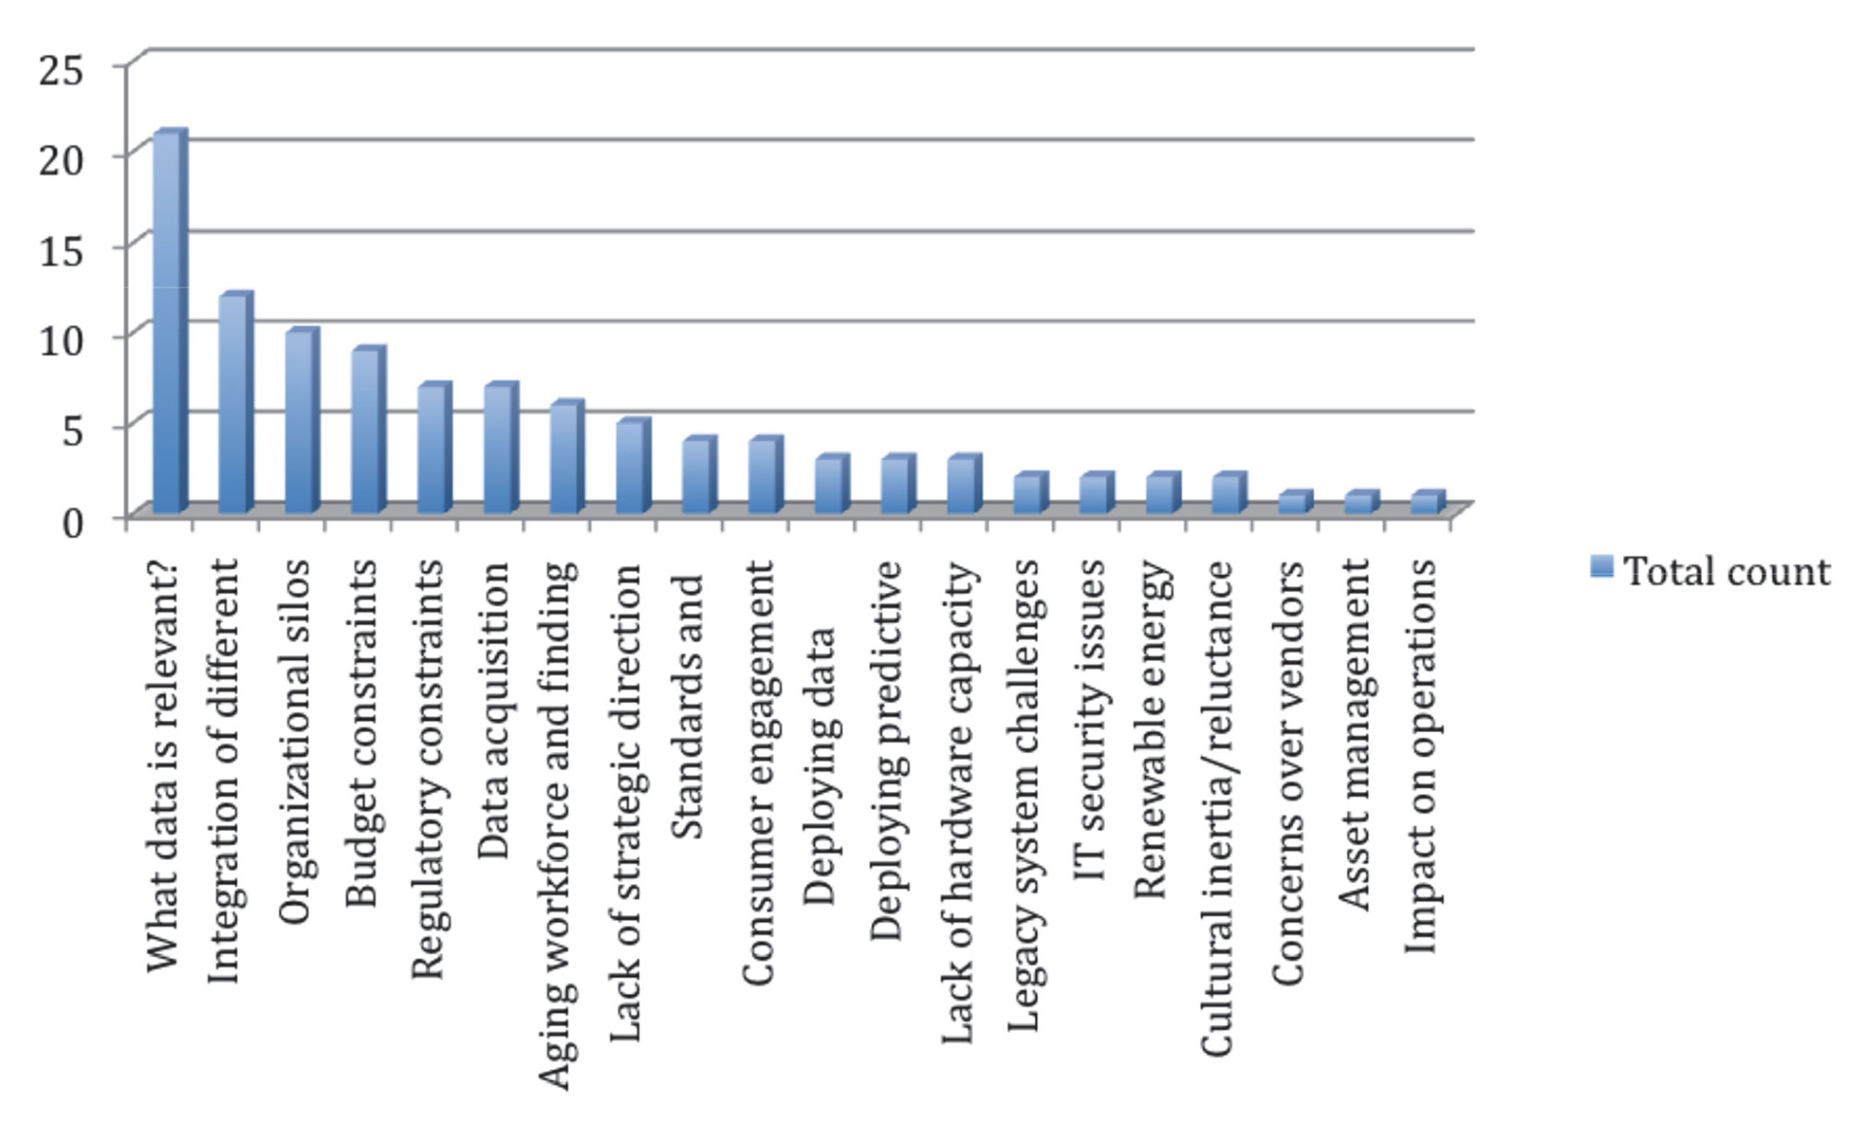
Figure 21. Key challenges in data management.

Customers
On the other side of the network are customers, with the bulk of the value flow being the transaction between utilities and consumers. A general consensus from conversations with people and utilities is that customers are changing. They are becoming more demanding of information about the power they consume; and they are demanding the information necessary to make decisions about power consumption and to control their own demands, as well as produce their own power and interact with the grid in ways that were inconceivable in the past. Customers have many requirements for the use of data from the smart grid, such as
- Maintaining privacy of personal data
- Getting sufficient data to control consumption/production and billing
Receiving outage information in a timely and accurate fashion

Researchers
Given the novelty and uncertainty in using much of the data that are now available to utilities, much research has to be done to fully realize the value of the data. Doing so requires talented researchers who can devise schemes and methods to make sense of the data. Therefore, researchers from institutions such as research universities, national laboratories, and consultants are important stakeholders in data management for the grid. In feedback from the research community, several key issues come to the forefront repeatedly:
- Access to grid data is by far the issue most often mentioned by the research community.
- Public data sets are inconsistent, too small, too easy, and not representative of real systems.
- There are no systematic ways of comparing results from optimization algorithms.
- There is no consistent framework by which to evaluate and compare results.
Any model or simulation should be validated.

Governments, Regulators, and Standard Making Organizations
Governments and by extension regulatory agencies that exert control of the practices of utilities and the operation of the grid have a significant influence on the nature of the grid. Utilities make many decisions in order to meet certain regulations. Regulators have a strong interest in moving the grid toward better practices and they strive to mesh that with public policy goals. These decisions are sometimes made with insufficient information and analysis. Thus, data streams, flows, and management must account for the information needs of those in charge of policy and regulation of the grid. These concerns include:
- Supply chain security
- Damage assessment
- Fair payment systems
- Greater standardization
Distribution system management
The many stakeholder groups invested in seeing the grid managed well have many different concerns specific to their own domains. Taken together, these concerns represent the key constraints and values of a modern data management system on the power grid, and possibly a more organized coherent data system in which various parties work together instead of siloing data. A coordinated data management system (Figure 22) would benefit all parties involved, reduce costs and improving services for customers and allow utilities to reduce operating expenses while providing increased levels of service (Figure 23). Regulators with increased awareness could craft more effective regulations, enabled through increased coordination between researchers and utilities. Such a system can be realized by treating data as a valuable resource.
Establishing such a system will require a systematic evaluation of the values and costs associated with the various aspects of the data management system. Figure 24 represents a preliminary valuation matrix of the considerations of various stakeholders; it will be refined and adjusted based on further stakeholder input. It will also be used in further refining the valuation metrics for use in analyzing the technological and programmatic gaps in utility data management systems.

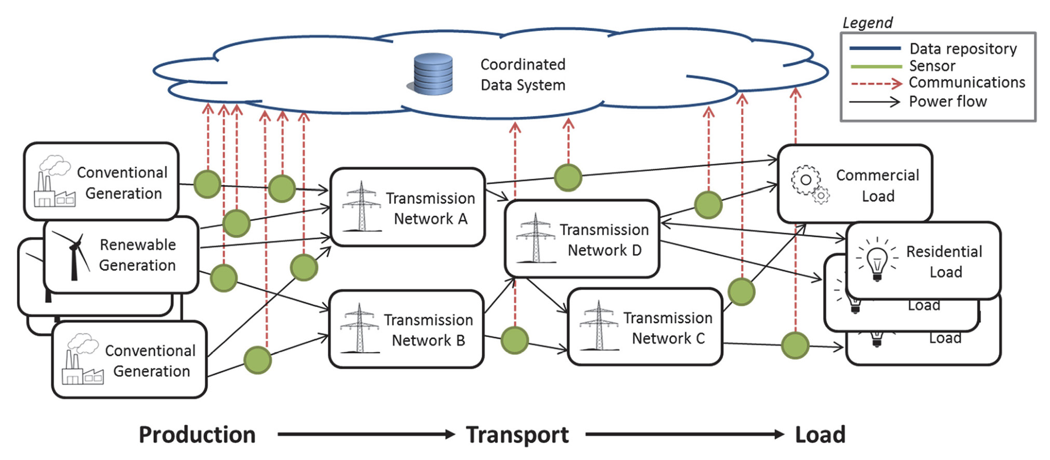
Figure 22. Coordinated data management system.

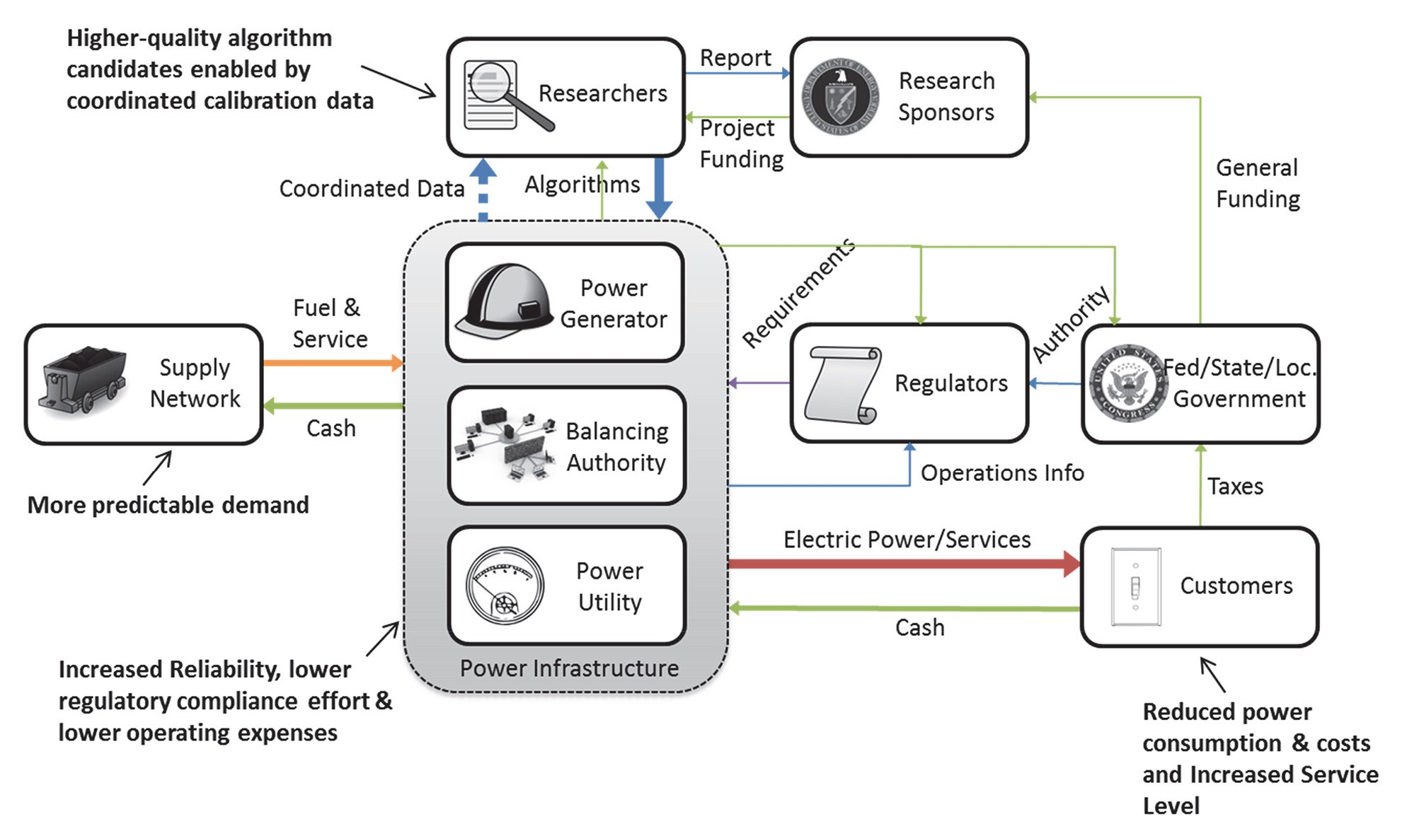
Figure 23. Improved value flow from a coordinated data management system.
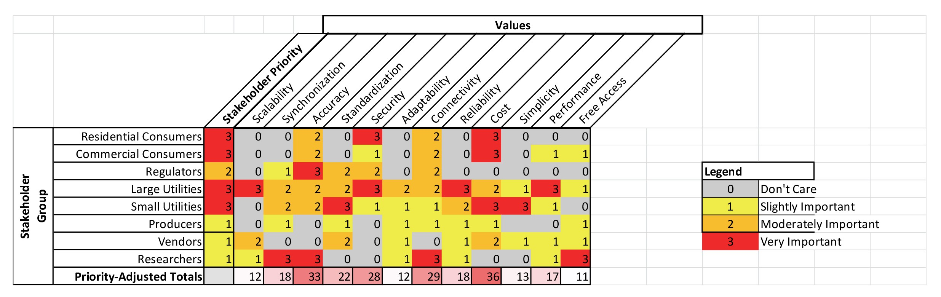
Figure 24. Value prioritization.

VALUATION METRICS
Proper valuation of overall solutions to data management issues in power grid systems comes through a rigorous analysis of the value chains and flows through the different stakeholders in the system. Different stakeholders value different things, and system costs are not borne equally by all participants. Take customers, for example: Some may be satisfied with having power most of the time and want power to be as inexpensive as possible. Others demand absolute reliability, and the actual cost of the power itself is insignificant compared with its value. Still others want to actively participate in the power market itself and desire the data and connectivity to be electricity prosumers. All of these different scenarios involve cost, but the factors that go into determining the cost and value vary greatly among the different customers. Beyond the immediate financial impacts are other considerations such as politics, security, and reliability. The cost of failure with regard to these topics can be extremely high, but occurrences of failure in those respects are exceptionally rare.
To proceed, a set of metrics based on specific aspects of sensing and data analytics must be developed. The initial valuation metric shows cost as the key concern of nearly all stakeholders. These metrics must cover the relevant design trade-offs in a fashion that is amenable to optimization for an overall system and tuned for a particular utility, but still allows the system to meet the operational requirements. These data will feed into the gap analysis and into the sensor placement optimization tool (SPOT) that is being developed.
Based on preliminary evaluation, metrics should define trade-offs with respect to connectivity, security, accuracy, and standardization; and some form of evaluation metric based on performance, reliability, and synchronization probably is needed. All of these metrics will be evaluated with respect to value and cost. As an example, Figure 25 shows a possible chart of the relative value of the data management system supporting varying numbers of data sets. For a particular utility with this valuation curve, the optimal number of data sources would likely be around 10,000, the point at which the incremental value declines considerably.
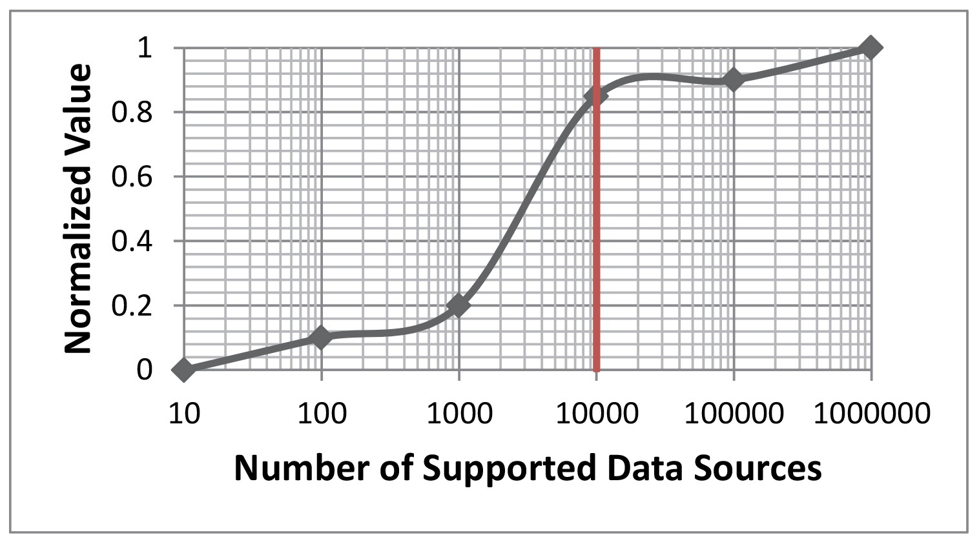
Figure 25. Valuation metric for scalability.
These metrics once refined in the roadmap will provide input to the gap analysis and to optimizing systems for maximizing value to stakeholders. The key point is that data management systems must be effective at what they do, they must support the kinds of data needed for use in power systems, and they must produce sufficient value to justify their expense. To explore the topic of effectiveness, the data types that must be managed and some existing technologies must be explored.

DATA TYPES AND CHARACTERISTICS
The data used in power system control and management vary widely in both scope and scale. Some data, like component characteristics, are updated only when new equipment is installed. Others, like streaming PMU data, come in at a rate of 30 times a second or higher. The variety implies that a data management system must be flexible enough to handle very diverse types of data and characteristics. The next subsections highlight some characteristics of the various kinds of data that a data management system would be expected to handle.

Grid Sensors
The broad category of grid-related sensors composes a majority of the actual volume of data a management system would be expected to handle. These include properties of the operating system including voltages, angles, impedances, real and reactive power, harmonics, frequency, currents, device temperatures, and others. Typical SCADA measurements come once every few seconds to minutes, and new PMU data are streamed along with a time stamp at 30 or 60 frames per second. These data need to feed into active operational algorithms in a real-time fashion and produce results that can be acted upon in seconds by automated algorithms or human operators. The data inform operators about current conditions on the grid and warn of any abnormalities (off-normal) conditions. Furthermore, many of these data are fed into a state estimator that is used as a proxy for missing measurements and unmeasured data, as well as source of redundancy for protecting against data errors or altered data.

Meter Data
The AMI systems on a power grid capture data at a lower frequency; but the volume is also high as they often operate on the single-customer level, and there are a lot of customers. Many of the same properties measured by grid sensors are also captured but at a much finer grid level granularity. These data are primarily used for billing, but the data sets are rich enough that they can be used for many other purposes.

Weather Sensors and Energy Production
The consumption of electricity is closely tied with the weather. The transfer capacity of transmission lines depends on temperature, wind, and humidity and these are key considerations in load forecasts and usage. Detailed weather conditions play a key role in forecasting for renewable resources and for sudden changes in production. Although particular installations and locations may have key sensors for specific properties, many of the weather data are pulled in through forecast service providers and tied in with grid forecasting systems. Two kinds of data exist within weather data: the actual measurements and the forecasted data. The forecasted data can be much more intensive than the raw data, as they can involve a number of forecasts and have high geographic resolution. The result is a large data cube that can be used by various other forecasting algorithms in use on the grid. Over longer time periods, precipitation plays a key role in how much power is available from hydro resources and how the grid is operated from a production perspective.

Communication Channel Data
All data are communicated from their place of origin to a processing location. Particularly in regards to remote sensors, information about the status of the communication channel is an important assessment that needs to be considered in a holistic analysis since the information (both from the sensors and related to the communication availability) relates to grid health.

Sensor Metadata
At a level above the sensors is information about sensors. This includes location, type, calibration, and accuracy. Some of this information is transmitted along with measurements such as PMU data with a timestamp accuracy measurement. Other properties are stored in databases and archives and need to be made available for some kinds of analysis. The data are low in volume and often static but are very diverse.

Grid Topology Information
Often, to understand sensor measurements, a model needs to be included to simulate the origination of the sensors and predict how things might change. The information necessary to model a grid is very important to consider as part of data management. Often, these models are constructed over time and represent a tremendous amount of effort to build and maintain.

Topology Measures
Topology is not a static data set; since connectivity and status of assets changes over time such as switching actions occur. Some parts change more than others, and several sensors can capture changes in switch state and connectivity. But in addition to the commonly changed values, there are also maintenance records and change orders that occur out in the field at a slow rate but may not be captured by traditional tools. Particularly in the case of distribution systems, having an accurate representation of the network that delivers power is crucial for proper functioning of many advanced analytics programs. And capturing changes over time will be an important function of a comprehensive data management platform.

System Equipment and Maintenance Records
A vast amount of information about the grid is stored in archives at utilities, including paper layouts, equipment specifications, maintenance records, and change logs. All of this information is potentially useful to planning tools, but only if it is available in electronic form.

Model Output Results
The execution of simulations sometimes produces even more data than the amount captured from the actual grid. In real-time operations, simulation results need to be presented to operators in a way that is useful and operationally relevant. Planners may need large numbers of simulation runs to get a grasp of the uncertainties and sensitivities of various aspects of grid planning, and the results and the input used to generate the results may need to be archived to preserve a record and justification for decisions made in planning or in operation. Simulations can cover a wide range of aspects of the grid, from simple power flow analysis to long-running dynamic simulations; also available are contingency analysis, stochastic simulations data, planning studies, market simulations, and a host of other simulations that people have invented for particular purposes.

Market Data
Much of the energy distributed through the grid is procured through market operations. This record of prices, bids, and operations is a valuable tool for assessing grid health and understanding grid operation. Thus, it should be made available to engineers, economists, and researchers.

Analytics Results
Just as data feeds into analytic systems, the same data must flow back into the operation of the grid for planning or real-time control, and some sort of record of it must also be maintained. The resulting algorithms can be very diverse. Although the details of particular algorithms are outside the scope of this document, the data set can be very rich and diverse and can potentially be used in other analytics as part of a pipeline.

Ancillary Systems
The power grid does not operate in a silo independent of other large physical systems. All the sensor data flow across a backbone of communication links, which need to be captured and understood to really model the power grid. In addition, EV technology will play an increasing role in the future smart grid, requiring input from the transportation system. Most power is now produced via natural gas generation facilities, linking this type of fuel production and transportation directly into the power grid along with all of the others sources of fuel. Data from these systems will need to be understood from a grid perspective.

Cybersecurity-Related Data
The grid also needs to be kept secure. One means of improving security is monitoring information about communication channels and assessing normal and abnormal activity on the cyber-related links. Beyond network traffic, security-related data could include entry logs, server logs, communication logs, video camera data from critical facilities, and many other kinds of data that may be unimportant most of the time but could become critical to security.

DATA CHARACTERISTICS
The types of data outlined in the previous section are associated with an assortment of diverse characteristics. These characteristics determine how the data should be handled and cared for to extract the most value.

Bulk Characteristics
The bulk characteristics of data include the sampling rate, numerical type, rate of change in the data, and delivery method. These characteristics determine the underlying technology and techniques for receiving the data and are an important factor in many services that a data management system must provide.

Data Quality
Some data are very noisy and must be cleaned up by filtering or as part of other analytic services. Other kinds of data are pristine and treated as absolute truth. Data uncertainty and redundancy are important data characteristics that must be maintained and propagated by various processing systems to assess overall system uncertainty. Also, records of the cleaning methodology and data verification should be maintained as historical record for future uses and reliability testing of the data itself. Overall data quality assurance should be tightly integrated into the aspects of the data to ensure quality through the data life cycle.

Synchronization
Some data arrive at a slow rate, and their properties change so slowly that synchronization is not important; other data change rapidly and arrive frequently. Processing systems use many such measurements to generate information. Synchronization of the various data points is a crucial factor in the operation of data management systems, and the accuracy of the synchronization is an important part of data management. Changes in accuracy must be reflected in the overall data quality assessment. Often, accounting for accuracy changes involves associating time stamps with the data point and evaluating the accuracy of the time stamps. The accuracy may change only rarely versus the actual data, or it could change on a sample-by-sample basis.

Ownership
The basic tenet of ownership is determining who can do what with the data. Someone or something is responsible for collecting, organizing, cleaning, distributing, archiving, and protecting the data. The issue of data protection leads into the broad topic of data security, which is detailed further in the Section 5.5.5. At a foundational level, the owners of all data must be determined.

Security
Some data are public, whereas some are so sensitive that extraordinary measures must be taken to protect it at high cost. Most data fall between these extremes. A number of classifications have been made regarding the sensitivity of data, including public, shareable, business sensitive, and security sensitive. NERC and the Department of Homeland Security have characterized some data as requiring special protection to protect the national interest. The classification of data within this range contributes to determining what measures of protection must be taken regarding the data, such as access controls and encryption both in transit and at rest in an archive or dataset. The entire range of possibilities must be accounted for in a data management system to ensure that private data stay private while at the same time remaining accessible to those who should have access.

EXISTING TECHNOLOGIES
Many technologies exist to deal with data, and many companies of all sizes base their business models on the organization and analysis of “big data.”

Databases
General databases store information in tables indexed by a key value, which could be a name, identification code, or any other unique identifier. The various tables are related through a set of keys. Many major database vendors—both open source, such as MySQL and commercial, such as ORACLE and Microsoft SQL server—represent a well-established data storage technology. However, much work is required for proper organization, and flexibility is limited once databases are established.

Time Series Databases
Time series databases store data keyed by time, recognizing that data often come in sequence related by time and should be analyzed accordingly. This approach allows fast retrieval along a time index and requires the coordination of a large number of keys. It also allows for compression-type algorithms that ignore small changes in the data and can effectively reduce the sample rate. The major commercial vendor in this space is OSIsoft; there are a few open source startups, such as opentsdb and the openHistorian project from the Grid Protection Alliance.

Geospatial Databases
Many of the data associated with a power system topology are referenced to geographical locations. Systems that store information by geographical location are known as geographical information systems (GIS). Databases of this type, such as ArcGis, are in common use throughout utilities, as are geospatial extensions to common database products, such as Oracle or MySQL.

Other Types of Databases
In recent years, the availability of different types of data stores has risen considerably. It is now possible to represent data in terms of key-value pairs, graphs, clusters, or other custom formats. In one sense, this tremendous variety allows a data storage system to be tuned to the particular features of a given data set; but at the same time, it presents the added complexity of a new piece of technology in the overall data management system.

File Transfer and Archiving
It is often the case that, after a short time, some fraction of the data is not needed by operational systems. However, it may be useful for training purposes or for training advanced machine learning algorithms. These data can be stored in an archive format and extracted as needed. They may also need to be transferred to a different system in large blocks. In either case, some form of lossless compression and file format is needed to effectively store and transfer archived data. One commonly used format for scientific data storage is HDF5. This format is used in many industries and projects around the world and allows flexible storage for any type of data, including data compression in the files. A number of other compression algorithms, such as 7z and szip, could also be used to reduce storage requirements for other types of files and archives.

Communication
Significant detail for the various options for communication and networking architectures was provided in Section 3 of this report. The required performance of the communication system for any given situation will depend greatly on the size and nature of the data management system, whether it is distributed or centralized, and how big it is. In practice, the specifics of the communication system will play a role in the overall evaluation of the system and its optimization.

Analytics
The nature of data analytics is broad enough that many individual projects are devoted solely to this topic, including GMLC 1.4.9, and other projects that can identify and rectify specific gaps in analytic capability. The central theme that is expressed repeatedly is access to data. Utilities collect data, and the data are organized and used by the utilities in justified ways, such as for reliability, operations, billing, and meeting regulations. Researchers have a tremendous wealth of techniques and knowledge including visualization that could potentially be applied to great benefit for the utilities. However, there are conflicting values and barriers associated with fully utilizing existing technologies and knowledge in the area of analytics. In some cases, data visualization and representation can play a key challenge.
The nature of analytic algorithms also impacts the structure of the data management system. Some analytic algorithms are distributed and operate on distributed streaming data. Others operate on data from a central repository. The end result is that the data management system must support analytical algorithms in various forms and with varying degrees of connectivity to the data.

OVERALL CONCLUSIONS AND PATH FORWARD
The conclusions of the sensing and measurement technology roadmap development effort were ultimately based upon targeted stakeholder engagements and feedback in collaboration with the DOE national laboratory technical team. However, the development of this Technology Review and Assessment document yielded useful insights about the current technology status within the identified application domains and emerging needs in the area of sensing and measurement devices to serve as a foundation for the technology roadmapping effort. The following are examples of important insights derived from the development of the Technology Review and Assessment document:
Harsh-environment sensors, diagnostics, and instrumentation capable of deployment in high-temperature processes relevant to conventional thermal-based generators (e.g., fossil, nuclear) can enable more flexible operation and minimize long-term impacts of cycling and ramping on plant longevity and efficiency. Capabilities of existing AGC systems and associated sensing and measurement devices for operation in a more dynamic system should be evaluated critically in terms of the potential need for technology innovation.
A broad range of weather monitoring and forecasting technologies currently exists at high technology readiness levels for predicting renewable generation (e.g., solar, wind) to generate actionable information through measurement of parameters such as irradiance and wind speed. Innovations in renewable generation forecasting often involve the adaptation of mature sensing technology developed in other fields. Emerging trends include the use of UAVs and lidar-based techniques, among others.
Widespread deployment of power flow and grid state monitoring tools to achieve the desired level of visibility is necessarily tied to cost and performance trade-offs with key technology innovations, such as distribution-level PMUs. Deployment relies largely upon the ability to reduce costs and maintain necessary performance metrics at the distribution level. PMUs are a key technology for power flow and grid state monitoring throughout the electricity grid infrastructure. Despite the maturation of the core technology, opportunities remain for improvements in reliability, speed, accuracy, and applications. Emerging electromagnetic phenomena–based current and voltage transducers have significant technology advantages. While commercial products have become a reality, significant opportunity also exists for innovation.
Asset monitoring of electrical grid assets can be classified into both “functional performance” and “health monitoring.” The former requires predominantly electrical parameter sensors, and the latter requires sensors for a broad range of parameters, such as temperature, chemistry, and strain. Established sensor instrumentation exists for many established grid components, such as large power transformers and transmission lines (e.g., DLR) but costs currently limit deployment to critical assets. Low-cost sensing technologies capable of multi-parameter and multi-function operation can enable broader deployment. New sensing technologies may also be required for emerging grid components, such as energy storage devices and high-frequency power converters.
Deployment of sensors on the end-use and buildings side necessarily requires a trade-off between sensor cost and required performance. Trends of increased generation at the residential and commercial use scale, as well as projections for widespread EV deployment, require increased visibility at the load to enable DR and transactive energy strategies. Low-cost sensor technologies for monitoring power flow as well as parameters that are characteristic of current and forecasted load (e.g., illumination, irradiance, temperature, humidity) will be of increasing importance.
In addition to these key findings, the following common crosscutting themes have emerged across the application domains:
Although needs still exist for advanced instrumentation at the centralized generation and transmission levels, a relative lack of visibility exists within the distribution system compared with the transmission system.
The “per unit” value of a sensor for a parameter of interest installed and deployed on the distribution system or at the end-use level is dramatically lower than for a sensor employed at the corresponding transmission level. Therefore, the goal of enhancing visibility across the electricity grid infrastructure, including the distribution system, requires advances in (1) low-cost and (2) multi-function or multi-parameter sensor technologies to make widespread deployment economically feasible.
Standards and interoperability will be important aspects of new sensing and measurement device development and deployment, particularly for deployment within the T&D for power flow, grid state monitoring, asset monitoring, and for fault diagnostics application domains.
As the number of sensing and measurement devices deployed in the electric power system becomes larger, the monitoring and control task also poses significant challenges for the underlying communication networks. Insights derived by the team in the development of this Technology Review and Assessment document include that a paradigm shift is anticipated toward broader implementation of distributed rather than centralized architectures as characterized by communications and intelligence at lower levels (“edge”) of the system. This shift will require reduced latencies and robust peer-to-peer communication, in addition to communication between various nodes and the control center. Therefore, a hierarchical architecture of communication with different layers of communication is needed with the following attributes:
Scalability and interoperability to manage a large number of smart sensing and measurement devices
Flexibility and expandability to incorporate new types of data and applications
Efficiency in leveraging the unique features of different communication technologies
Reduced latency with more distributed data processing and control, which significantly reduces the communication and computational burden of the control center
It is clear that the goals outlined under the GMI of dramatically increased grid visibility through widespread deployment of advanced sensing and measurement devices requires developments in technologies for managing and analyzing the unprecedented amounts of information contained within spatially and temporally variable multidimensional data sets. The team has identified a shift toward distributed data analytics methodologies as a potential key component of the required technical solution for these emerging needs. But these early findings also suggest that, even for the existing sensing and measurement infrastructure, there remains a great amount of value to be extracted through advanced data management and analytics approaches, even at the distribution system level. Developing a clear understanding of the potential to enhance visibility and generate new actionable information for the existing sensing and measurement infrastructure requires strong engagement with industrial/utility partners and other stakeholders to understand current infrastructure and methodologies. That engagement is a significant focus of the effort moving forward for the Sensing and Measurement Technology Roadmap.

BIBLIOGRAPHY OF RELEVANT ROADMAPPING DOCUMENTS
- Buildings Sensors and Controls R&D Program Roadmap Session Summary Report, June 2015. Available at http://www.energy.gov/sites/prod/files/2015/08/f26/T10S3_Sofos.pptx; https://www.energy.gov/eere/buildings/sensors-and-controls-rd-0. (Accessed November 2018)
- Electric Power Research Institute, Transmission and Substations Research Area. Available at http://mydocs.epri.com/docs/Portfolio/P2014/Roadmaps/PDU-01-Transmission.pdf. (Accessed November 2018)
- J. H. Eto et al., Scoping Study on Research and Development Priorities for Distribution-System Phasor Measurement Units, SAND2016-3546R, Lawrence Berkeley National Laboratory, April 2016. Available at https://prod.sandia.gov/techlib-noauth/access-control.cgi/2016/163546r.pdf. (Accessed November 2018).
- Bonneville Power Administration, Transmission Technology Roadmap, February 2013. Available at https://www.bpa.gov/Doing%20Business/TechnologyInnovation/Documents/2013/201303-BPA-Transmission-Roadmap-February-2013.pdf. (Accessed November 2018).
- US Department of Energy, 2014 Smart Grid System Report, Report to Congress, August 2014. Available at https://www.smartgrid.gov/files/2014-Smart-Grid-System-Report.pdf. (Accessed November 2018)
- International Energy Agency, Technology Roadmap: Smart Grids, 2011. Available at https://www.iea.org/publications/freepublications/publication/smartgrids_roadmap.pdf. (Accessed November 2018)
- Bonneville Power Administration, Collaborative Transmission Technology Roadmap, March 2014. Available at https://www.bpa.gov/Doing%20Business/TechnologyInnovation/Documents/2014/
Collaborative-Transmission-Technology-Roadmap-March-2014.pdf. (Accessed November 2018).
- S. Geol, S. F. Bush, and D. Bakken, “IEEE Vision for Smart Grid Communications: 2030 and Beyond,” IEEE Standards Association, 2013.
- Southern California Edison, Southern California Edison Smart Grid Strategy & Roadmap, Advanced Technology Transmission & Distribution Business Unit, 2010.
- V. S. Warrier, A. De, P. Chitkara, et al., Smart Grids: A Roadmap for Communication and Application Interoperability in India, India Smart Grid Task Force, 2013. Available at https://www.climatelinks.org/resources/smart-grids-roadmap-communication-and-application-interoperability-india. (Accessed November 2018).
- Olivier Huet, IEEE Distribution Automation Working Group, “EDF Distribution System of the Future and DA Roadmap” (presentation). Available at http://grouper.ieee.org/groups/td/dist/da/doc/2007-06_GM_EDF_Distribution_Roadmap.pdf. (Accessed November 2018).
- Hydro Quebec Distribution, Distribution System Automation Roadmap 2005–2020, Report 30012-05-044-R, October 2005. Available at http://grouper.ieee.org/groups/td/dist/da/doc/2006-08-31HQDA_roadmap_final.pdf. (Accessed November 2018).
- “NIST Interim Smart Grid Standards Interoperability Roadmap Workshop,” IEEE PES Distribution Automation Working Group. Available at http://grouper.ieee.org/groups/td/dist/da/NIST%20
INTERIM%20SMART%20GRID%20WORKSHOP%20IEEE%20PES%20DAWG%20
CONTRIBUTIONMay1st09.pdf. (Accessed November 2018).

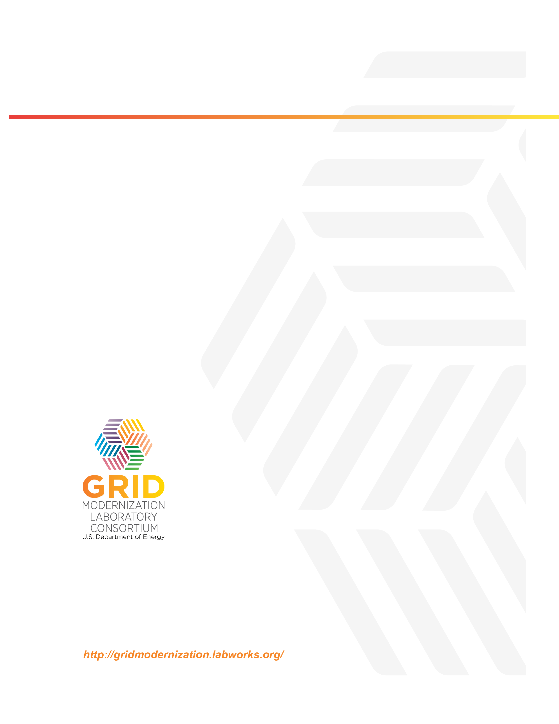
U.S. Department of Energy
National Energy Technology Laboratory
626 Cochrans Mill Road
P.O. Box 10940
Pittsburgh, PA 15236-0940
412-386-4984

http://energy.gov/articles/doe-announces-220-million-grid-modernization-funding
http://energy.gov/under-secretary-science-and-energy/grid-modernization-initiative
http://energy.gov/downloads/grid-modernization-multi-year-program-plan-mypp
Task 1 of Project 1.2.5, Sensing and Measurement Project.
Sensing & Measurement Technology Roadmap, prepared by the GMLC Sensing & Measurement Strategy Project, PI: D. Tom Rizy, Task Lead: Paul Ohodnicki, to be published as ORNL/SPR-2018/963 and posted on the GMLC website: at https://gridmod.labworks.org/resources.
https://www.energy.gov/grid-modernization-initiative
http://energy.gov/downloads/grid-modernization-multi-year-program-plan-mypp
Extended Grid State Definition Document, prepared by the GMLC Sensing & Measurement Strategy Project, PI: D. Tom Rizy, Task Lead: Jeff Taft, Version 3.2 current draft, to be published as a PNNL and GMLC Report.
Sensing & Measurement Technology Roadmap, prepared by the GMLC Sensing & Measurement Strategy Project, PI: D. Tom Rizy, Task Lead: Paul Ohodnicki, to be published as ORNL/SPR-2018/963 and posted on the GMLC website: at https://gridmod.labworks.org/resources.
Robin Bedillion, “The Need for Flexible Generation in the Bulk Power System,”2016 EIA Energy Conference, July 2016. https://www.eia.gov/conference/2016/pdf/presentations/bedilion.pdf. Accessed July 2016.
National Energy Technology Laboratory, Crosscutting Research Technology Program Plan, January 2013. https://www.netl.doe.gov/File%20Library/Unassigned/Program-Plan-Crosscutting-Research-2013.pdf. Accessed July 2016.
EPRI, Program on Technology Innovation: Fossil Fleet Transition with Fuel Changes and Large Scale Variable Renewable Integration, EPRI report 3002006517 (2015).
EPRI, Electric Power System Flexibility, EPRI report 3002007374 (2016).
DOE Office of Nuclear Energy, “2016 NEET Advanced Sensors and Instrumentation Award Summaries,” May 2016. http://energy.gov/ne/downloads/2016-neet-advanced-sensors-and-instrumentation-award-summaries. Accessed July 2016.
Toby Lockwood, “Advanced Sensors and Smart Controls for Coal-Fired Power Plant,” CC/251- June 2015, IEA Clean Coal Centre, www.iea-coal.org.
See https://www.caiso.com/Documents/FlexibleResourcesHelpRenewables_FastFacts.pdf
A string refers to the connection of multiple solar PV modules in which each module is a connection of multiple solar cells to provide the required output voltage and power.
Islanding is when the PV system is separated electrically from grid generation and continues to operate and feed local load.
Solar irradiance is the power per unit of area received in the form of electromagnetic radiation due to the sun.
Lidar, light detection and ranging, is a remote sensing method that uses light in the form of a pulsed laser.
Sodar, sonic detection and ranging, uses a meteorological instrument to measure the scattering of sound waves by atmospheric turbulence.
Yaw is the orientation of the wind turbine rotor toward the wind.
Radar is a system for detecting the presence, direction, distance, and speed of objects by transmitting pulses of high-frequency electromagnetic waves that are reflected off the object and sent back.
Andrea Michiorri et al., “Forecasting for Dynamic Line Rating,” Renewable and Sustainable Energy Reviews 52, 1713–1730 (2015), http://dx.doi.org/10.1016/j.rser.2015.07.134
Harald Müllejans et al., “Spectral Mismatch in Calibration of Photovoltaic Reference Devices by Global Sunlight Method,” Measurement Science and Technology 16, 1250 (2005).
B. Marrion, “Deriving the Solar Resource Using PV Data,” NREL PV Reliability Workshop, 2015.
M. Lave, W. Hayes, A. Pohl, and C. W. Hansen, “Evaluation of Global Horizontal Irradiance to Plane-of-Array Irradiance Models at Locations Across the United States,” IEEE Journal of Photovoltaics 5(2), 597–606 (2015).
See http://www.kippzonen.com/Product/14/CMP21-Pyranometer#.V04DK77wmPU
See http://www.eppleylab.com/instrumentation/standard_precision_pyranometer.htm
See https://www.licor.com/env/products/light/pyranometer.html
See http://www.apogeeinstruments.com/pyranometer-sp-110/
A photon is an elementary particle (quantum) of electromagnetic (or light) energy.
See http://noaasis.noaa.gov/NOAASIS/ml/genlsatl.html
See http://dx.doi.org/10.1016/S0038-092X(02)00122-6
See http://proceedings.ases.org/wp-content/uploads/2014/02/2010-038small.pdf
See e.g., https://www.campbellsci.com/107
See e.g., https://www.campbellsci.com/fw05
See e.g., https://www.campbellsci.com/43347-l
See e.g., https://www.campbellsci.com/tb4-l
See e.g., http://www.vaisala.com/en/products/rainandprecipitationsensors/Pages/DRD11A.aspx
Dimensionless unit used mostly in weather radar. It compares the equivalent reflectivity factor (Z) of signal reflected off a remote object to the return of a rain droplet.
See e.g., Vaisala, http://www.vaisala.com/en/products/thunderstormandlightningdetectionsystems/Pages/NLDN.aspx
See https://www.nrel.gov/docs/fy15osti/63112.pdf; https://www.nrel.gov/docs/fy10osti/47465.pdf
See http://www.flir.co.uk/ instruments/building/display/?id=41872
See http://link.springer.com/article/10.1007/s40095-014-0149-6
See http://www.ieawindtask32.org
See http://openlidar.net
Solar Variability Datalogger (SVD), http://dx.doi.org/10.1115/1.4034071
E. G. Kipp and Zonen Razon, http://www.kippzonen.com/Product/378/RaZON
S. D. Miller et al., “Short-Term Solar Irradiance Forecasting via Satellite/Model Coupling,” Solar Energy (2017), ISSN-092X, https://doi.org/10.1016/j.solener.2017.11.049
https://madis.ncep.noaa.gov. The NOAA Meteorological Assimilation Data Ingest System (MADIS) is an observational database and delivery system that integrates real-time observations from a wide variety of observing infrastructures to make them usable for forecasting models and nowcasting.
https://nationalmesonet.us; R. Mahmood et al., “MESONETS: Mesoscale Weather and Climate Observations for the United States,” American Meteorological Society, 2017, https://journals.ametsoc.org/doi/pdf/10.1175/BAMS-D-15-00258.1
Y. L. Pichugina et al., “Assessment of NWP Forecast Models in Simulating Offshore Winds through the Lower Boundary Layer by Measurements from a Ship-Based Scanning Doppler Lidar,” Monthly Weather Review 145(10), 42774301 (2017), http://dx.doi.org/10.1175/MWR-D-16-0442.1
E. P. James, S. G. Benjamin, and M. Marquis, “Offshore Wind Speed Estimates from a High-Resolution Rapidly Updating Numerical Weather Prediction Model Forecast Dataset,” December 2017, http://dx.doi.org/10.1002/we.2161
J. Wilczak et al., “The Wind Forecast Improvement Project (WFIP): A Public-Private Partnership Addressing Wind Energy Forecast Needs,” BAMS (Oct. 2015).
See WFIP2: https://vtechworks.lib.vt.edu/bitstream/handle/10919/54654/1_Marquis_etal.pdf?sequence=2&isAllowed=y ; https://www.ofcm.gov/meetings/atd/gmu2016/pdf/6%20Fernando.pdf
Phasor is a magnitude and angle of the voltage or current based on the Fourier transform of the instantaneous voltage or current waveform.
S. R. Júlíusson, “Using PMU Measurements to Assess Dynamic Line Rating of Transmission Lines,” MSc Thesis, http://projekter.aau.dk/projekter/files/77194901/Dynamic_Line_Rating.pdf
W. Wang and S. Pinter, Dynamic Line Rating Systems for Transmission Lines, Smart Grid Demonstration Program Topical Report, April 2014.
FiberCore, http://fibercore.com/application/fiber-optic-current-sensors-focs-optical-current-transformers-oct
MicroPMU, http://www.powersensorsltd.com/Download/MicroPMU%20Data%20Sheet%20Rev1_3.pdf
MicroPMU, ARPA-E site, http://pqubepmu.com/about.php
International Loran Association, “eLoran Definition Document, Version 1.0,” October 2007, http://www.loran.org.
G. Offermans, A. Helwig, and D. van Willigen, “eLoran’s Role as GNSS Backup and Its Standardisation Process,” Proc. ENC-GNSS 2008, Toulouse, France, April 2008.
O. Huet, “IEEE Distribution Automation Working Group: EDF Distribution System of the Future and DA Roadmap,” EDF, June 2007.
G. Simard, Hydro Quebec: Distribution System Automation Roadmap—2005–2020, report 30012-05-044-R, Hydro Quebec Distribution, October 2005, revised January 2006.
“Smart Grids for Distribution Systems: The Benefits and Challenges of Distribution Automation (DA), (Draft Version 2) White Paper for NIST.”
A. Phillips, “Roadmap: Transmission and Substation Area,” EPRI, January 2016, http://www.epri.com. Accessed July 2016.
Utility-Scale Smart Meter Deployments: Building Block of the Evolving Power Grid, IEI report, September 2014 (online), http://www.edisonfoundation.net/iei/Documents/IEI_SmartMeterUpdate_0914.pdf
http://magazine.ieee-pes.org/files/2011/12/10mpe01-bobba.pdf
IEEE C37.118.2, “Standard for Synchrophasor Data Transfer for Power Systems,” IEEE Standards Association, 2011.
A. G. Phadke and J. S. Thorp, “Communication Needs for Wide Area Measurement Applications,” 5th International Conference on Critical Infrastructure, 2010 (CRIS 2010), https://ieeexplore.ieee.org/document/5617484.
W. Liu, H. Luo, S. Li, and D. Gao, “Investigation and Modeling of Communication Delays in a Wide Area Measurement System,” in Proceedings of Asia-Pacific Power and Energy Engineering Conference, 2012, https://ieeexplore.ieee.org/document/6307397.
DOE, Communications Requirements of Smart Grid Technologies, technical report, 2010, https://www.energy.gov/sites/prod/files/gcprod/documents/Smart_Grid_Communications_Requirements_Report_10-05-2010.pdf.
“Enabling Extreme Real-Time Grid Integration of Solar Energy (ENERGISE),” DOE Office of Energy Efficiency and Renewable Energy (EERE), DE-FOA-0001495, 2016, https://www.energy.gov/eere/solar/enabling-extreme-real-time-grid-integration-solar-energy-energise.
J. Wang, X. Lu, and C. Chen, Guidelines for Implementing Advanced Distribution Management System—Requirements for DMS Integration with DERMS and Microgrids, technical report, Argonne National Laboratory, 2015, https://publications.anl.gov/anlpubs/2015/08/120642.pdf.
DOE, Communications Requirements of Smart Grid Technologies, technical report, 2010, https://www.energy.gov/sites/prod/files/gcprod/documents/Smart_Grid_Communications_Requirements_Report_10-05-2010.pdf
NIST, “NISTIR 7628: Guideline for Smart Grid Cybersecurity, Vol. 1, Smart Grid Cybersecurity Strategy, Architecture, and High Level Requirements,” National Institute of Standards and Technology, Gaithersburg, MD, 2014, https://www.hsdl.org/?abstract&did=758327
F. Cleveland and A. Lee, “NESCOR: Cyber Security for DER Systems,” Electric Power Research Institute, 2013, http://smartgrid.epri.com/doc/der%20rpt%2007-30-13.pdf
International Electrotechnical Commission (IEC), “Communication Networks and Systems for Power Utility Automation—Part 90-7: Object Models for Power Converters in Distributed Energy Resources (DER) Systems,” 2013, https://www.document-center.com/standards/show/IEC-61850-90-7
IEA, “Smart Grid Technology Roadmap, 2011,” https://www.iea.org/publications/freepublications/publication/smartgrids_roadmap.pdf
FERC, “Definition of Demand Response,” http://www.ferc.gov/industries/electric/indus-act/demand-response/dem-res-adv-metering.asp
C. Chen, J. Wang, and S. Kishore, “A Distributed Direct Load Control Approach for Large-Scale Residential Demand Response,” IEEE Transactions on Power Systems 29(5), 2219–2228 (2014), https://ieeexplore.ieee.org/document/6766290
Wisconsin Public Service, Contracted Direct Load Control, 2012 (online), http://www.wisconsinpublicservice.com/business/cdlc.aspx
Con Edison, Demand Response/Distribution Load Relief Program, 2018, https://www.coned.com/-/media/files/coned/documents/save-energy-money/rebates-incentives-tax-credits/smart-usage-rewards/smart-usage-program-guidelines.pdf?la=en
Ameren Illinois Utilities, Ameren Power Smart Pricing, 2012 (online), http://www.powersmartpricing.org/how-it-works/
ComEd Utilities, ComEd Residential Real-Time Pricing (RRTP), 2012 (online), https://hourlypricing.comed.com
DOE, “Communications Requirements of Smart Grid Technologies,” technical report, 2010, https://www.energy.gov/sites/prod/files/gcprod/documents/Smart_Grid_Communications_Requirements_Report_10-05-2010.pdf
DOE APRA-E, “Network Optimized Distributed Energy Systems (NODES),” Funding Opportunity DE-FOA-0001289, http://arpa-e.energy.gov/?q=arpa-e-programs/nodes
DOE, Communications Requirements of Smart Grid Technologies, technical report, 2010, https://www.energy.gov/sites/prod/files/gcprod/documents/Smart_Grid_Communications_Requirements_Report_10-05-2010.pdf
ZigBee Alliance, “ZigBee: The Choice for Energy Management and Efficiency,” IS-2007-78, 2007, http://www.caba.org/CABA/DocumentLibrary/Public/IS-2007-78.aspx.
Office of the National Coordinator for Smart Grid Interoperability, NIST Framework and Roadmap for Smart Grid Interoperability Standards, Release 1.0, technical report, National Institute of Standards and Technology (NIST), 2010, https://www.hsdl.org/?view&did=30051.
V. C. Gungor, D. Sahin, T. Kocak, S. Ergut, C. Buccella, C. Cecati, and G. P. Hancke, “Smart Grid Technologies: Communication Technologies and Standards,” IEEE Transactions on Industrial Informatics 7(4), 529–538 (2011).
Wi-Fi Alliance, Wi-Fi for the Smart Grid: Mature, Interoperable, Secure Technology for Advanced Smart Energy Management Communications, technical report, 2009, https://ieeexplore.ieee.org/document/6011696/authors#authors.
Quang-Dung Ho, Yue Gao, and Tho Le-Ngoc, “Challenges and Research Opportunities in Wireless Communication Networks for Smart Grid,” Wireless Communications IEEE 20(3), 89–95 (2013), https://ieeexplore.ieee.org/document/6549287.
Siemens, Communications Network Solutions for Smart Grids, technical report, https://w3.siemens.com/smartgrid/global/drafts/services/metering-communications-services/smart-communications-solutions/Documents/Communications-network-solutions-for-Smart-Grid.pdf.
B. Kushnick, “What Are the Public Switched Telephone Networks, ‘PSTN’ and Why You Should Care?” Huffington Post Blog, March 2013, https://www.huffingtonpost.com/bruce-kushnick/public-switched-telephone-networks_b_2377773.html.
Quang-Dung Ho, Yue Gao, and Tho Le-Ngoc, “Challenges and Research Opportunities in Wireless Communication Networks for Smart Grid,” Wireless Communications IEEE 20(3), 89–95 (2013), https://ieeexplore.ieee.org/document/6549287/authors#authors.
A. Kailas, V. Cecchi, and A. Mukherjee, “A Survey of Communications and Networking Technologies for Energy Management in Buildings and Home Automation,” Journal of Computer Networks and Communications 2012, 1–12 (2012), https://www.hindawi.com/journals/jcnc/2012/932181/.
Quang-Dung Ho, Yue Gao, and Tho Le-Ngoc, “Challenges and Research Opportunities in Wireless Communication Networks for Smart Grid,” Wireless Communications IEEE 20(3), 89–95 (2013), https://ieeexplore.ieee.org/document/6549287/authors#authors.
C. Chen, J. Wang, and S. Kishore, “A Distributed Direct Load Control Approach for Large-Scale Residential Demand Response,” IEEE Transactions on Power Systems 29(5), 2219–2228 (2014), https://www.researchgate.net/publication/264828727_A_Distributed_Direct_Load_Control_Approach_for_Large-Scale_Residential_Demand_Response.
W. Wang, Y. Xu, and M. Khanna, “A Survey on the Communication Architecture in Smart Grid,” Computer Networks 55, 3604–3629 (2011), https://www.researchgate.net/publication/220447190_A_Survey_on_the_Communication_Architectures_in_Smart_Grid.
Cisco, “Cisco GridBlocks Architecture: A Reference for Utility Network Design,” solution overview, 2012, https://www.cisco.com/c/dam/en_us/solutions/industries/docs/energy/overview_gba.pdf.
IEEE Standard 1815-2012, “Standard for Electric Power Systems Communications—Distributed Network Protocol (DNP3),” October 2012, https://standards.ieee.org/standard/1815-2012.html.
IEEE Standard C37.118.2, “Standard for Synchrophasor Data Transfer for Power Systems”, https://standards.ieee.org/standard/C37_118_2-2011.html.
Modbus Organization, home page: http://www.modbus.org/
G3-PLC Overview, http://www.g3-plc.com/what-is-g3-plc/g3-plc-overview/.
OpenADR Alliance, “OpenADR Overview,” http://www.openadr.org/overview.
USNAP Alliance, “USNAP Technical Overview,” http://www.usnap.org/technical-overview.
Z-Wave Alliance, “About Z-Wave Technology,” http://z-wavealliance.org/about_z-wave_technology/
IEEE Standard 1901.2-2013, “Standard for Low-Frequency (less than 500 kHz) Narrowband Power Line Communications for Smart Grid Applications,” 2013, https://standards.ieee.org/standard/1901_2-2013.html.
ASHRAE, “BACnet website,” http://www.bacnet.org/
Manas Saksena, Smart Energy Profile (SEP) 2.0 Uncovered, 2011 (online), http://www.eetimes.com/document.asp?doc_id=1279156
HomePlug Alliance, “HomePlug Green PHY 1.1 The Standard for In-Home Smart Grid Powerline Communications: an application and technology overview,” white paper, 2012, http://www.homeplug.org/media/filer_public/92/3f/923f0eb3-3d17-4b10-ac75-03c3c2855879/homeplug_green_phy_whitepaper_121003.pdf.
“The M-Bus: An Overview,” http://www.m-bus.com/info/mbuse.php
National Electrical Manufacturers Association (NEMA), “American National Standard for Utility Industry End Device Data Tables,” ANSI C12.19-2008, https://www.nema.org/Standards/ComplimentaryDocuments/C12-19-2012-Contents-and-Scope.pdf.
National Electrical Manufacturers Association (NEMA), “American National Standard Protocol Specification for ANSI Type 2 Optical Port,” ANSI C12.18-2006, https://www.nema.org/Standards/ComplimentaryDocuments/ANSI-C12-18.pdf .
National Electrical Manufacturers Association (NEMA), “American National Standard Protocol Specification for Interfacing to Data Communication Networks,” ANSI C12.22-2008, https://www.nema.org/Standards/ComplimentaryDocuments/ANSI-C1222-2008-Contents-and-Scope.pdf.
Metering.com, “Narrowband Powerline Communications Standards Approved by ITU,” 2012, http://www.metering.com/narrowband-powerline-communications-standards-approved-by-itu/.
IEEE, “IEEE 2030 Guide for Smart Grid Interoperability of Energy Technology and Information Technology Operation with the Electric Power System (EPS), and End-Use Applications and Loads,” http://grouper.ieee.org/groups/scc21/2030/2030_index.html.
GTM Research, “Trends in Utility Smart Grid Communications Managements,” white paper, 2013.
US Government Accountability Office (GAO), “Critical Infrastructure—More Comprehensive Planning Would Enhance the Cybersecurity of Public Safety Entities’ Emerging Technology,” 2014, https://www.gao.gov/products/GAO-14-125.
Idaho National Laboratory, “Common Cyber Security Vulnerabilities Observed in Control System Assessments by the INL NSTB Program,” 2008, https://www.energy.gov/sites/prod/files/oeprod/DocumentsandMedia/31-INL_Common_Vulnerabilities_Report.pdf.
N. Falliere, L. O. Murchu, and E. Chien, “W32. Stuxnet Dossier,” 2011, https://www.symantec.com/content/en/us/enterprise/media/security_response/whitepapers/w32_stuxnet_dossier.pdf.
SANS Institute and Electricity Information Sharing and Analysis Center (E-ISAC), “Analysis of the Cyber Attack on the Ukrainian Power Grid—Defense Use Case,” March 2016 (online), https://ics.sans.org/media/E-ISAC_SANS_Ukraine_DUC_5.pdf
North American Electric Reliability Corporation (NERC), “NERC Critical Infrastructure Protection (CIP) Reliability Standards,” 2018, https://www.nerc.com/pa/Stand/Reliability%20Standards%20Complete%20Set/RSCompleteSet.pdf.
DOE, “A System View of the Modern Grid,” 2007, https://www.smartgrid.gov/files/a_systems_view_of_the_modern_grid.pdf.
DOE, Roadmap to Achieve Energy Delivery Systems Cybersecurity, 2011, https://www.energy.gov/sites/prod/files/Energy%20Delivery%20Systems%20Cybersecurity%20Roadmap_finalweb.pdf.
North American Electricity Reliability Council (NERC), “Critical Infrastructure Protection (CIP) Standards,” 2016, http://www.nerc.com/pa/Stand/Pages/CIPStandards.aspx.
National Institute of Standards and Technology (NIST), Guidelines for Smart Grid Cybersecurity, Volume 1—Smart Grid Cybersecurity Strategy, Architecture, and High-Level Requirements, 2014, http://nvlpubs.nist.gov/nistpubs/ir/2014/NIST.IR.7628r1.pdf .
National Electric Sector Cybersecurity Organization Resource (NESCOR), “Electric Sector Failure Scenarios and Impact Analyses—Version 3.0,” 2015, http://smartgrid.epri.com/NESCOR.aspx.
Z. Li, M. Shahidehpour, and F. Aminifar, “Cybersecurity in Distributed Power Systems,” Proceedings of the IEEE 105(7), 1367–1388 (2017), https://ieeexplore.ieee.org/document/7932449.
S. Sridhar, A. Hahn, and M. Govindarasu, “Cyber-Physical System Security for the Electric Power Grid,” Proceedings of the IEEE 100(1), 210–224 (2012), https://ieeexplore.ieee.org/document/6032699.
US Department of Homeland Security, Control Systems Security Program, “Common Cybersecurity Vulnerabilities in Industrial Control Systems,” May 2011, https://www.hsdl.org/?view&did=714560.
S. Sridhar, A. Hahn, and M. Govindarasu, “Cyber-Physical System Security for the Electric Power Grid,” Proceedings of the IEEE 100(1), 210–224 (2012), https://ieeexplore.ieee.org/document/6032699.
North American Electric Reliability Corporation and US Department of Energy (Jointly Commissioned Summary Report), High-Impact, Low-Frequency Event Risk to the North American Bulk Power System, June 2010, https://www.energy.gov/sites/prod/files/High-Impact%20Low-Frequency%20Event%20Risk%20to%20the%20North%20American%20Bulk%20Power%20System%20-%202010.pdf.
A. Ashok, M. Govindarasu, and J. Wang, “Cyber-Physical Attack-Resilient Wide-Area Monitoring, Protection, and Control for the Power Grid,” Proceedings of the IEEE 105(7), 1389–1407 (2017).
NIST Computer Security Resource Center, https://csrc.nist.gov/publications/sp800.
The term “grid’s edge” refers to the technologies (hardware and software) and analytics/models that are distributed out into the power delivery system (transmission, distribution, end-use) and are advancing the transition of the grid into a decentralized, distributed and transactive electric grid.
https://securityledger.com/2018/01/researchers-warn-physics-based-attacks-sensors/.
Wenjie Che, Mitchell Martin, Goutham Pocklassery, Venkata K. Kajuluri, Fareena Saqib, and Jim Plusquellic. “A Privacy-Preserving, Mutual PUF-Based Authentication Protocol,” Cryptography 1(3) (2016), http://www.google.com/url?sa=t&rct=j&q=&esrc=s&source=web&cd=1&ved=2ahUKEwiO8qnyrsjeAhXMtlkKHX6UABYQFjAAegQICBAC&url=http%3A%2F%2Fwww.mdpi.com%2F2410-387X%2F1%2F1%2F3%2Fpdf&usg=AOvVaw1NPCImc5yhCRVGhz3SNTwi.
DOE, “Roadmap to Achieve Energy Delivery Systems Cybersecurity,” 2011, https://www.energy.gov/ceser/downloads/roadmap-achieve-energy-delivery-systems-cybersecurity-2011.
https://www.dama.org/
Jeff Taft, Paul De Martini, and Leonardo von Prellwitz, “Cisco, Utility Data Management & Intelligence,” 2012, https://www.google.com/url?sa=t&rct=j&q=&esrc=s&source=web&cd=1&cad=rja&uact=8&ved=0ahUKEwiHh9qyjNXMAhXJ5SYKHdo1A_ wQFgglMAA&url=http%3A%2F%2Fwww.cisco.com%2Fc%2Fdam%2Fen%2Fus%2Fproducts%2Fcollateral%2Fcloud-systems-management%2Fconnected-grid-network-management-system%2Fmanaging_utility_data_intelligence.pdf&usg=AFQjCNEUtbvq5g2FaU1IJWJEEgvV_Y7aww&sig2=D1ipHSdu6RqZoaieNb7Cog .
IEA, “Smart Grid Technology Roadmap,” 2011, https://www.iea.org/publications/freepublications/publication/smartgrids_roadmap.pdf
DOE, “2014 Smart Grid Systems Report,” https://www.energy.gov/oe/downloads/2014-smart-grid-system-report-august-2014
SmartGrid Update, “Data Management and Analytics for Utilities, In-depth Briefing.”
R. Rajagupta, Stanford University, presentation at PESGM 2016.
Accenture, “Achieving High Performance in Smart Grid Data Management,” 2010, https://www.smartgrid.gov/files/Achieving_High_Performance_in_Smart_Grid_Data_Management_201012.pdf
IEA, Smart Grid Technology Roadmap, 2011, https://www.iea.org/publications/freepublications/publication/smartgrids_roadmap.pdf.
https://www.eia.gov/tools/faqs/faq.php?id=427&t=3.
http://www.mysql.org/
http://www.oracle.com/
http://www.osisoft.com/
http://opentsdb.net/
https://github.com/GridProtectionAlliance/openHistorian
http://server.arcgis.com/en/
Oracle, “Oracle Spatial and Graph: Advanced Data Management,” http://www.oracle.com/technetwork/database/options/spatialandgraph/spatial-and-graph-wp-12c-1896143.pdf
http://dev.mysql.com/doc/refman/5.7/en/spatial-extensions.html
https://www.hdfgroup.org/
http://www.7-zip.org/
http://www.compressconsult.com/szip/
https://www.energy.gov/eere/buildings/downloads/gmlc-149-integrated-multi-scale-machine-learning.

